FORM GEN. 160 (Rev. 11-02)

CITY OF LOS ANGELES
INTERDEPARTMENTAL CORRESPONDENCE

Date: September 15, 2016

To: Kevin James, President Board of Public Works

Heather Marie Repenning, Vice-President Board of Public Works

Michael R. Davis, President Pro Tempore Board of Public Works

Joel F. Jacinto, Commissioner Board of Public Works

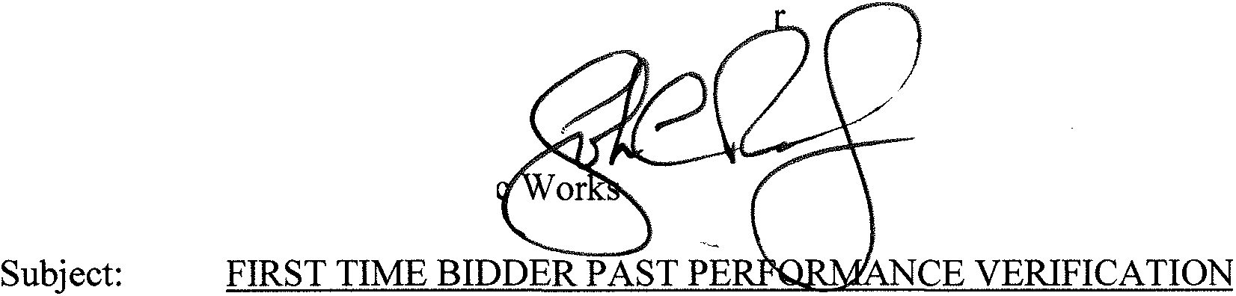
Fernando Campos, Executive Office
Board of Public Works
From:
John L. Reamer, Jr.
Inspector of Publi

Project: LOS ANGELES NEIGHBORHOOD INITIATIVE (LANI) HIGHLAND PARK IMPROVEMENTS ALONG FIGUEROA BETWEEN AVE 50 & AVE 60

Project No.: E1907805

In accordance with your motion adopted April 1, 1985, I am transmitting the following information on the low bidder:

Low Bidder: AXIOM GROUP
200 N. San Fernando Rd. Ste. 314 Los Angeles, CA 90031
323-612-6343
Bid Amount: $146,900.04

State Contractor's License No: 766918 Class: B
Expiration Date: 06/3012018

Officers

According to Esteban Torres, President, the officers of this organization are: President, Secretary, Treasurer Esteban Torres

Work Experience and Agency Comments

- West Adams Heights Park, for Los Angeles Neighborhood Initiative Completion Date: January 30, 2015
Axiom Group was the Prime contractor on this $359,727.00 project which consisted of the construction of a new pocket park with landscaping, play and exercise equipment, fencing, gates, and shade structures.

Melanie Nelson, Construction Manager, 310-548-9292, stated Axiom Group did an excellent job.

On a scale of 1 to 10, 10 being best, Melanie Nelson rates Axiom Group a 10.

- Gladys Jean Wesson Park, for Los Angeles Neighborhood Initiative Completion Date: April 25, 2014
Axiom Group was the Prime contractor on this $243,000.00 project which consisted of the construction of a new pocket park with landscaping, play and exercise equipment, fencing, gates, and shade structures.

Melanie Nelson, Construction Manager, 310-548-9292, stated Axiom Group did an excellent job.

On a scale of 1 to 10, 10 being best, Melanie Nelson rates Axiom Group a 10.

- Los Angeles River North Valleyheart Riverwalk, for Los Angeles County Public Works Completion Date: February 2014
Axiom Group was the Prime contractor on this $1.8 million dollar project which consisted of a pedestrian trail along the north side on the Los Angeles River.

Elizabeth Ajaelo, Construction Manager, 626-300-3241, stated Axiom Group did a good job.

On a scale of 1 to 10, 10 being best, Elizabeth Ajaelo rates Axiom Group a 9.

Compliance with Wages, Regulations, and Contract Provisions

The agencies contacted and the Office of Contract Compliance did not indicate any known violations of wages, regulations, or contract provisions.

Past Performance with Affirmative Action Requirements No known unresolved past problems.
Criminal Convictions

No knowledge of any criminal convictions.

Allegations or Charges of Wrongdoing or Unethical Conduct by the Bidder of Principal in Connection with Either Award or Performance on Past Contracts

Unknown.

MBE/WBE Participation

The agencies did not indicate any MBE/WBE participation problems. Compliance with State Senate Bill No. 223
The validity and status of the contractor's license has been verified.

CS:bes
axiongroupftb.mem. doc

cc: Bureau of Engineering, Construction Division - Awards Unit

