|  |  |  |
| --- | --- | --- |
| - 100B1880 | | |
|  | | **City of Los Angeles**  **Department of Public Works**  **Bureau of Engineering**  **Environmental Engineering Division** |
|  | | Hyperion Treatment Plant  Wastewater Capital Improvement Program |
|  | | HTP Service Water Facility UpgradeFINAL DRAFT Pre-Design Report **CIP 2506, W.O. SZH11313** |
|  | | July 2009 |
|  | Environmental Engineering Division | |

|  |
| --- |
| **Hyperion Treatment pLANT**  **cip 2506 HTP Service Water Facility UPGRADE Project**  **FINAL Draft Pre-Design Report**  **w.o. SZH11313**  **July 2009** |

## Project Management

Richard Mayer, Project Manager

Danielle Jeppson, Project Engineer

## Design Engineering

William Hartnett, Process Engineer

Andy Gajjar, Mechanical Engineer

Armond Badkerhanian, Instrumentation & Controls

Peter Maguire, Electrical Engineer

Henry Yun, Structural Engineer

Kolony Ponce, Structural Engineer

# Program Management

Kenneth R. Redd, Division Engineer

Michael Sarullo, Assistant Division Engineer

Edick Ohanian, Assistant Division Engineer

Prepared by

# ENVIRONMENTAL ENGINEERING DIVISION

**BUREAU OF ENGINEERING**

**DEPARTMENT OF PUBLIC WORKS**

**CITY OF LOS ANGELES**

Table of Contents

**Table of Contents i**

**TIWRP & Project Manager Approval ii**

1. **Introduction 1**
2. **Background 1**
3. **Project Scope 2**
   1. Design Criteria 3
4. **Preliminary Testing 4**
5. **alternative Analysis 6**
   1. Option 1 – Do Nothing 6
   2. Option 2 – Utilize Existing DCT Cloth Filters for Installation

in HTPSWF 6

* + 1. Option 2.1 – Install Filters in Bottom of Existing

SWF Micro-Screen Basins 7

* + 1. Option 2.2 – Install Filters Above Existing SWF

Micro-Screen Basins 7

* 1. Option 3 – Procure and Install Entirely New Filters 7

1. **Recommended Project 7**
2. **Schedule 9**
3. **Construction Budget 10**
4. **QA/QC Program 10**
5. **Staffing Recommendation 10**
6. **Design Development 10**

**Appendix A** (service water facility design criteria)

**Appendix B** (Aqua-AeRobic Systems Preliminary bench study)

**appendix c** (DCT Pilot Study on Aquadisk Filter – Graphed results)

**Appendix d** (System Flow Sheet & Dwgs of filters in existing Basins)

**Appendix E** (HTP SWF Hydraulic Profile & Hyraulic Analysis Calcs)

**Appendix F** (Class “C” Cost Estimate)

This document hereby confirms the HYPERION TREATMENT PLANT of the BUREAU OF SANITATION and the HYPERION TREATMENT PLANT of the ENVIRONMENTAL ENGINEERING DIVISION of the BUREAU OF ENGINEERING have discussed, reviewed, and jointly approved the direction of work, scope, alternative selection, and design parameters of the Pre-Design Report for the Hyperion Treatment Plant Service Water Facility Expansion Project (CIP 2506).

HYPERION TREATMENT PLANT

BUREAU OF SANITATION

______________________________________________

Mark Starr, P.E., Sr. Sanitary Engineer Date

ENVIRONMENTAL ENGINEERING DIVISION

BUREAU OF ENGINEERING

______________________________________________

Richard Mayer, P.E., Project Manager Date

1. **Introduction**

This Pre-Design Report will serve as a basis for the detailed design of the Hyperion Treatment Plant Service Water Facility (HTPSWF) Upgrade project. This report provides an overview of the proposed modifications to the existing facilities to meet the plant’s increasing service water demand and for improved operation and maintenance.

1. **Background**

The HTPSWF was constructed in 1995 as part of the Hyperion Full Secondary (HFS) program to meet HTP service water needs following the completion of the HFS program. The Service Water Facility treats HTP secondary clarifier effluent and provides the following types of service water:

1. Effluent Cooling Water Supply (ECWS, or cooling water)
2. High pressure effluent (HPE).

Service water is used as a lower cost alternative to freshwater, where freshwater is not required. ECWS, originally planned to service the Hyperion Energy Recovery System (HERS) Facility and the Cryogenic Air Separation Facility, currently only serves the latter as HERS is abandoned. The original facility had difficulty meeting the HPE demand of the plant, a problem rectified by switching out the 35 micron screens on four of the units with screening panels having 1/16 inch holes. While this resolved the problem of HPE quantity, it also resulted in a reduction in the quality of the filtrate from those screens and ultimately resulted in higher backwash loads on the pressure filters. This combination of screen panels does not remove a sufficient quantity of particulates to ensure reliable operation of the downstream services which depend upon a clean source of cooling water. In addition, the need to pass the HPE through a second stage of filtration in the High Pressure Sand Filters results in substantial annual power expenditure. HPE is widely used for many plant activities including wash downs, line flushing, equipment seal water, equipment cooling, sluice water, chemical dilution, etc., and, therefore, is critical to plant operations.

The ECWS is only micro-screened prior to use whereas the HPE is micro-screened, filtered through high pressure sand filters, and chlorinated with Sodium Hypochlorite prior to use. The current maximum throughput for the HTPSWF is 13.4 million gallons per day (MGD).

Currently, the micro-screens, while still functional, are severely corroded and badly in need of replacement. This report looks at removing four (4) of the existing micro-screens and installing six (6) AquaDisk cloth media filters that are currently installed at the Donald C. Tillman Plant (DCT). These filters provide high quality filtrate in a single pass, thus avoiding the need for the continued use of the high pressure Sand Filters currently installed and utilized in the HTPSWF.

DCT completed the installation of 10 AquaDisk PA-13 nylon pile cloth media filter test units on-site in 2006 following an intensive pilot program at the site using a full-scale Disk filter. The test unit was operated over a wide range of flow and influent quality conditions. The latter testing was accomplished by mixing RAS with the secondary effluent to vary the influent TSS and turbidity properties over a wide range of values. The testing proved so successful, that 9 additional filters were installed to provide additional capacity and improved filtration of the secondary effluent at DCT. Due to the configuration of the existing sand filters at the DCT facility, it was necessary install the disk filters above ground and to pump the secondary effluent up to the disk filters. When Aqua Aerobics successfully proved that their “Aqua-Diamond” In-Tank filtration system would meet the City’s requirements with the units installed in the existing basins and thus eliminating the need for pumping, the City initiated a project to convert the DCT sand filters, making the Disk Filters available for relocation. As a result of the DCT conversion, the Bureau of Sanitation has requested that six (6) of the cloth media disk filters from DCT be transferred and installed at the Hyperion Service Water Facility as replacements for some of the existing micro-screens. The scope of this project includes the dismantling, transport, modification, and installation of the AquaDisk cloth media filters at the Hyperion Treatment Plant only. The remaining four (4) disk filters will be utilized to augment the tertiary filtration systems at the Los Angeles Glendale Plant (LAG) under another project.

The existing cloth media filters at DCT use AquaDisk PA-13 nylon pile media that can filter particles as small as 10 microns. Being a woven pile filter media, the filter must establish a “pre-coat” of biomass, after which the filtration becomes most effective. DCT operates an air-based, activated sludge secondary treatment system which also involves denitrification. Therefore, the quality of the secondary effluent from the DCT system is substantially better than the quality of the secondary effluent from the HTP pure-oxygen based activated sludge system. The latter system tends to produce somewhat smaller particles which result in increased suspended solids concentration and turbidity of the secondary effluent leaving the clarifiers. This report will discuss the subject of whether the cloth media currently in use on the AquaDisk filters will be able to effectively filter the “dirtier” HTP secondary effluent entering the SWF, while retaining a reasonable backwash to filtrate ratio.

1. **Project Scope**

The purpose of this project is to replace the aging and corroding micro-screens with filtration that will more effectively and efficiently filter the secondary effluent entering the HTP Service Water Facility.

The scope of this project is as follows:

* Dismantle and transport six (6) of the existing Aqua-Aerobics Disk Filters and instrumentation from DCT to HTP.
* Dismantle the steel structure and associated equipment currently housing the Aqua-Aerobics Disk Filters at DCT.
* Modify the filters as required to fit the existing basins at the HTPSWF. This will include, but not be limited to:
  + Modify inlet piping
  + Relocate backwash pumps, valves, piping to the operating floor
  + Modify the filtrate tank and add a new filtrate trough
  + Relocate the Aqua-Aerobics controls to the operating floor
* Modify the existing concrete basins at the HTPSWF to accept the Aqua-Aerobics Disk Filters.
* Procure new cloth media to replace the old cloth media currently installed on each filter. The new cloth will be the same type (PA-13 nylon pile media) and size (10 microns) as the cloth currently installed, but will also be chlorine resistant.
* Install two (2) AquaDisk cloth media filters from DCT in the empty basins at the HTPSWF.
* Remove four (4) of the existing micro-screens in the HTP SWF and replace with the modified remaining four (4) AquaDisk Filters. It is expected that this will proceed by replacing two filters at a time.

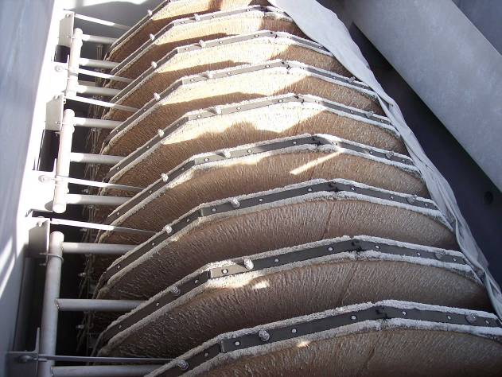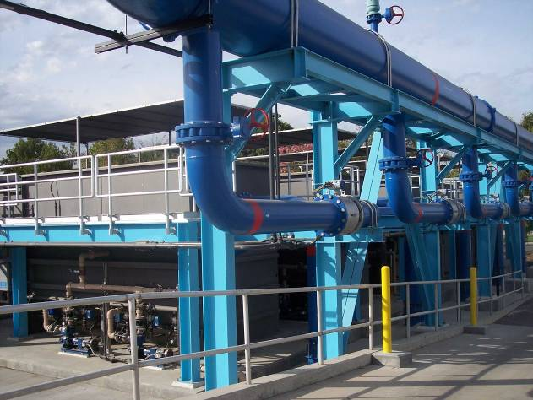

**Figure 2.** Showing one AquaDisk cloth media filter.

**Figure 1.** Showing elevation of AquaDisk filters currently installed at DCT.

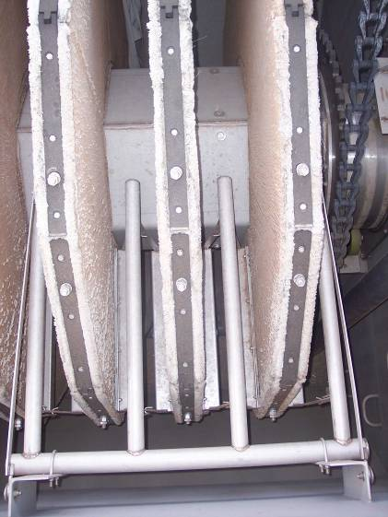

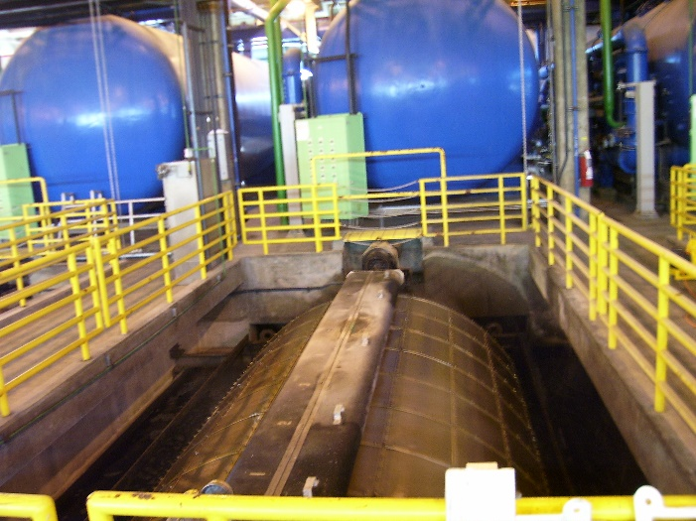

**Figure 4.** Existing micro-screen and basin in the HTP SWF where the AquaDisk filters from DCT will be installed.

**Figure 3.** Showing the vacuum on the cloth media filter.

* 1. **Design Criteria**

Table 1 shows the design criteria for the new filtration system in the SWF as received from the Bureau of Sanitation on November 18, 2008 (also shown in Appendix A):

**Table 1. SWF Design Criteria**



The maximum flow rate for the existing SWF is 13.4 MGD. The maximum flow rate for the ultimate SWF (and the design flow rate for this project) is 27.5 MGD.

It is anticipated that the service water usage and requirements from the HTPSWF will significantly increase in the near future due to the Scattergood-Hyperion Alternative Renewable Energy (SHARE) Project. The SHARE Project will involve using HTP digester gas, supplemented with natural gas, to repower the Scattergood Generation Station (SGS) and produce process steam for use at HTP. This process will require the use of cooling water in a condenser used for heat rejection and will demand an estimated additional flow of 30 MGD of service water from the HTPSWF. This would raise the total throughput of HTPSWF to roughly 60 MGD. Please note that the requirements of the SHARE Project are not a part of the scope of this project. Under the current project scope, utilizing six (6) AquaDisk cloth media filters from DCT will provide 35-40 MGD of treated HPE once installed. Therefore, this number of filters will not provide enough service water to provide for the SHARE Project needs. Furthermore, additional filters of this capacity will eventually need to be procured and installed in the remaining six micro-screen basins in the HTPSWF if accommodating the SHARE Project requirements is desired. If accommodating the SHARE Project is desired, the additional filters will be procured at a later date under a separate project, and the plant (HTP) has recommended that the Department of Water and Power (DWP) provide the necessary funding in order to meet the SHARE requirements.

1. **PReliminary Testing**

A 10 gallon volume sample of the HTP secondary effluent was sent to Aqua-Aerobic Systems, Inc. for testing on December 2, 2008. The objective of this preliminary bench study was to determine the feasibility of using the existing AquaDisk cloth filters from DCT to sufficiently filter the HTP secondary effluent in accordance with Title 22 reuse criteria. (Note that Title 22 quality is NOT required for use as cooling water or HPE in the HTP.) The results of the bench study, summarized in Table 2 below, indicate that the AquaDisk PA-13 pile media is capable of reducing the levels of turbidity and TSS in the HTP secondary effluent stream from 7.49 NTU and 10.7 mg/L to 3.47 NTU and 2.3 mg/L (averages), respectively. The TSS in the HTPSWF effluent obtained by the existing micro-screens is 6.6 mg/L. Therefore, the AquaDisk cloth filters provide a significant increase in effluent quality from the SWF. The following is a summary of the results from the preliminary bench study from Aqua-Aerobic Systems, Inc:

* 3 gallons per minute per square foot (3 gpm/ft2) hydraulic loading rate.
* Ultra-Violet Transmittance (UVT) at 254 nanometers (nm): 56.3%; 56.9%
* SE Particle distribution less than 10 microns: 86%

**Table 2. Summary of Aqua-Aerobic Systems Bench Study**



It was further noted by Aqua-Aerobics, and also demonstrated at DCT, that the filtrate quality will improve with lengthier runs as the filter media becomes highly “ripened.” Ripening of the cloth media means that, over time, as the larger particles are trapped on the cloth, they will make the effective measured openings in the cloth smaller and will strain out smaller particles in the effluent that would otherwise pass through cleaner media. For the full bench study report, please see Appendix B.

Although the bench study found the existing cloth media filters currently installed at DCT can sufficiently filter the secondary effluent from HTP, the limiting factors of the study were the sample size and the fact that it was a “batch” filtration study. Because the secondary effluent at HTP has more suspended solids and particulates than the secondary effluent at DCT, there was some uncertainty as to how the existing DCT AquaDisk filters would perform over a long period of time. There was concern that the higher quantity of smaller particulates in the secondary effluent would, require more frequent backwashing, and perhaps eventually plug the cloth filters, despite the automatic backwash system installed on the filters.

However, a study conducted by UC Davis in preparation for Title 22 approval, and a separate, full-scale pilot study (CIP 6151) performed at DCT in 2004 each tested the filters under abnormally high influent TSS concentrations. In the 2004 DCT pilot study, the filter feed was spiked with mixed liquor from the DCT Secondaries and the filters performed very well. The following is a summary of the two studies’ conditions and results (please see Appendix C for the graphed results of the DCT AquaDisk Pilot Study):

UC Davis Report:

* Influent was spiked to 45 NTU, or 91.35 mg/L.
* No pluggage was reported.

2004 DCT Pilot study:

* Filters performed well at 8 MGD (which is 3 MGD above manufacturer’s recommended maximum for Title 22).
* Generally met 2 NTU effluent quality.
* No damage to media at high loading.
* Filter unit has high hydraulic loading capacity:
  + 3.25 gpm/ft2 average flow
  + 6.5 gpm/ft2 peak flow

These two studies indicate that additional testing (i.e. a pilot study or an additional laboratory test) is not required. This opinion is further enhanced by a technical article entitled “Pilot-Scale Evaluation of Cloth Media Filtration Technology” presented in Wastewater Professional, October 2007, wherein a single-disc filter was tested by Los Angeles County Sanitation Districts. The filter was able to meet Title 22 requirements under all tested conditions (including high solids loading), there being no effect on the filters by the County’s use of polymer in their clarifiers. The criteria specified in Title 22 state that effluent turbidity should not exceed: (1) an average of 2 NTU within a 24-hour period, (2) 5 NTU more than 5% of the time within a 24-hour period, and (3) 10 NTU at any time. They did experience higher backwash volumes under extraordinary influent turbidity conditions (approximately 20 NTU), but normal backwash flows were in the range of 1.0 – 1.4% of the influent flow rate.

1. **Alternative Analysis**

Although the existing cloth media filters are able to filter the HTP secondary effluent entering the SWF, the feasibility and cost-benefit of installing the filters in the SWF with all the required amenities must be determined. It is currently proposed that the cloth media filters from DCT be installed in the HTPSWF, but if too many modifications of the SWF are required to install the available AquaDisk cloth media filters, it may be more cost-effective to procure and install entirely new filters.

Several approaches to the project have been investigated: 1) do nothing, 2) utilize the cloth filters currently installed at DCT by installing the available six Aqua-Aerobics cloth filters in or above the existing micro-screen basins, or 3) procure and install entirely new filters.

* 1. **Option 1 – Do Nothing**

The existing micro-screens are old, rusting, and difficult to maintain. The backwash system on the existing micro-screens also produces a fog in the SWF which is resulting in the corrosion of surrounding equipment as well as the steel structure of the building itself. If the micro-screens and pressure filters in the SWF are left as-is, the quality of the service water exiting the SWF will remain substandard, and the maintenance and repair costs will continue to increase, ultimately resulting in replacement in any case.

* 1. **Option 2 – Utilize Existing DCT Cloth Filters for Installation in HTPSWF**

Utilizing the AquaDisk PA-13 nylon pile media filters from the Diamond Filter installation at DCT is a great opportunity as the filters are in excellent working condition, they are extremely effective at filtering secondary effluent, and the filters themselves are free. There will be some expense to disassemble the existing system and transport the filters and accessories from DCT to HTP, but the cost to procure new filters would far exceed the labor and transportation costs associated with using the available units from DCT.

Installing the cloth media filters will significantly increase the quality of the filtered SWF effluent, and use of the high pressure sand filters in the SWF will no longer be required. This will result in significant cost savings as procurement, installation, and maintenance costs for the sand filters will no longer be necessary.

* + 1. **Option 2.1 – Install Filters in Bottom of Existing SWF Micro-Screen Basins**

There will need to be minor modifications done to the existing micro-screen basins in the SWF, but the new AquaDisk filters from DCT fit the existing basins quite nicely. By installing the filters inside the existing basins, HTP will be able to keep the existing SWF influent pumps and motors as there will not be any additional head required to get the HTP secondary effluent to the filters. Another advantage of placing the filters inside the existing basins is that the existing channels, backwash pipelines, and valves currently used for the micro-screens can also be used for the new filters. Each basin will be retrofitted with the necessary filter supports. The inlet-side support of each existing micro-screen basin will be built up to form an “inlet chamber”, isolating the exterior of the filter housing from the secondary effluent. The inlet pipe of the filter will be extended through this wall to allow the secondary effluent to pass into the filter tank. The filtrate tank of the filters will be modified to connect the effluent weir via a new trough to the existing filtrate port in the basin wall, and into the filtrate channel. The backwash valves, pumps, etc. will be relocated to the operating floor for easy access, as will the individual filter control panels.

* + 1. **Option 2.2 – Install Filters Above Existing SWF Micro-Screen Basins**

This option is quite expensive as the SWF influent motors and pumps would need to be replaced in order to provide the additional head to pump the HTP effluent up to the height of the filters for treatment. If the AquaDisk filters were to be installed over the top of the basins, the existing micro-screen basins would also need to be modified more extensively than in Option 5.2.1. This is not ideal as there are valves and piping that will need to be moved and modified in order to maintain proper working order of the SWF. Additional platforming required to service the filters will also add to the expense of this type of installation.

* 1. **Option 3 – Procure and Install Entirely New Filters**

It will be quite a bit more expensive to find and buy entirely new filters that fit the existing Service Water Facility exactly; and it is more likely that the existing micro-screen basins in the SWF will still need to be modified in some way to accommodate the new filters. Therefore, the cost to modify the existing micro-screen basins in the SWF would be added to by the additional cost of the new filters for this option.

1. **recommended project**

It is recommended that Option 2.1 (in section 5.2.1) be utilized for this project, i.e., the six AquaDisk PA-13 nylon pile media filters from DCT will be installed down inside the existing micro-screen basins. Each of the six AquaDisk cloth media filters will come as a complete assembly, including all required controls, backwash systems, and inlet valves for each filter to be completely operational.

The estimated dry weight of the filters is 22,200 lbs (11.1 tons) and the estimated operating weight of the filters is 132,750 lbs (66.4 tons). The bottom of the cloth filters in the basins will be supported approximately 1.5 feet off the bottom by a concrete pad. Structural design of a concrete pedestal will be required to support the filters in each basin. A 3-dimensional drawing of the filters and micro-screen basins is provided in Appendix D.

Because the AquaDisk filters are being installed inside the micro-screen basins in the HTPSWF, the steel supports and framework that were constructed at DCT under the Diamond Filter installation project that currently house the AquaDisk filters will not be used at HTP after demolition. Similarly, DCT staff do not foresee a need or opportunity for the utilization of the existing framework anywhere else in the plant (DCT). Therefore, the steel structure and framework currently housing the AquaDisk filters at DCT that will be disassembled under this project will not be salvaged. If the contractor can receive compensation for the steel structure parts, it will be reflected in the bid amount.

The Secondary Effluent enters the SWF via the Influent Wetwell, from whence the Influent Pumps transfer it into the Microscreen/Filter Feed Channel. The channel is fitted with several overflow weirs at the upstream end to allow excess pumped material to return to the wetwell should the pumps deliver more than the treatment systems (currently Microscreens) can handle. There was concern that the increased liquid elevation at the inlet of the new filters to achieve 6 mgd throughput, could result in exceeding the invert elevation of the overflow weirs, thus limiting throughput to the filters. However, by doing a preliminary hydraulic analysis of the filter feed channel, it was discovered that the level required at the filter inlets to deliver 6 mgd is 31.63 ft. At 3.5 mgd, the level is 30.98 ft. The invert of the overflow weirs is 31.76 feet and the ceiling of the channel is at elevation 32.76 ft so it is anticipated that modifications to the overflow weirs are not required. Please see Appendix E for the HTP SWF hydraulic profile and hydraulic analysis calculations.

Currently, there are two empty micro-screen basins in the SWF, so only four HTP micro-screens need to be removed from the SWF in order to install all six cloth filters from DCT. The new cloth filters from DCT will be installed two at a time (and, therefore, the four micro-screens will be removed two at a time) until all six of the cloth filters are installed in the SWF. The reason for demolishing only two micro-screens at a time instead of all four at once is so the proper redundancy for filtration of service water can be maintained, even during construction and installation of the new cloth filters. The remaining micro-screens that do not need to be removed to install the cloth filters will remain in place until it is necessary that they be removed (i.e. when more cloth filters are procured and installed to meet future demand). Although the micro-screens will be left in place in the SWF, they will not be used – only the newly installed cloth filters will be used as they will provide enough service water to meet the plant’s current needs. There are a total of 10 micro-screens currently installed in the SWF; four of those will be removed and demolished (not salvaged) for the installation of the 6 cloth filters (2 installed in existing empty micro-screen basins). Therefore, 6 micro-screens will be left as-is for the time being.

As previously mentioned, installing the AquaDisk cloth media filters will increase the quality of the effluent (HPE and cooling water) leaving the SWF. This increase in quality eliminates the need to use the high pressure sand filters in the HTPSWF. Although the sand filters will no longer be necessary, they will not be demolished as part of this project because HTP wants to ensure the level of quality of the HPE from the cloth filters alone is as high as anticipated before taking the sand filters off-line permanently. Leaving the sand filters in place during this project will not affect the construction or installation of the new cloth filters.

The suction pumps for the backwash system will be installed above the cloth filters on top of the deck next to each of the six basins in the SWF. Backwash of the cloth filters utilizes approximately 2% of the filtrate flow from the filters to clean the cloth media. Although the secondary effluent being treated at HTP has more particulates than the secondary effluent treated at DCT, the backwash lines will not need to be enlarged because the backwash does not flow through a pipe but into a channel, thus the backwash flowrrate is constant. More particulates in the HTP effluent only require the frequency of backwash to be increased when the filters are operating at HTP. The higher rate of backwash will keep the cloth media on the filters from plugging. The anticipated backwash rate at HTP will be between 30 and 60 minutes.

The cloth media on the existing AquaDisk filters will be replaced with newer and chlorine resistant cloth media of the same filtration size – 10 microns. The cloth will be replaced prior to installation of the filters in the micro-screen basins and will cost approximately $25,000 per filter. The quality of the HPE after filtration through the cloth filters and exiting the HTPSWF is anticipated to be 3.47 NTU turbidity and 2.3 mg/L TSS. For more information on the water quality that will be produced by the cloth filters, please see the bench study performed by Aqua-Aerobic Systems, Inc. in Appendix B, or the summary of the bench study in Section 4 – Preliminary Testing, Table 2 of this report.

It is estimated that each AquaDisk filter can run 5 MGD each while satisfying the requirements to meet Title 22 conditions. However, because it is not necessary that HTP reach Title 22 standards, each filter could hydraulically run as high as 6 or 7 MGD. Therefore, only 3 or 4 cloth filters are required to treat the current HTPSWF flow rate of 13.4 MGD. However, to allow for an increased future need of service water, all six available AquaDisk filters from DCT will be installed. Ultimately, twelve filters of this type could be installed into the existing HTPSWF, yielding a hydraulic capacity to treat up to approximately 75-80 MGD, if required.

1. **schedule**

This project is scheduled for delivery in the 2012/13 fiscal year. Minor schedule adjustments were made from the UPRS schedule to obtain further project information in order to complete an adequate and accurate Class “C” estimate. Based on the recommended project, below is the new project schedule.

**Start Finish**

* Pre-Design Sep 2008 Jul 2009
* Design Aug 2009 Jul 2010
* Bid & Award Aug 2010 Jan 2011
* Construction Feb 2011 Jul 2012
* Post Construction Aug 2012 Jan 2013

1. **Construction budget**

The total construction cost to complete the SWF Expansion project as described above is estimated (Class “C”) to be $4,500,000. Please see Appendix F for the Class “C” cost estimate.

1. **QA/qc program**

QA/QC for the Project will be carried out by EED staff. Reviews will be carried out by design team, project management, construction management, and the client at the 50% and 90% stages. Standard QC checklists will be used to record the results of the QC checking. All comments will be incorporated or addressed for Quality Assurance / Quality Control (QA/QC) purposes.

1. **staffing recommendation**

The following disciplines will be required for this project:

* Electrical Engineering
* Instrumentation and Controls Engineering
* Mechanical Engineering
* Process Engineering
* Structural Engineering

1. **Design Development**

*Electrical:*

For the six (6) cloth filters that will be installed in the HTPSWF, it is anticipated that the following will be required for:

* Power – 150 feet of 1 inch conduit per filter (times 6 filters = 900’ of 1” conduit) and will each contain three (3) #8 and one (1) #10 GND (times 6 filters = (18) #8, and (6) #10) that will run from the MCC to the Local Control Panel (LCP).
* 3 Motors/filter – (Assuming the motors are 50 feet from the LCP) 50 feet of 1 inch conduit (times 3 motors, times 6 filters = 900’ of 1” conduit) and contain three (3) #8 and one (1) #10 GND per motor (times 3 motors/filter, times 6 filters = (54) #8 and (18) #10) that will run from each motor to the LCP.
* Controls – 50 feet of 1.5 inch conduit (times 6 filters = 300’ of 1.5” conduit) containing 10 TSP #16 cables per filter (times 6 filters = 60 TSP #16 cables).

*Structural:*

In order to accommodate the installation of the six new Aqua-Aerobics Disk Filters into the existing micro-screen basins in the SWF:

* Install one reinforced concrete pad at the bottom of all six (6) micro-screen basins measuring roughly 2’ H x 18.5’L x 11.25’ W.
* Dowel and fill in a 3-sided opening of an existing influent micro-screen basin inlet pipe wall in each of the 6 micro-screen basins measuring roughly 1.25’ thick x 11’ wide x 9.33’ high.
* Create 2 holes in each new 1.25’ thick inlet pipe wall (as described above) measuring 18” in diameter (times 6 basins = 12 holes in inlet side of basins).
* Create 1 hole in each existing 1.25’ thick effluent channel wall measuring 18” in diameter (times 6 basins = 6 holes in effluent side of basins).

*Instrumentation and Controls:*

Each of the six AquaDisk cloth filters will have its own LCP. In the existing micro-screen system, two micro-screens share one control panel. Therefore, each old micro-screen LCP will be replaced with 2 new cloth filter LCPs side by side in the same location.

*Mechanical:*

The backwash pumps and motors will be located at the deck level within a 4’ wide x 10’ long footprint near the filter inlet side of each filter. Each pump will have 3” diameter suction from the backwash header inside the basin through a vertical riser and 3” diameter pump discharge. Both discharge pipes will be connected to a header and the header discharge will be tied into the existing 6” diameter backwash pipe flange running near the top of the basin on the filter inlet side.

There will also be additional piping in the basement of the HTPSWF. It will be 24 inch pipe with 16 inch LCV and bypass. See Iso View Drawing in Appendix D for more details.

*Process:*

(Also see Flow Sheet Drawing FS-1 in Appendix D)

Secondary Effluent from the activated sludge process enters the SWF via an underground influent channel feeding the Low-Lift Pump Wet Well. The wet well supports seven Low-Lift Pumps, 1503-A thru G, each of which is rated at 13,500 gpm (19.44 MGD) at 27’ of differential head. Each Low-Lift Pump is fitted with a 125 HP Variable Frequency Drive which varies the speed of the pump(s) to maintain a constant water level in the Cooling Water Sump, downstream of the Filters/Micro-screens. The Low Lift Pump (typically only one is required to operate at the current loadings) lifts the influent from the wet well and discharges it into the Filter Influent Channel (currently known as the Micro-screen Influent Channel) which passes between the twelve Filter/Micro-screen basins. The influent wet well is provided with overflow weirs which recycle excess secondary effluent from the Filter Influent Channel to the wet well during periods when the filtrate demands are less than the minimum flow that a single pump can deliver.

From the Filter Influent Channel, the water flows through the gate valve into each Filter Influent Chamber, and then, via the filter feed pipe, containing a flow meter, into the filter body over the internal weir. During the initial installation of first two filters when both Micro-screens and Filters will be in operation, the slide gates at the inlets of the basins will be used to adjust the flow to the various units. Once all the filters are installed, and the Micro-screens will no longer be used, the internal weir on each filter will passively distribute equal flow among the online units. At that time, the slide gates will be used solely for isolation purposes.

The secondary effluent then passes through the cloth media on the filter discs where solid particles of 10 micrometer or larger are contained on the outer surface of the cloth media, while the filtered water passes into the filtrate collection pipe upon which the cloth disks are mounted. The filtered effluent then exits the filter, flowing over the discharge weir and thence into the existing Filter Effluent Channel which feeds the Cooling Water Sump. Each filter is fitted with a filtrate turbidity analyzer which will alert the operator should there be a malfunction of the filter. As solids accumulate on the cloth media surface, the pressure drop through the media increases, thereby increasing the liquid level in the filter body. A level sensor located therein, sends a signal to the filter controller (UC) which then places the filter in Backwash Mode by opening the backwash valves, starting the Backwash Pump(s), and then vacuuming the solids from the surface of the media and discharging them into the existing Micro-screen Backwash collection header. In the event that the pressure drop does not increase sufficiently to raise the liquid level to the point that backwash cycle is initiated, a timer in the control module will initiate a backwash cycle at the specified interval to ensure that the media does not become clogged. The backwash solids flow to the existing Wash Water Return Sump and from there are pumped, under level control, to the Primary Effluent Channel by the Wash Water Return Pumps, 1510-03-A/B.

Filtrate then flows via the Filter Effluent Channel to the Cooling Water Sump from which the Cooling Water Pumps, 1501-A thru E, and Cooling Water Pumps 1501-01-G thru I can take suction. Currently, there is insufficient demand for Cooling Water (EWCS) as the only user is the Cryogenic Oxygen Separation Facility. Therefore, only the smaller pumps 1501-01 G, H, & I (5000 gpm @ 70’ head) are currently in regular service. Flow of EWCS is controlled within the Cryogenic Facility and changes in that flow are reflected in variations in the level in the Cooling Water Sump. A level controller, LIC32, in the Cooling Water Sump is used to regulate the speed of the Low-Lift Pumps to maintain a consistent liquid level in the Cooling Water Sump.

In order to meet the HPE demand of the plant, a new crossover pipe from the 24” EWCS header to the 24” PFE header will be installed so the pumps 1501-01 G, H, & I can both feed the EWCS system and supply feed to the chlorine Contact Basin, bypassing the existing Pressure Filters (4013 – A thru D) and their associated Filter Influent Pumps, 1510-01 A, B, &C. During the interim Disk Filter installation period, it will be necessary to retain the ability to utilize the Pressure Filters as there is no means of isolating the Micro-screen’s filtrate from that of the Disk Filters, so the crossover has been installed with tees and valves to allow use of the Pressure Filters until all six (6) of the Disk Filters have been installed and all the secondary effluent can be treated by the Disk Filters alone.

The filtrate entering the Chlorination Contact Basin is pre-mixed with NaOCl solution in the Rapid Mix Chamber upstream of the Basin and is then retained in the Basin for the requisite time period. Following chlorination, the disinfected filtrate flows to the HPE Storage Basin from which the existing HPE Pumps, 1501-02 – A thru E, and the Irrigation Pumps, 1501-04 A/B take suction. A level controller, LIC78, currently varies the speed of the Filter Feed Pumps, 1510-01A, B, &C to maintain the level in this basin. Once the Disk Filters are all on line, and the Pressure Filters are no longer in service, LIC78 will be used to then modulate the new level control valve located in the new, afore-mentioned crossover line from the EWCS header to the Pressure Filter Effluent (PFE) header to maintain a constant liquid level in the HPE Storage Basin.

**Appendix A**

**(Service water facility Design Criteria)**

**appendix B**

**(Aqua-AeRobic Systems Preliminary bench study)**

**appendix c**

**(DCT Pilot Study on Aquadisk Filter – Graphed results)**

**Appendix d**

**(System flow Sheet & Drawings of Aquadisk filters in existing HTPswf Basins)**

**Appendix E**

**(HTP SWF Hydraulic Profile & Hydraulic Analysis Calculations)**

**Appendix F**

**(Class “C” Cost Estimate)**