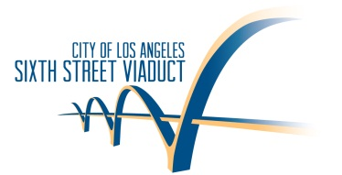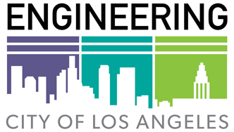For immediate release: February 2, 2016

Contact: Mary Nemick, Director of Communications, Bureau of Engineering - 213-485-5085 or mary.nemick@lacity.org

City Releases Details of Demolition of Sixth Street Viaduct

Ahead of Downtown Freeway Closure – the “101SlowJam”

40-Hour Shutdown of 101 Freeway This Weekend

Friday February 5th at 10 p.m. to Sunday February 7th at 2 p.m.

LOS ANGELES (February 2, 2016) -- The City of Los Angeles’ Bureau of Engineering released details today on how the Sixth Street Viaduct will be demolished over the coming months. The information was announced ahead of this weekend’s “101SlowJam”, a 40-hour closure of the 101 Freeway in Downtown LA, which will allow workers to remove a 220-foot section of the viaduct over the freeway.

“Removing a structure of this size takes significant planning” said Gary Lee Moore, City Engineer for the City of Los Angeles. “Our goal is to make the entire process as safe as possible for our workers and for everyone who lives and works in the project area.”

Demolition of the viaduct begins this weekend with the removal of a section located over the 101 Freeway, making it necessary for the City to close a 2.5-mile stretch of the freeway through Downtown Los Angeles. The closure will begin Friday at 10 p.m. February 5th and end on Sunday, Feb. 7th at 2 p.m.

In advance of the 101 Freeway closure, the asphalt surface is being removed from the viaduct to expose the concrete structure. The City will also be salvaging the existing light poles. The demolition process will involve the use of equipment that will break the concrete into small pieces that will fall to the ground. The freeway surface will be covered in a two-foot layer of dirt, a “dirt blanket”, to protect the roadway. Metal in the bridge structure will be cut and bundled, then transported to a recycling facility.

The viaduct suffers from Alkalai Silica Reaction (ASR), a type of “concrete cancer” that causes significant deterioration, which has facilitated the need to replace the structure. This will be the first time the City has demolished a bridge with ASR.

“Demolition is a controlled process,” added Moore. “Many people expect explosions and while that might make for good cinema, it isn’t a realistic way to remove a structure in the middle of Downtown Los Angeles.”

The City is estimating that more than 110,000 tons of concrete will be removed during the nine-month demolition. Workers use water to minimize dust and noise is monitored throughout the area.

The Sixth Street Viaduct not only stretches across the 101 Freeway, it also spans 18 railroad tracks and the LA River, and is adjacent to multiple businesses.

Detour signage is in place to assist the public in finding local alternate routes. California Department of Transportation signs are also on freeways throughout Southern California to direct drivers to alternate freeways during the closure of the 101 Freeway.

The demolition of the Sixth Street Viaduct is expected to take nine months, working from the east side in Boyle Heights to the west side in the Arts District. Construction of the new viaduct will be completed in late 2019.

Details on 40-Hour Closure of 101 Freeway

The 2.5-mile section of the 101 Freeway will be closed from the 10/101 split to the 5/10/101 interchange just east of downtown Los Angeles. In addition, motorists travelling west on Rte 60 from the Pomona area will not be able to access the 101 Freeway.

Traffic detours will be as follows – SEE DETOUR MAP BELOW

**When traveling N/B 5 from the Orange County area approaching the 5/10/101 Interchange :** Exit to N/B 101 closed

* Exit to W/B 10 open
* Exit to N/B 5 open

Primary Detour: N/B 710 to W/B 10

Secondary Detour: W/B 10 to N/B 110

**When traveling W/B 60 from the Pomona area approaching 5/10/101 Interchange:**

* Exit to N/B 101 closed
* Exit to W/B 10 open
* Exit to N/B 5 open

Primary Detour: N/B 710 to W/B 10

Secondary Detour: W/B 10 to N/B 110

**When traveling S/B 101 from the San Fernando Valley area approaching the 10/101 Split:**

* Exit to S/B 101 closed
* E/B 10 open

Primary Detour: S/B 110 to E/B 10

Secondary Detour: E/B 10 to S/B 710

101 Freeway On-Ramp closures will be as follows:

•         NB 101 6th Street - CLOSED

•         NB 101 Euclid Avenue - CLOSED

•         NB 101 Soto Street - CLOSED

•         SB 101 Los Angeles Street - CLOSED

•         SB 101 Commercial Street - CLOSED

•         SB 101 Mission Road - CLOSED

•         SB 101 4th Street - CLOSED

Also, Off Ramp closures are:

* SB 101 to Alameda Street – CLOSED
* SB 101 to Mission Road - CLOSED
* WB 60 to Soto Street – CLOSED
* NB 5 to Soto Street - CLOSED

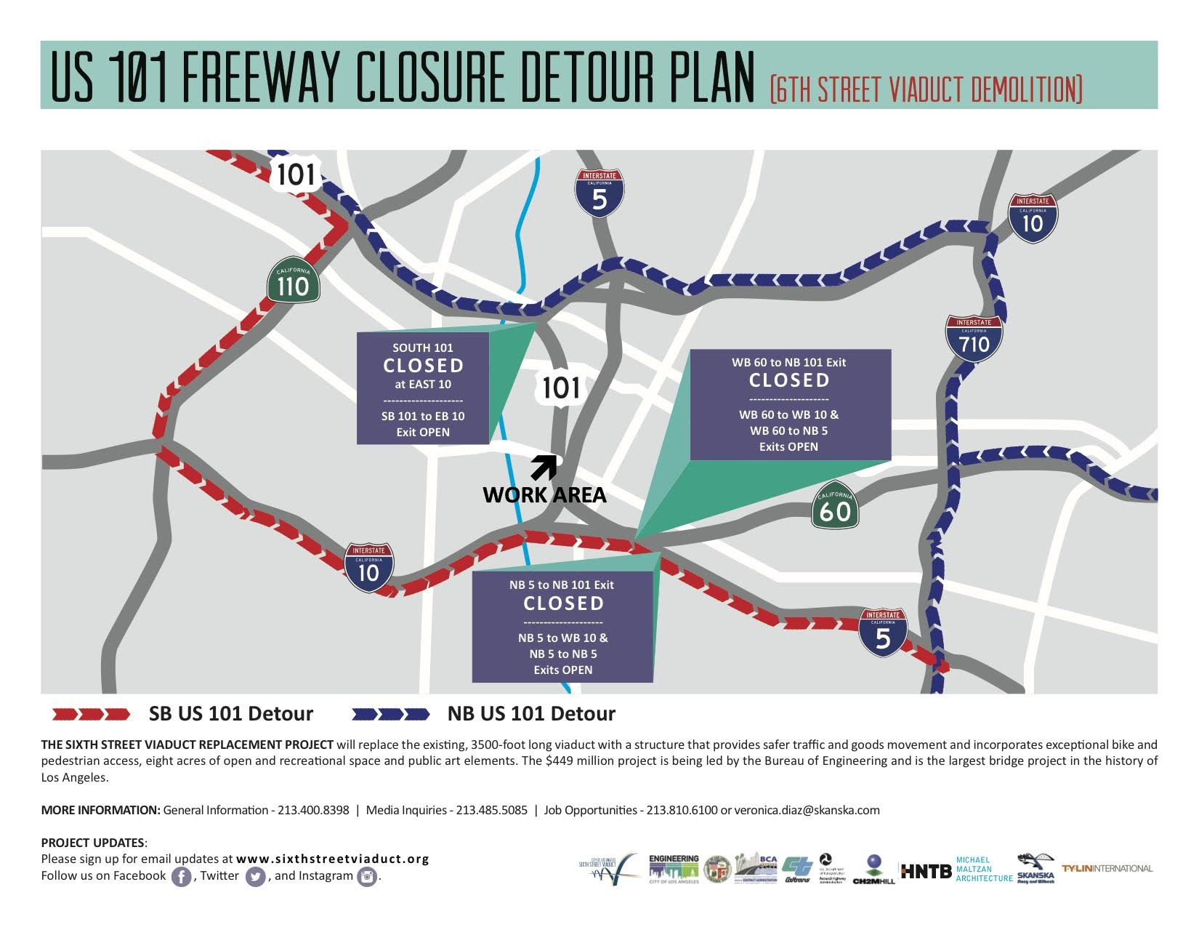

The construction team is led by Skanska-Stacy and Witbeck (SSW).

The project HOTLINE number is 213-400-8398.

For more detailed information on the closure, please go to [www.sixthstreetviaduct.org](http://www.sixthstreetviaduct.org) or follow the closure on Facebook: <https://www.facebook.com/sixtstreetbridge>, Twitter: <https://twitter.com/6thStViaduct>, and  
Instagram: <https://instagram.com/6thstviaduct>.

MEDIA CONTACT:

Mary Nemick, Director of Communications, Bureau of Engineering: 213-485-5085 or [Mary.Nemick@lacity.org](mailto:Mary.Nemick@lacity.org) ######