- \-
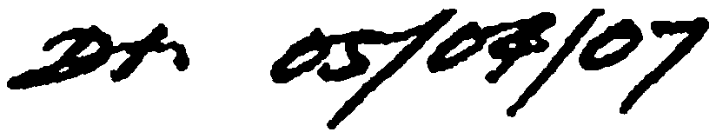

""' -- t,..

PROJECT CLSEOUT PROCEDURE

The project closeout procedures are designed to enable the Contractor to receive any retention funds, withheld during the construction of the project, within 60 days of Final Field Acceptance (FA) of the project. This is mandated by the Board of Public Works and the California Public
Contracting Code Section 7107.

On January 19, 2001,the Board of Public Works adopted A loint Board Report from the Bureaus

of Engineering and C.
ontract AdministratiIon. The Board Report directed t.he two bureaus to;

  - Establish the date of completion of 4 project to be the date of Final Field Acceptance (FA) of the project when all physi corrections have been completed.

  - Establish a policy for closing projswithout disputes. within 3 months of Final Field Acceptance and within 6 months of IFinal Field Acceptance when t.here are disputes.
Acceptance of the Contract by the Board!of Public Works may or may not occur at the same time as release of retention funds, but will oewr as soon as possible following Final Field Acceptance.
The following is a chronology of events a' s they occur in the close-out process of the project:
- Upon acceptable completion of all "7ork, the District Prilicipal Inspector will request a Final Inspection. I

- The Final Inspection will be conduOted by the Bureau of Contract Administration
Final Inspector, and a Final Inspectjon Correction LiSt will be issued to the Contractor.
'
- The Contractor is to forward the Fi Subcontracting Report and all outstanding Certified Payrolls to the Office of Contract Compliance (0.C.C.) within fifteen (15) days following the Final Inspection.

- At the time of Final Inspection, the Project Administration Section of the Bureau of Contract Administration will genete a draft copy of the Final Acceptance Board Report. r •

S . Upon completion of all physical cotrections required by the Final Inspection Correction List, the Final Inspector will issue a Statment of Completion for the project.

  - The issuance of the Stateinent of <;!ompletion shall signify the Final Field Acceptance (FA) date of the project. 1

- It is the goal of Con-Ad and a requirement of the Public Contract;ing Code to have the contractor receive withheld rettio..n within sixty (60) days of Final Field Acceptance date.
f
I

ti ..... \.

l
· A Retention will be released ls any disputed monies (potential penalties or
withholdings requested by e Project Engineer or 0. C. C.).

B. Failure of the Contractor to torward the Final Subcontracting Reports, Certified Payrolls to 0.C.C., or to sign final Change Orders will result in funds being held in retention until such time as ljll administrative processes have been completed
I
I
- Acceptance of the Contract by the Bo'1-d of Public Works shall take place upon completion of any iilvestigations(s) by OCC and/or negotiations of final Change Orders(s) by the Bureau of Engineering, and the placing on file with BCA, Contractor Perfonnance Evaluations ftom both
·BCA and BOE participants. .
'
- In the event a claim is filed against th City, and a final Inspection has been performed, the City Attorney will issue a written notice to the Inspector of Public Works to estimate any outstanding monies to be withhel and proceed with the closeout of the project.

The Contractor has a direct influence on the Final Acceptance of the project. The following are some of the items for which project accej>tance and/or full release of retention may be delayed. ·
1
  - Failure of the Contractor to comple items of work listed on the Final Inspection Correction List

  - Penalty investigation(s) by OCC into potential illegal substitution of subcontractors.

  - Investigation(s), by OCC Labor Copliance, of potential vio.ation(s) of labor laws.
i
'
  - Failure ofthe Contractor to submit Final Subcontracting Reports and all Certified Payrolls within fifteen (IS) days following the Final Inspection.

S. Failure of the Contractor to c.omplet!e negotiations and sign all Change Orders.
The Project Engineer also has a direct intluence on the Final Acceptance of the project. Ifthe negotiations of Change Orders or disputes ire not successful within thirty (30) days following the Final Field Acceptance date, a Unilateral Change Order shall be written to expedite the closeout of the project.

._; ..
.

DEPARTMENT OF PUBLIC )VORKS

BlIBEAll QF CQNTR A CT AQMINISIRATION BUREAU.OF ENGINEERING!
IS J:i{ElIDEij. ¥-
AOOPTE fy THE BOARD OF
PUBLIC W'cjRKS OF THE CITY
of Los Angeles. Callforn11

·JOINT.REPORT NO. I JAN 19 2001
Janpary 17I2001 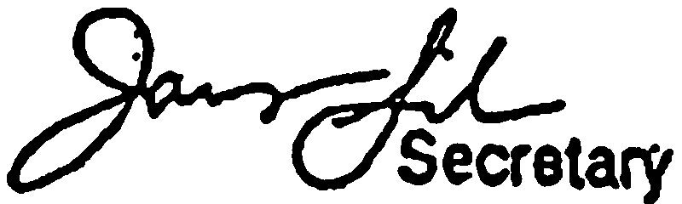
C. D. No.:All
I
I
Honorable Board of Public Wotlcs
- i
- I • EXPEDITING CONTRAcr. CtOSEOUT
RECOMMENDATIONS:

: . !
.. ..
I :
:!

1· ;

Adopt this rev.art and direct: the Bureaus of Contract dministration·ci Engineering, vely, to implement the following aCtions:

- POLICY CHANES/CRIFICATIONS
 L ·EstablisJi the.da of \t3C" of a project to be ·the date of. Final Field.
Acceptance of die project whn all physical correctiom have ·been cofupleted..
    - Establish a policy of closing projects without disputes within 3 months of fmal acceptance, and within 6 months of final aptanee when there are dispu.
· B. · ACTIQN·STEPS FOR IMPLEMENTATION
'
. .
      - I .

·, .
. ,.. 1. The Bureau of donttacr Aduiinistration shall:

- . ·Notify the Office . of Contract Compliance (OCC) ·:when ·each ·. subconctor's projeet 'Yorlc is complete. ·
. ., . . .. ' . .. .

•
.. . ..
. I • .
Jnclu4e tile following two items·oil"the..F lnspection-CorrtctiC?I1 List in ,·
oder to expedite -ipt of infonnati6n fro the·Contractor:
- ··a. · ·Forward Final ·SubconttctiBg·Repon.to··occ..

. ......
:· · · -:·; ·· ·Fotward Crtlfi:ed Payrolls·tb.:-occ. ..: :.:'. ·:·

: : .
'.• .lnitia reparation:of the ·Final Acceptance BO·Report at the time the::

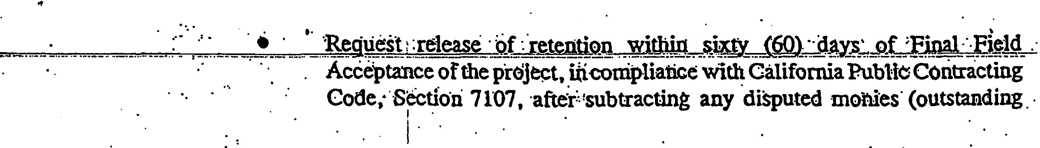
:z
..,Finalpection·is conducte
.
· ·. .:
···. .!·· ·· ·

.-. r

. .

·• ,f

Joint Report No. · · Page

I
i
I .
adminisiive corrections, such aswage violations, illegal substitutions, ()f
liquidate? damages).

  - Inthe event a claim is filed against the City, and .the project has had Final
·Inspection, the City Atto_mey wiU issue written notice to the inspector of
"Pilblic "jorks, reconuncnding that the·Bureau of Contract Administration· tiate ·tl)e project closeout. Dollar values will be estimated and withheld
. i for all oµtstanding corrections and/or potential penalties, and the Final Aeceptarice ·Report will proceed to the Board of Public Works for
. . accep and the release of reteJition (minvs the monies held).
2.. . The Bureau of Engineering hall: · ·

i
I ••

I
- Adopt a j,oucy to issue a unilateral Fm'
al Cbauge Order upon detenninatioii .

. . .

•
.. t:. ....
DISCUSSION·!
I
that all onable efforts to negotiate any remaining disputed items with · .
the coilt[:actor have n emausted. . :
Ad.opt a :policy of h:aving an intemal Advisory Board to assess the items
er CQntention for .any consttuctiou project that bas not been clos_ed .
within 61montbs Qf the end of constructjqn activities.. ·
. I
I
. I

. . .
-

..
. On October 6,.2000, the Board of Public V{orlcs dlhe.B 9f Cotraci tion
· and Eogring, :with assistance from the Clty Attorney, to expedie contract closeout in order to fully comply ·with th provlsions of Public .cQnu:a((t, Code·. on 7107. The period to ·be
addressed is from inal Aptalice of the project by the final insPector tbrOugh Board of.Public Wodc.s acceptance. . . : · ·. · . . · · ·· · . · · . · · ·
. ' . .
. . . ,. I . ·. . . . -. . . .. . .. .
Fmal Atance is determin¥ to be·when all physi c:Oons requiring. the contractor's · presence at.thej ·.site have·n completed.: :
. .
Proj closeout mos_t often: fa\lls, into:eithei: a·."rotine" Q\egdtJ or a "delayed" tegocy. A project be.closed as "rou,iliie"( minimum delay) wb.en. tJir ateno penalty tecQmmeiidatioi no claims fr9.m the contractor, no delay innegotiation·and issuance o.the FiDal Change Order, .
·.and When all requm:d.r-epo 1,iave b.eeri prc;>vided bylhe C9JJ,trac;:t0r. ThC: average cl9se<>ut tiuie
for projts of this'nature bas ii45 days. · :· . , ., · ·

. . .
. . .

i: . .
.
\ . .

,._.==·=
,.,...........-·.·=...',!J.?..r.,o,.,,j,cc.LClOSCQllt ¥ c4ielay.¢<1lt=Of-.penait:y V-tig.atiell$-fd-e\a. iR=eb fied--=

"m-.--.
payi:oll, final .sv. ntracting report.S,.ancJJo fmal chg 9rder n.egQtiao. Projects which
:experience. such obstacles are,closed out the e of 7. 20 months [. inspectio.

· •' ;.

