For J3PW M,tg of Fr iday . July 29 . 2016
Attachment 23.1-2
Page 1 of 4
ADOPTED BY THE BOARD PUBLIC WORKS OF THE Cl1Y
of Los Angeles California
JUL 2 9 2016

CD No. 4

MOTION

Execu'2 cer Board of Public Works

On an undetermined date, prior to March 4, 2016, a contractor operating on private property at 1680 Sunset Plaza Drive, removed a significant portion of the City street without authorization, leaving it unsupported and thereby a threat to public safety. City staff was forced to close the street at this address in order to prevent a catastrophic incident, which could involve damage to public and personal property, as well as possible injury or loss of life to those using this right-of-way.

This location remains closed to public travel, causing considerable inconvenience to both the local residents and other citizens who regularly use this street, some of which do not have direct access to their homes at this time. This hazardous condition must be repaired immediately for the street to be made safe again and opened to the public.

On February 28, 2014, the Board of Public Works (Board) approved the selection of six Emergency Pre-Qualified On-Call (PQOC) Geotechnical/Structural Contractors to provide emergncy construction services on Public Works projects throughout the City of Los Angeles. Subsequently on April 28, 2014, the Board approved the inclusion of a seventh contractor onto the Emergency PQOC Geotechnical/Structural Contractors List. Additionally, on March 20, 2015, the Board approved the procedural guidelines for the administration of the Emergency PQOC Geotechnical/Structural Contractors List to require the City Engineer to notify the Bureau of Engineering (BOE) Liaison Commissioner and to authorize the City Engineer to issue a construction order for emergency projects with costs between $100,000 to $500,000. Emergency projects with costs greater than $500,000 shall require authorization from the BOE Liaison commissioner to issue a construction order and shall require the City Engineer to submit a Board Motion for Board adoption.

The repair of the street at 1680 Sunset Plaza Drive was declared to be an emergency by the City Council as identified in Council Motion 16-0453, dated April 22, 2016 (Attachment). Therefore, on April, 26 2016, the first interested contractor on the rotating Emergency PQOC Geotechnical/Structural Contractor List, Kiewit Infrastructure West Company, was issued a Notice-to-Proceed for the work on a "Time and Material" basis, in an amount not-to-exceed $499,000. The scope of work consists of constructing an approximately 30-foot long, 18-foot high bulkhead, and a new curb and gutter and pedestrian handrail.

The costs incurred to date for this project are approximately $425,000 and approximately 60 percent of the work is complete. In order to prevent a suspension in the construction work, it is recommended that the Board approve an additional $114,000 for the project and authorize a construction budget for an amount not-to-exceed $613,000, which is the

- 2 -

amount authorized by the City Council. Final negotiations with the Contractor are in process as is a revised City Council authorization for the remainder of the work.

The funding for the Project comes from the 1680 Sunset Plaza Drive Emergency Bulkhead Project, Work Order No. E1908010, Fund No. 682, Department No. 50, Appropriation Unit No. 50MVBS.

I THEREFORE MOVE, that the Board authorize the execution of a Revised Construction Order for the 1680 Sunset Plaza Drive Emergency Bulkhead Project, Work Order No. E1908010, to Kiewit Infrastructure West Company for a not-to-exceed amount of $613,000.

( CFJ RMK JKS ALM )

Motion reviewed by: Respectfully submitted,

BOE (ADM and PAC)
Motion prepared by: Je

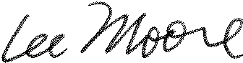
Moore, PE, ENV SP

Geotechnical Engineering Group

Christopher F. Johnson, PE, GE Group Manager
Phone No. (213) 847-0538

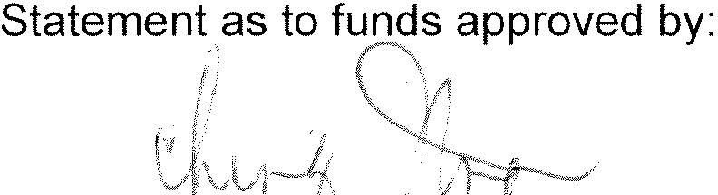
Victoria A. SanNago, Director Office of Accounting
Fund Ref. 682/50MVBS/$613,000 Date: -----
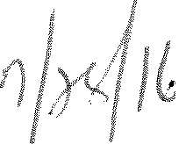

CFJ/Motion No. 24-2016.GEO.eeg
Attachment: Council Motion No. 16-0453 Questions regarding this Motion
may be referred to
Christopher F. Johnson, PE, GE Phone No. (213) 847-0538
E-mail: Christopher.Johnson@lacity.org
City Engineer

I N


On an undetermined date prior to March 4, 2016, a contractor operating on private property at l 680 Sunset Plaza Drive removed significant portions of the City street without authorization, leaving it unsupported and a threat to public safety. City staff was forced to close the street at this address in order to prevent a catastrophic incident and potential further damage to public and personal propeny as well as injury orloss of life. This location remains. closed to the public, causing considerable inconvenience to local residents and conunuters, some of whom no longer have direct access to their homes.

The Bureau of Engineering (BOE) quickly completed a design for the needed repairs consisting of a bulkhead, retaining structures, backfill, paving, concrete curb, and guard rail. Tue BOE maintains a Pre-Qualified On..Call GeotechnicaVStructural Contractor List (List) approved by the Boa.rd of Public Works (Board) for tfus type of work, including the emergency repairs critically needed on this portion of Sunset Plaza Drive. Tue BOE has indicated that they can use their List to hire a contractor to assist in completing these emergency repairs iffunding is available to do so. The contractor's forces, working togethe1·with City staff, will be able to repair the street so that Sunset Plaza Drive can be reopened and safe for the public to use.

A Class "C" estimate has been prepared by the BOE and represents a base amount for the cost of these repairs, estimated at approximately $613,000. ·

The repairs to these hazardous street conditions near 1680 Sunset Plaza Drive are critical to maintaining public safety and accessibility for the residents in this area, and as sufficient funds have been reserved by the Mayor and City Council for these types of emergencies within the Reserve Fund.

I THEREFORE MOVE that the City Council determine, as provided in Section 54954-2(b)(2) of the Government Code, and pursuant to Rule 23 of the Rules of the City Council, that there is a need to take immediate action on this matter AND that the need for action came to the attention of the City Council subsequent to the posting of the agenda for today's Council meeting.

I FURTHER MOVE that, subject to the Mayor, $613,000 be transferred from the Reserve Fund to the Unappropriated Balance Fund No. 100-58, and be appropriated therefrom to a new account in the Engineering Special Services Fund No. 682-50, entitled "I680 Sunset Plaza Drive Street Repairs," for urgently needed emergency street repairs in the vicinity of 1680 Sunset Plaza Drive, as further described inthe text of this Motion, and in advance of selecting a contractor from the Bureau of Engineering Pre-Qualified On-Call GeotechnicaJ/Structural Contractor List so that BOE can select the contractor and expedite the completion of the emergency repairs; and further with the understanding that any of these funds remaining and not used for this emergency shaU be returned to the Reserve Fund upon of the

I FURTHER MOVE that the City Engineer, be authorized to make any corrections, clarifications or revisions to the above fund transfer instructions, including any new in order to effectuate the intent of this Motion, and including any corrections and changes to fund or account numbers; said corrections I clarifications I changes may be made orally, electronically or by any other means.

PRESENTED BY: 
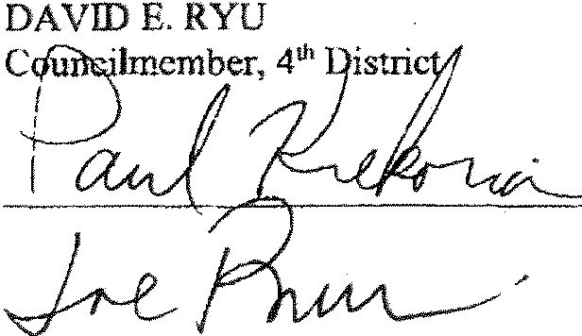

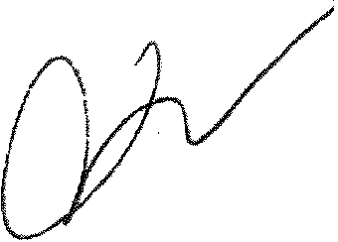

SECONDED BY:

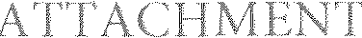

DocuSig Envelope ID: 97487E72-0E77-47C6-8EOE-F851285867CC
HOLLY L. woLcon City of Los Angeles
Attachment 23.1-2
Page 4 of 4
OFflCE OF THE

GTY CLERK

SHANNON D. HOPPES
EXECUTIVE OFFICER

When making inquiries relative to
CALIFORNIA


ERIC GARCETTI
CITY CLERK

Council and Public Services Division
200 N. SPRING
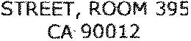

LOS ANGELES,
GENERAL !NFORMAT!ON - (213) 978-1133
FAX: (213) 978-1040

this matter, please refer to the Council File No.:
MAYOR BRIAN E. WALTERS
ACTING DIVISION CH!Er

April 22, 2016

Council File No.: Council Meeting Date:
Agenda Item No.: Agenda Description:


April 22, 2016

Special 02
MOTION (RYU KREKORIAN - BUSCAINO) relative to repairing hazardous street conditions near 1680 Sunset Plaza Drive.

Council Action: MOTION (RYU - KREKORIAN - BUSCAINO) ADOPTED FORTHWITH

Council Vote:

ABSENT | BLUMENFIELD | ABSENT | FUENTES | YES | MARTINEZ
YES | BONIN | YES | HARRIS-DAWSON | YES | O'FARRELL
YES | BUSCAINO | ABSENT | HUIZAR | YES | PRICE
YES | CEDILLO | YES | KORETZ | YES | RYU
ABSENT | ENGLANDER | YES | KREKORIAN | YES | WESSON

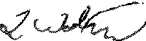

HOLLY L WOLCOTT CLERK

Pursuant to Charter/Los Angeles Administrative Code Section(s): 341

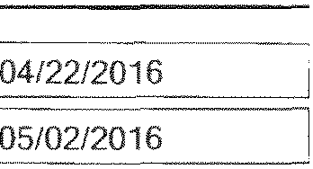

FILE SENT TO MAYOR:

LAST DAY FOR MAYOR TO ACT:

x

APPROVED *DISAPPROVED *VETO

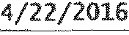
MAYOR DATE SIGNED
This form has been electronically signed and authorized by Eric Garcetti
AN EQUAL EMPLOYMENT OPPORTUNITY ·AFFIRMATIVE ACTION EMPLOYER

