Attachment 22.2-1
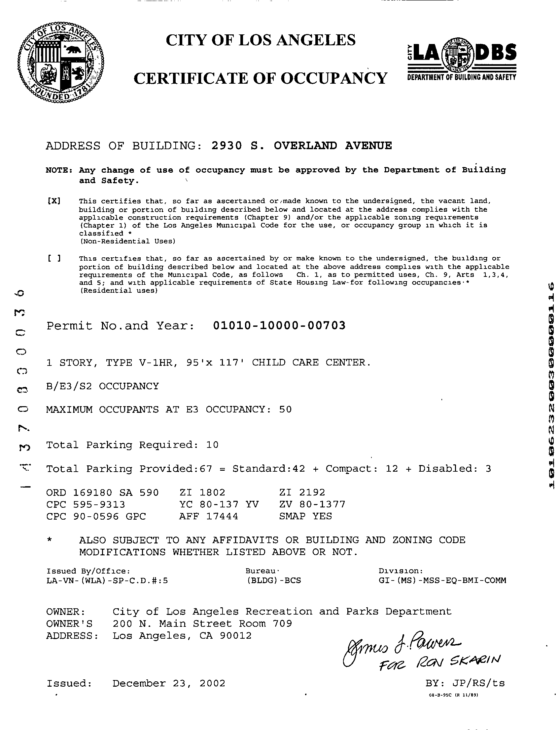

Page 1 of 1

SAMPLE

