OCT WRP NdeN Blower Facility CIP: 6158 WEEK LOOK-AHEAD

Date: 5/1/2007

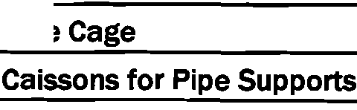

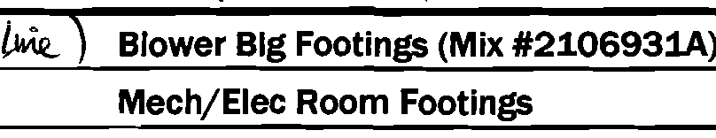
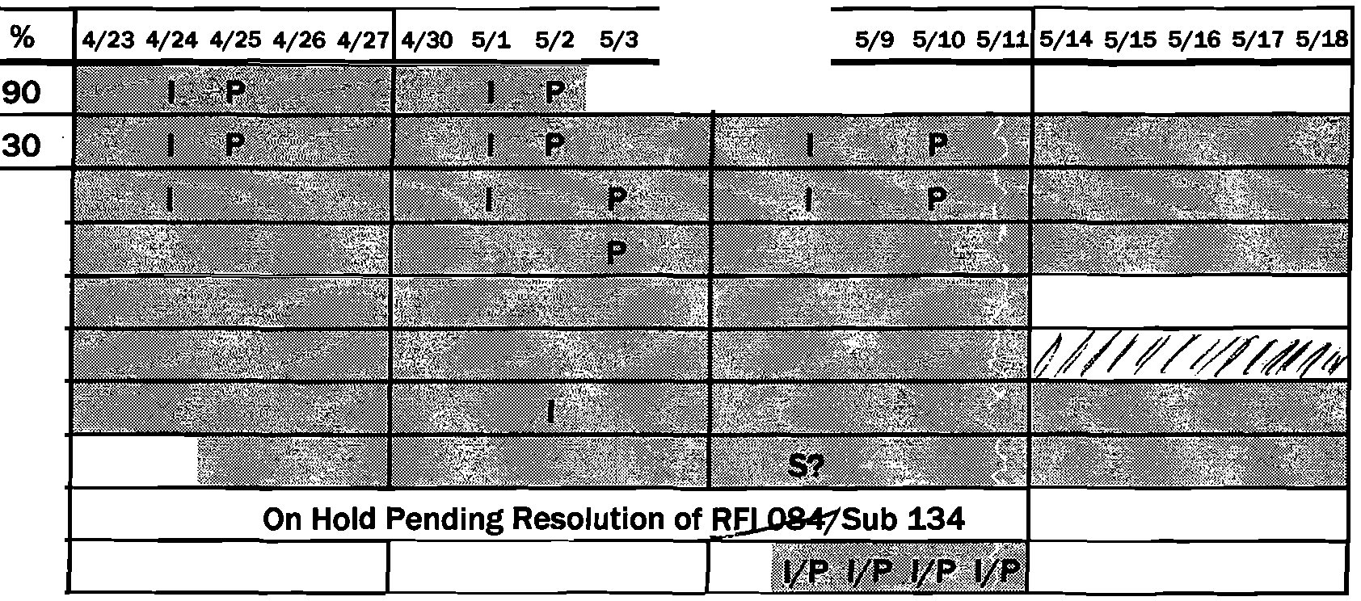
Act No. Description 5/41 5/7 5/8
(f,
Blower Room Walls (Mix #99013) 20
Pedestals for Pioe Suooorts 1-11 50
Underslab Electric 85
Site Electric 55
Underslab Plumbi 20
Demo Exist Aeration Piping 0
Pipe 2
0
Legend: P Concrete Pour
I Inspections S Shutdown

:b

g. clJS (Q(!)
(!)a

""""'""""'
0
.... """"'
"""'01

Page 1 of 1

