City of Los Angeles Department of Public Works Bureau of Engineering
Attachment 16.7-2
Page 1 of 13

WASTEWATER CONVEYANCE CONSTRUCTION DIVISION
PROGRESS MEETING NO. 4
LCIS REHAB BLACKWELDER TO OLYMPIC

Date: 08/24/2017 File: 1-5-2-1
Time: 10:02 AM – 11:45 AM W.O.: SZC12539
Location: Field Trailers - DWP Transmission R/W / Caltrans Park & Ride

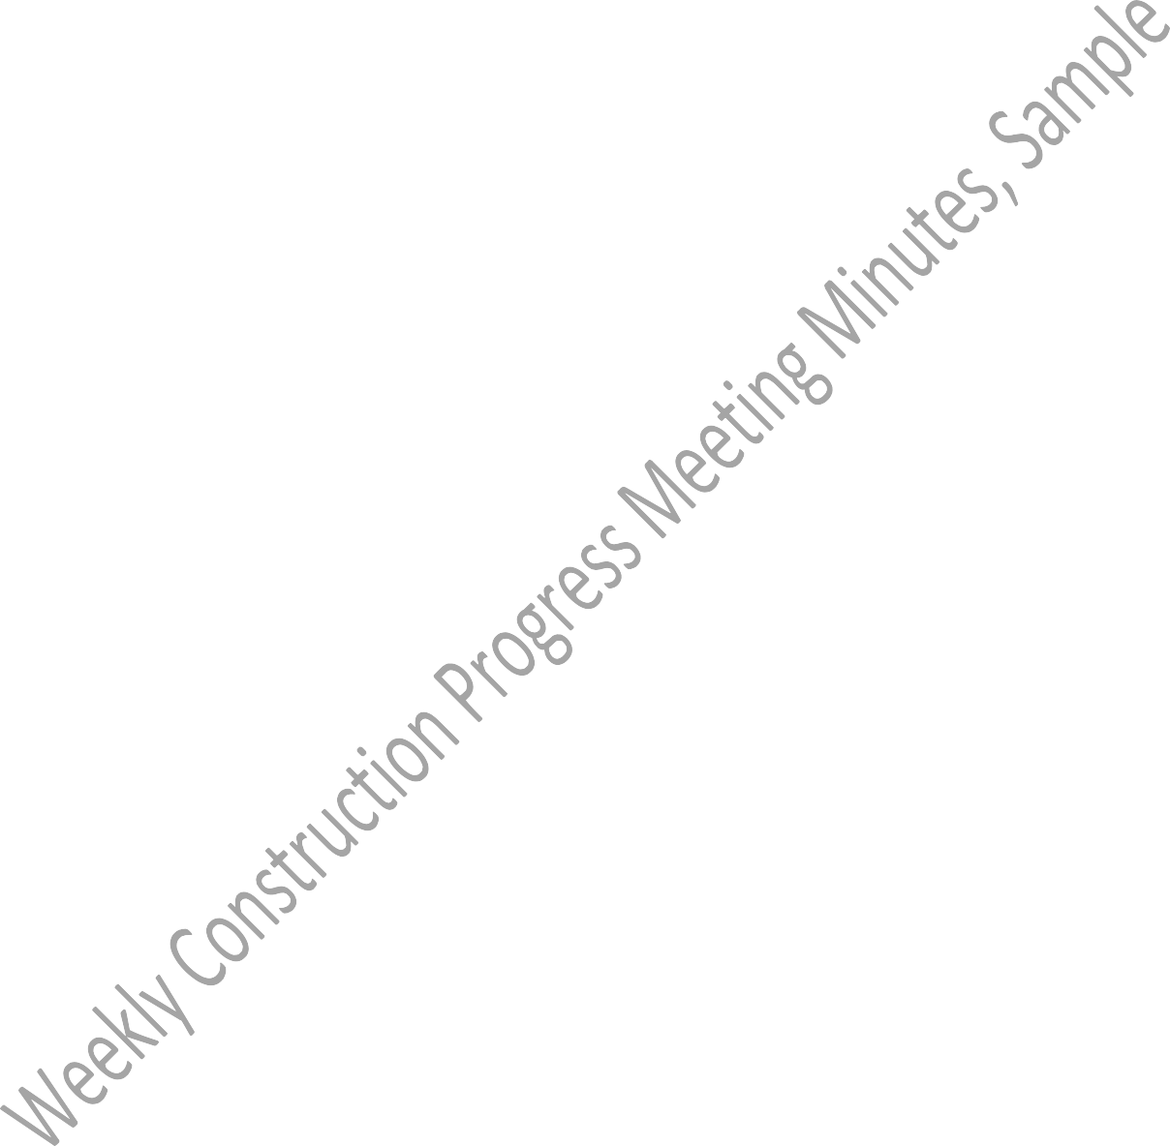
The City and Kiewit accepted the minutes of Progress Meeting No. 3 of 7/27/17.
Attendance: See the attached attendance sheet.
PROJECT VISION STATEMENT:
“Working together to perform a quality project, while being sensitive to the community, and overcoming the challenge of all traffic and the major intersection.”
CONTRACT STATUS:
Contractor:Kiewit Infrastructure WestContract No.:C-129167 Contract Award:March 22, 2017Contract Award Amt: $21,455,000 Notice-To-Proceed:April 25, 2017Finalized C.O. Amt:$0 (0%) Original Contract Duration:810 Calendar DaysAmt Paid to Date:$0 (0%) Original Contract Completion:July 13, 2019Time Elapsed:122 CD
Work Completed:0%

GR 01321 Construction Schedule
No. | Subject
1 | On 8/24/17: the contractor indicated that the updated schedule for the month of August will be submitted in the first week of September.  On 7/27/17: the engineer indicated that the baseline schedule was approved with a B on 7/20/17.  On 7/13/17: the engineer indicated that the baseline schedule was resubmitted on 6/27/17 and is in review.

GR 01330 Submittals/ Shop Drawings
SD # | Subject | Date Received | Date Responded | Status
001-R0 | Injury and Illness Prevention Program | 04/26/17 | 05/25/17 | B
002-R0 | Contractor’s Representative at the Site | 04/26/17 | 05/25/17 | B
003-R2 | 39” Reinforced Polymer Mortar Pipe (RPMP) | 08/22/17
004-R2 | 42” Reinforced Polymer Mortar Pipe (RPMP) | 08/23/17
005-R0 | DIS Excavation, Shoring, Scaffold Permits | 05/01/17 | 05/17/17 | B
006-R1 | DWP Laydown 1 Land Use Proposal | 07/14/17 | 08/10/17 | B
007-R0 | Kiewit Senior Construction Scheduler’s Resume | 05/09/17 | 05/17/17 | A

GR 01330 Submittals/ Shop Drawings
SD # | Subject | Date Received | Date Responded | Status
008-R1 | LCIS Baseline Schedule | 06/27/17 | 07/20/17 | B
009-R1 | 63” Reinforced Polymer Mortar Pipe (RPMP) | 06/26/17 | 07/24/17 | C
010-R0 | Contractor’s Contact List/ Authorized Representatives and Emergency Contact | 05/10/17 | 06/08/17 | A
011-R0 | Kiewit Alternate Project Manager Resume | 05/18/17 | 06/13/17 | A
012-R1 | Spill Response Plan | 06/19/17 | 07/12/17 | B
013-R0 | Fugitive Dust Control Plan | 05/19/17 | 06/14/17 | B
014-R0 | Vitrified Clay Pipe and Fittings | 05/19/17 | 06/15/17 | B
015-R0 | Field Superintendent Resume | 05/26/17 | 06/13/17 | A
016-R0 | Import Aggregates | 05/31/17 | 06/20/17 | B
017-R0 | Competent Persons | 05/31/17 | 06/20/17 | B
018-R1 | Manholes and Traps for the New 8 Inch Sewer | 07/06/17 | 07/26/17 | B
019-R0 | Wet Weather Erosion Control Plan | 06/10/17 | 06/29/17 | B
020-R1 | CCTV/LIDAR | 07/07/17 | 07/31/17 | B
021-R0 | Type 1 PVC Liner MH Rehab | 06/16/17 | 07/07/17 | B
022-R1 | Shoring and Street Plating for New 8” Sewer | 07/29/17 | 08/22/17 | C
023-R0 | Project Signs | 06/26/17 | 06/27/17 | B
024-R1 | Shoring and Street Plating for New MH | 08/04/17
025-R1 | Waste Management Plan | 08/23/17
026-R0 | Potholing Plan | 07/17/17 | 08/07/17 | B
027-R0 | Asphalt Concrete | 07/26/17 | 08/21/17 | B
028-R0 | Reinforcing Steel Pit 11 | 07/27/17 | 08/22/17 | C
029-R0 | Reinforcing Steel Pit 12 | 07/27/17 | 08/22/17 | B
030-R0 | Reinforcing Steel Pit 13 | 07/27/17 | 08/22/17 | C
031-R0 | Bedding and Zone Material for 8” Sewer Pipe | 07/31/17 | 08/22/17 | C
032-R0 | Reinforcing Steel Pits 6, 7, & 10 | 08/02/17 | 08/23/17 | B
033-R0 | 4000psi Concrete Mix Design #: 45C44 | 08/03/17
034-R0 | 4000psi Concrete Mix Design #: 650CW4000 | 08/03/17
035-R0 | 4000psi Concrete Mix Design #: 660CW4000P | 08/03/17

City of Los Angeles Department of Public Works Bureau of Engineering
Page 3 of 13

WASTEWATER CONVEYANCE CONSTRUCTION DIVISION
PROGRESS MEETING NO. 4
LCIS REHAB BLACKWELDER TO OLYMPIC

Date: 08/24/2017 File: 1-5-2-1
Time: 10:02 AM – 11:45 AM W.O.: SZC12539
Location: Field Trailers - DWP Transmission R/W / Caltrans Park & Ride

GR 01330 Submittals/ Shop Drawings
SD # | Subject | Date Received | Date Responded | Status
036-R0 | 4000psi Concrete Mix Design #: D45C44P | 08/03/17
037-R0 | 2000psi Lean Concrete Mix Design #: C470C044 | 08/03/17
038-R0 | Slurry Mix Design #: 100E100 | 08/03/17 | 08/23/17 | B
039-R0 | 6ft and 4ft Precast Manholes for LCIS | 08/04/17
040-R0 | 2500psi Sitework Concrete Mix Design | 08/07/17
041-R0 | Flatwork | 08/07/17

Shop Drawings Need to be Submitted
No. | Subject
1 | Confined Space
2 | Rebar Layout for MH base
3 | Labor and Equipment Rates for T&M Work
4 | Odor Control
5 | Shoring Designs for Pits
6 | Approved Traffic Control Plans (soft closures)
7 | Approved Traffic Control Plans for Pits

GC 00204 RFIs |  | Date Received | Date Responded
No. | Subject | Date Received | Date Responded
001 | La Cienega Holiday Moratorium | 05/15/17 | 05/18/17
002 | Manhole Details | 06/01/17 | 06/09/17
003 | 39” and 42” RPMP Sizes | 06/01/17 | 06/08/17
004 | Traffic Lane Requirements – La Cienega | 06/02/17 | 06/08/17
005 | Traffic Lane Requirements – Access Pit 12 | 06/02/17 | 06/08/17
006 | Utility Conflicts Access Pit 13 | 06/10/17 | 06/15/17
007 | Utility Conflicts Access Pit 12 | 06/10/17 | 06/15/17
008 | Utility Conflicts Access Pit 8 | 06/10/17 | 06/15/17
009 | Utility Conflicts Access Pit 7 | 06/10/17 | 06/15/17
010 | Utility Conflicts Access Pit 3 | 06/10/17 | 06/15/17
011 | Utility Conflicts MH Sta. 41+88.30 | 06/10/17 | 06/15/17
012 | Incorrect MH Coordinate | 07/25/17 | 07/27/17
013 | Conflicting MH Sta Numbers | 07/25/17 | 07/27/17

GC 00204 RFIs |  | Date Received | Date Responded
No. | Subject | Date Received | Date Responded
014 | Conflicting MH Sta at Pit 10 | 07/25/17 | 08/01/17
015 | Utility Conflicts Access Pit 9 | 07/28/17 | 08/02/17
016 | House Connection Pipe Size | 08/02/17 | 08/07/17
017 | Pit 12 Waterline Interference | 08/04/17 | 08/09/17
018 | Pit 6 Utility Interference | 08/04/17 | 08/09/17
019 | Pit 13 Utility Conflicts | 08/04/17 | 08/10/17
019- R1 | Pit 13 Utility Conflicts | 08/10/17 | 08/17/17
020 | 8” Sewer Utility conflicts Whitworth - Olympic | 08/04/17 | 08/10/17

GC 00204 Plan Clarifications |  | Date Issued
No. | Subject | Date Issued
 | None

Engineer’s Communication Status |  | Date Issued
No. | Subject | Date Issued
 | None

Correspondence from GC |  | Date Issued
No. | Subject | Date Issued
001 | Kiewit Submittal Log | 05/17/17
002 | Subcontractor List for Approval | 06/01/17
003 | Pothole Reports | TBD
004 | Pit Relocations - Eliminate Pit 1, Modify Pit 5 (expected to be submitted in September) | TBD

Correspondence to GC |  | Date Issued
No. | Subject | Date Issued
001 | Response to Contractor’s Correspondence No. 002 – Subcontractor List for Approval | 06/01/17

City of Los Angeles Department of Public Works Bureau of Engineering
Page 5 of 13

WASTEWATER CONVEYANCE CONSTRUCTION DIVISION
PROGRESS MEETING NO. 4
LCIS REHAB BLACKWELDER TO OLYMPIC

Date: 08/24/2017 File: 1-5-2-1
Time: 10:02 AM – 11:45 AM W.O.: SZC12539
Location: Field Trailers - DWP Transmission R/W / Caltrans Park & Ride

Inspector’s Job Site Memos |  | Date Issued
No. | Subject | Date Issued
 | None

GC 00310 Notice of Non-Compliance Status |  | Date Issued | Date Resolved
No. | Subject | Date Issued | Date Resolved
 | None

GC 00311 Subcontractors: The City (BCA) must approve all subcontractors (including lower-tiers) before starting work. Subcontractors approved to-date are as follows:
No. | Name | Description of work
01 | Griffith Company | Paving
02 | Sterndahl Enterprises | Striping
03 | Professional Pipe Services | CCTV/Laser/Lidar
04 | Penhall Company | Sawcutting
05 | Ayala Engineering Inc | Manhole PVC Lining
06 | Southwest V-ditch | Pneumatically Placed Concrete
07 | Alameda Construction Services | Flatwork
08 | United Pumping | Pipe Cleaning
09 | Throop | Grouting
10 | Santa Margarita Plumbing | UV Light Cured-in-place pipe (CIPP) Liner
11 | Olson Precast Company | Manhole and Trap Installation
12 | Gerdau | Rebar
13 | Norcal Pipeline (PLA Approved) | Pothole
14 | Barneys | Pile Drilling
15 | Maxim Crane | Crane Service
16 | Deans Welder | Welding
17 | Highway Safety (PLA Approved) | Traffic Control
18 | Culver Group | Survey

GC 500 / GR 01254 Changes and Extra Work/ Outstanding Change Orders |  | PCO Date Issued | CO Date Issued | FECO  Date Issued
No. | Subject | PCO Date Issued | CO Date Issued | FECO  Date Issued

Note: The Contractor’s quotation shall conform to the requirements of Section 01251- Change Order Requests, and be submitted in the Change Order Cost Summary Form provided (see attachment 01251-A1).
Comments:
Tally of Change Orders
Comments:
GC 500 / GR 01254 Changes and Extra Work/ Outstanding Change Orders |  | PCO Date Issued | CO Date Issued | FECO  Date Issued
No. | Subject | PCO Date Issued | CO Date Issued | FECO  Date Issued

CO  No. | Issue | Resolution/Action

No. of FECO | 0
No. of CO in City’s court | 0
No. of CO in Kiewit’s court | 0
No. of T&M CO | 0
No. of Unilateral CO | 0
No. of Cancelled CO | 0
Total No. of Change Order | 0

GR 01212 Fixed Cash Allowance Order Status |  | PAO Date Issued | AO Date Issued | FEAO  Date Issued
No. | Subject | PAO Date Issued | AO Date Issued | FEAO  Date Issued
4-001 | Executive/Initial Partnering Workshop – June 20, 2017

AO No. | Issue | Resolution/Action

Tally of Allowance Orders
No. of FEAO | 0
No. of AO in City’s court | 0
No. of AO in Kiewit’s court | 0
No. of T&M AO | 0
No. of Unilateral CO | 0
No. of Cancelled CO | 0
Total No. of Allowance Order | 0

GC 501 Differing Site Conditions (DSCs) Rejected / In-Review/AO or CO |  | Status
No. | Subject | Status
 | None

GC 601 Claims and Protests |  | Status
No. | Subject | Status
 | None

GR 01310 Worksite Safety |  | Action
No. | Subject | Action
1 | Pre-construction safety conference held on 7/21/17. | All
2 | As reminded by the Inspector, traffic control shall be per the approved LADOT WTCP. Continue to monitor. | All
3 | Reminder for all personnel to wear PPE at all times in the field. PPE not necessary at trailers except laydown yard. Continue to monitor. | All

GC 00217 Permits and Construction Easements / and Special Notes |  | Action
No. | Subject | Action
1 | Caltrans Encroachment for potholing - Approved | Contractor
2 | Culver City (submitted) | Contractor
3 | LADOT for pothole/CCTV Approved for 8” work on La Cienega; Crescent Heights - Approved | Contractor
4 | SD Relocation at Pit 12 & Pit 13 | Contractor
5 | Noise Variance (night work) – the sewer alignment up to Pit 5 has been Approved | Contractor

GR 01313 Work by City or Others (Community Relations)

Community Related Concerns – Contact Danielle Sevilla, BOE Public Relations Phone: (213) 978-0333/(310)710-3264, Email: Danielle.Sevilla@lacity.org
No. | Subjects
1 | On 7/27/17, the engineer indicated that credit signs have been approved. Contractor has coordinated with Inspector on locations of the signs. PAO indicated that residents have complained about signs installed on private property. Contractor/Inspector verified that all signs are on public right-of-way. Council Representatives do not object to sign locations.  On 6/8/17, the engineer indicated that credit signs shall be submitted for approval. Contractor to coordinate with inspector on locations of the signs.
2 | On 7/27/17, the PAO indicated that notification for the upcoming CCTV/potholing work has been sent out.  On 6/8/17, the PAO indicated that notification for the upcoming CCTV/potholing work will be sent out in the next couple of weeks.
3 | On 6/08/17, the PAO indicated that crews/laborers are not to formally respond to issues with residents. Any discussion/question from residents shall be relayed to the Engineer/Inspector/PAO.
4 | On 6/08/17, the PAO reminded that work areas shall be kept clean and graffiti on signs/equipment/etc… shall be removed in a timely manner.
5 | On 7/13/17, the engineer stated a resident complaint was received from apartment owner located at 6087 Cashio St.
6 | On 7/27/17, the engineer stated the meeting with faculty members of Temple Beth Am located on La Cienega was held on 7/18/17 to discuss scope, schedule, and traffic in the area. Temple Beth Am to follow up with PAO with information on school pick up times, drop off times, and holidays.  On 7/13/17, the engineer stated the meeting with principal of Temple Beth Am located on La Cienega is scheduled on 7/18/17 to discuss scope, schedule, and traffic in the area.
7 | On 7/13/17, the engineer mentioned Neighbors United requested for the city to attend their next meeting scheduled on 9/11/17.
8 | On 7/27/17, the PAO mentioned Pico Neighborhood Council requested for the city to attend their next meeting scheduled on 8/9/17.
9 | On 8/24/17, the engineer indicated that property owner located at 1901 S. Crescent Heights inquired about work near her property. Property owner claims that the city should be responsible for damaged/block lateral caused by tree on public right-of-way.

GR 01322 Construction Progress Photography
Contractor to submit paper prints and electronic copies on compact disk(s) with each application for payment. Catalog and index negatives and/or electronic copies in chronological sequence. Provide typed table of contents.
On 8/24/17, Engineer indicated that the Contractor shall upload August 2017 progress photos and/or pre-existing photos into e2020.

GR 01783 Record Drawings and Record Project Manual
The Contractor shall prepare Record Drawings and Record Project Manual. Record drawings shall be produced in electronic computer aided drafting (CAD) format (AutoCAD latest version). The Engineer will review and approve the Record Drawings prior to submittal of all Monthly Payment Requests. The Contractor shall submit a signed certification with each Monthly Payment Request stating that all Record Drawings are complete and accurate as of the date of the payment request.
On 8/24/17, the Engineer indicated that record drawings need to be updated monthly.

Field Activities
Contractor to provide and discuss a 3 week schedule. Please see attached 3 week schedule provided at 8/24/17 meeting.
Odor Control | -
Access Pit #13 (Olympic Blvd and Schumacher Dr) | - Pit #13 was potholed on 8/2/17.
Between Pit #13 and Pit # 12 | -
Access Pit #12 (La Cienega Blvd and Packard St) | - Pit #12 was potholed on 8/3/17.
Between Pit #12 and Pit #11 | -
Access Pit #11 (Cashio St and Crescent Heights Blvd) | -
Between Pit #11 and Pit #10 | -
Access Pit #10 (Crescent Heights Blvd and Pickford St) | - Pit #10 was potholed on 7/25/17.

City of Los Angeles Department of Public Works Bureau of Engineering
Attachment 16.7-2
Page 10 of 13

WASTEWATER CONVEYANCE CONSTRUCTION DIVISION
PROGRESS MEETING NO. 4
LCIS REHAB BLACKWELDER TO OLYMPIC

Date: 08/24/2017 File: 1-5-2-1
Time: 10:02 AM – 11:45 AM W.O.: SZC12539
Location: Field Trailers - DWP Transmission R/W / Caltrans Park & Ride

Field Activities
Between Pit #10 and Pit #9 | -
Access Pit #9 (18th St and  Stearns Dr) | -
Between Pit #9 and Pit #8 | -
Access Pit #8 (Stearns Dr and 18th St) | -
Between Pit #8 and Pit #7 | -
Access Pit #7 (Stearns Dr and Guthrie Av) | -
Between Pit #7 and Pit #6 | -
Access Pit #6 (Burchard Av and Venice Blvd) | - Pit #6 was potholed on 7/31/17.
Between Pit #6 and Pit #5 | -
Access Pit #5 (Ballona Creek - Siphon) | - Pit #5 was potholed on 7/26/17.
Between Pit #5 and Pit #4 | -
Access Pit #4 (Burchard Av and David Av) | - .
Between Pit #4 and Pit #3 | -
Access Pit #3 (Washington Blvd and Fairfax Av) | -
Between Pit #3 and Pit #2 | -

City of Los Angeles Department of Public Works Bureau of Engineering
Page 11 of 13

WASTEWATER CONVEYANCE CONSTRUCTION DIVISION
PROGRESS MEETING NO. 4
LCIS REHAB BLACKWELDER TO OLYMPIC

Date: 08/24/2017 File: 1-5-2-1
Time: 10:02 AM – 11:45 AM W.O.: SZC12539
Location: Field Trailers - DWP Transmission R/W / Caltrans Park & Ride

Field Activities
Access Pit #2 (Fairfax Av and Washington Blvd) | -
Between Pit #2 and Pit #1 | -
Access Pit #1 (La Cienega Blvd and Fairfax Av) | -

Old Business
Item No. | Subject | Action
1 | On 7/27/17, the contractor mentioned that a scope of work is being finalized for the survey subcontractor to submit a cost proposal for the work to be performed.  On 7/13/17, the engineer and contractor indicated that a meeting will be scheduled to discuss cost for 3rd party surveyor. | Contractor
2 | On 8/24/17, the contractor mentioned that the traffic control plans are being finalized and will be submitted to DOT for Pit 12 and Pit 13 in the upcoming weeks.  On 7/27/17, the engineer stated the pre-submittal meeting with DOT was held on 7/19/17 for the traffic control at Pit #12.  Contractor striping plans are in review by DOT. Contractor is to compile traffic and striping plans for other necessary pits for submittal to DOT.  On 7/13/17, the engineer stated the pre-submittal meeting with DOT scheduled for 7/19/17 for the traffic control at Pit #12. | Contractor
3 | Partnering Session was held on 6/20/17. | All
4 | Follow-up Partnering Session will be held on 9/12/17. | All

New Business
Item No. | Subject | Action
1 | On 8/24/17, the contractor stated that the driveway impact plan will be provided prior to work beginning at impacted locations. | Contractor
2 | On 8/24/17, the contractor mentioned that the new 8” sewer is located under an existing bus pad that is not shown on the plans. Contractor to submit RFI. | Contractor

City of Los Angeles Department of Public Works Bureau of Engineering
Page 12 of 13

WASTEWATER CONVEYANCE CONSTRUCTION DIVISION
PROGRESS MEETING NO. 4
LCIS REHAB BLACKWELDER TO OLYMPIC

Date: 08/24/2017 File: 1-5-2-1
Time: 10:02 AM – 11:45 AM W.O.: SZC12539
Location: Field Trailers - DWP Transmission R/W / Caltrans Park & Ride
Next Meeting: Time: Location:
Minutes prepared by:
8/31/17
10:00 AM – 11:00 AM
Field Trailers - DWP Transmission R/W / Caltrans Park & Ride Ashley Coakley – Construction Engineer

3 | On 8/24/17, the contractor mentioned that the new 8” sewer line and the new manhole for the 8” sewer line are conflicting with a 3” interconnect for the traffic signals between Whitworth Dr. and Olympic Blvd (sheet # C-17). All parties to determine whether this is a DSC. | All

Attachment 16.7-2
Page 13 of 13

LCIS REHAB BLACKWELDER TO OLYMPIC | Previous |  |  |  |  | WEEK 1 |  |  |  |  | WEEK 2 |  |  |  |  | WEEK 3 |  |  |  |  | WEEK 4
Description | M | T | W | R | F | M | T | W | R | F | M | T | W | R | F | M | T | W | R | F | M | T | W | R | F
Description | 8/14 | 8/15 | 8/16 | 8/17 | 8/18 | 8/21 | 8/22 | 8/23 | 8/24 | 8/25 | 8/28 | 8/29 | 8/30 | 8/31 | 9/1 | 9/4 | 9/5 | 9/6 | 9/7 | 9/8 | 9/11 | 9/12 | 9/13 | 9/14 | 9/15
Laydown Yard
Security System
Install Copiers
Water / Ice setup
Perm Power Set Up
FIELD
SURVEY:
Layout 8" Pico to Packard
Pothole Utilities
SOE Monitoring and 8" As Builting
POTHOLING:
Waiting on Culver City Approval
Pothole Pit 9
Pothole Pit 3
Pothole Pit 2
CCTV/LIDAR:
Board of Police Commissioners Approval of Night Work
Olympic & La Cienega 42"
Cashio 42"
Crescent Heights 39"
18th Street 39"
Stearns 39" (Have Permits In Hand)
Kaiser/Cadillac/Venice 45/48" (Have Permits In Hand)
Burchard 39" (Have Permits In Hand)
Ballona Creek to Fairfax 63"
Fairfax to Blackwelder 63"
8" SEWER (Pico to Packard):
Deliver & Stage Pipe and Fittings
Sawcut Trench
Grind for Plates / Remove AC / Plate Trench
Pothole and Expose Utilities Crossing Trench
Exc and Shore Tie In On Pico
Exc and Shore MH Trap
Tie 8" Into LCIS and Lay Pipe Thru Trap
Form / Pour / Finish Trap Base
Install Trap Risers
Backfill Trap / Tie In and Remove Shoring
Exc / Bed / Lay 8" Pipe
Connect Laterals and Zone the Pipe
Slurry Backfill Trench
Install MH Shoring Sta 3+00
Install MH Shoring Sta 5+89.10
Form / Pour / Finish MH Base Sta 3+00 & 5+89.10
Install MH Risers Sta 3+00 & 5+89.10
Backfill Manholes and Remove Shoring
Place and Finish Roadway Base on Trench Section
Pour Concrete Flatwork and Bus Pad Sections
Pave Trench
Raise Manholes to Grade and Weld / Test Liner
Cut Traffic Loops
Stripe Parking Spaces

