Attachment 16.1-1
Page 1 of 1

City of Los Angeles - Department of Public Works - Bureau of Engineering


CONTRACTOR'S SUBMITTAL TRANSMITTAL

Project Title: LCIS Rehab Blackwelder to Olympic
Project No:C898
Contractor:Kiewit Infrastructure West, Co.
File No: 8.10
Work Order No: SZC12539 Contract No:

Date  Submitted: 01/09/2018 |  |  | Requested Return Date: 02/09/2018
From: Isaac Vang  To: Stephen Chao - City of Los Angeles Bryan Choorut - City of Los Angeles King So - City of Los Angeles  Ashley Coakley - City of Los Angeles |  |  | Contractor's Submittal No: 0104
 |  |  | Schedule Activity No:
Check One:
[X] An Original Submittal [ ] A Submittal of
Item No. | * | Specification Section | Submittal Description
 |  | 02445 | 13+19.64 Saturn Shoring Plan
* Check for specified shop inspection requirements. For item source greater than 30 miles, attach laboratory documentation for acceptance.
Check One:

[X] It is hereby certified that the equipment material, color samples, or details shown and marked in this Submittal is that proposed to be incorporated into the Project; is in compliance with the Contract Documents and Project Manual and can be installed in the allocated space WITH NO EXCEPTIONS.
[ ] It is hereby certified that the equipment material, color samples, or details shown and marked in this Submittal is that proposed to be incorporated into the Project; is in compliance with the Contract Documents and Project Manual and can be installed in the allocated space, EXCEPT FOR THE FOLLOWING DEVIATIONS (LIST DEVIATIONS):

Comments:
Please see attachment for the 13+19.64 Saturn shoring plan.
Contractor Representative: 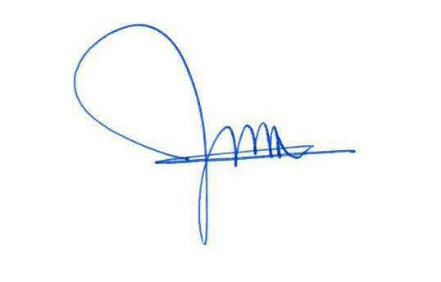 Date: 01/09/2018
Isaac Vang

Project Engineer
Uploaded Files
File Name Size(Bytes) Uploaded By
Pit 13plus19 Shoring Drawing.pdf 273657 Isaac Vang
Pit 13plus19 Shoring Design Calculations.pdf 1354141 Isaac Vang
Pit 13plus19 Access Pit Street Plate Calcs.pdf 1052283 Isaac Vang

Respond to GC
Forward to Reviewer
Back to Log

