Attachment 16.7-1 Page 1 of 4
Henry Ford Pumping Plant No. 668 (BC600317-CLA, HDS1994-POLB)
Pre-Construction Meeting
for
Date: Friday, January 19, 2001
Time: 1:30 PM
Location: POLB Administration Bldg., 925 Harbor Plaza, 5th floor Training Room
Kao Liao Marte San Diego Eric Keller Fred Gerringer Alex Lisenko Dean Guzman Art Cordero Terry Dickinson Bill Kumer Ken Kustra Brad Hunter Suzanne Pefferman Mary Stephan POLB 562-590-4180 Lloyd Jenkins Moffatt & Nichol Engineers 562-426-9551 Alan Ludwig Pascal & Ludwig Engineers 909-947-4631 Gordon Ludwig Pascal & Ludwig Engineers 909-947-4631 Thomas Youngblood Pascal & Ludwig Engineers 310-831-0569 Mike Sylvester West & Sylvester 714-963-4893
ATTENDEES: 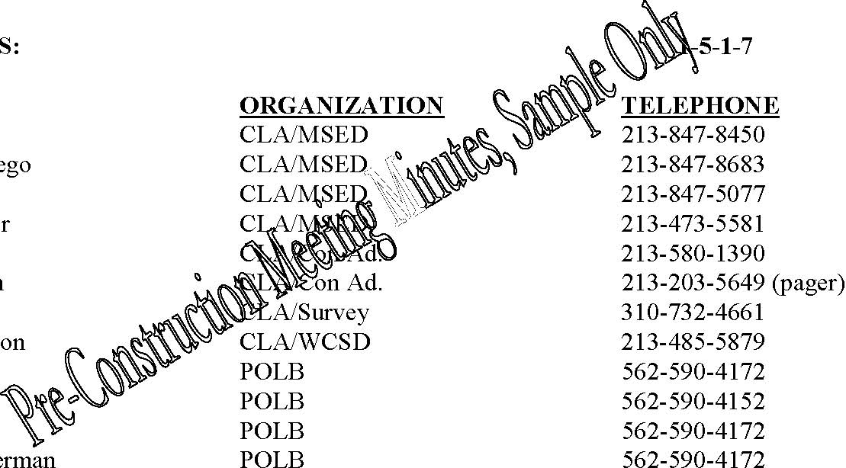
NAME
1. Opening Remarks/MSED
- Marte San Diego, Project Engineer, briefly explained the scope of the project.
- Ken Kustra, POLB, congratulated Pascal & Ludwig on the award of the contract, restating that P& L comes to the job with a considerable resume on similar projects, a number which have been with City of Los Angeles.
- Ken explained to P&L the project relationship with City of Los Angeles, by which POLB will be funding the project while CLA will be perform the inspection and construction management functions. From an operational standpoint, the contractor will not be dealing with POLB.

Attachment 16.7-1 Page 2 of 4
2. Survey
- Art Cordero, CLA Harbor Survey, provided their “Survey Request” form to P&L, Tom Youngblood. The first “Survey Request” must be received by Harbor Survey 48-hours prior, with additional “Survey Requests” only needing a 24-hour advance. The form should be filled-out in detail regarding the specific services needed.
- Art stated that the contractor is responsible to protect survey stakes placed by Survey.
- Marte communicated that the contract provides for CLA Survey to establish the baseline and one or more existing benchmarks for the contractor. The contractor may hire the Harbor Survey services for $1000 per day if needed.

3. Sanitation/WCSD
• Terry Dickinson emphasized that Sanitation needs to receive any RFI’s expiditiously from
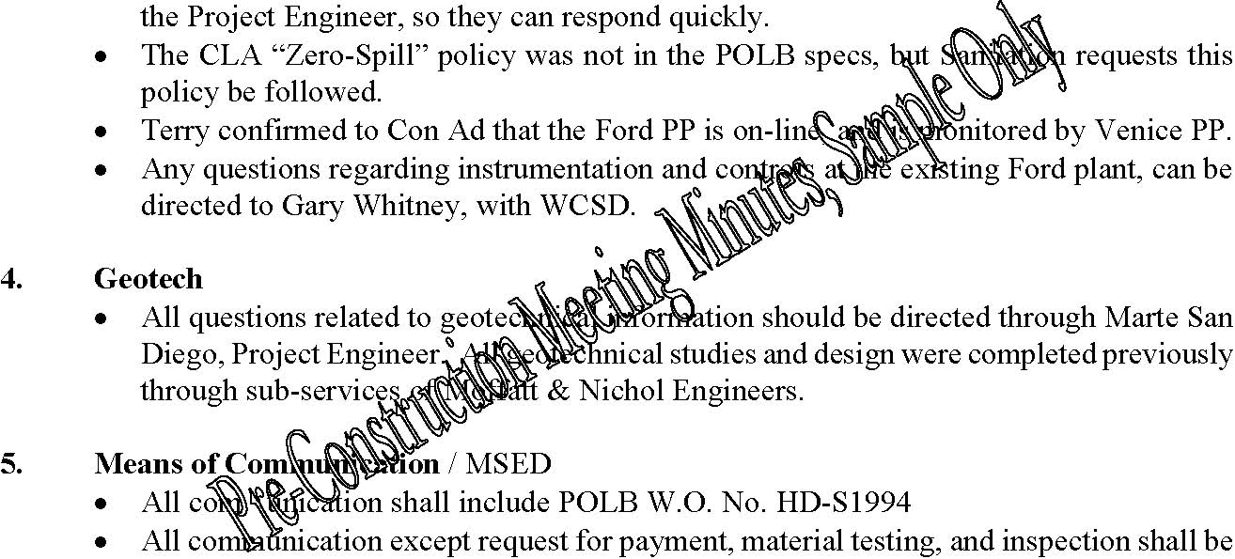
addressed to Kao Liao, attention Marte San Diego, Project Engineer.
- Request for payment shall be addressed to W.B. Kumer, Deputy Chief Harbor Engineer, and routed through the CLA Con Ad Inspector.
- Request for material testing and inspection shall be addressed to Alex Lisenko, and routed through the CLA Con Ad Inspector.
- As much as possible, the request for material testing and inspection, should cc the Project Engineer and Con Ad Inspector.
- Jeff McDonnell of P&L will be the Project Manager.
- Tom Youngblood will be Project Superintendent.
- Marte San Diego provided Alan Ludwig with CLA submittal transmittal and RFI forms.

6. Scheduling and Progress / Con. Ad./ MSED
• Preliminary Project Schedule, list of subcontractors, project submittal list, and the Schedule of Values were submitted by P&L Alan Ludwig, to Marte San Diego. A list of contractor personnel involved, with address and phone, will be provided next week.
Attachment 16.7-1 Page 3 of 4
• Jun Espiritu, from CLA MSED, will be the scheduler on the CM team. Alan Ludwig advised that Jeff McDonnell will call next week and set up the meeting to go over the proposed project schedule.
7. Payment for Work / Con. Ad. Inspection
- Marte stated that the deadline for request for payment will be the 15th day of each month, after which the contractor will have 5 days to submit the complete billing documents for payment by POLB. The documents should be submitted through the construction inspector for signature by the Inspector and Project Engineer. POLB will not pay for any work that does not have the CLA validation that the request for payment is proper.
- Periodic spot checks may be performed by POLB or CLA Inspector to verify that prevailing wage is in accordance with City of Long Beach.
- All Change Order requests must be sent in writing to the Project Engineer. Change order requests not in writing will not be authorized for payment.
- Job site meeting will be held with the CLA construction management team once per week, or as often as necessary. Until the contractor is mobilized on site, the meetings can be held at the existing San Pedro field office trailer.
- Extended working hours must be submitted for approval in writing to the POLB. Normal hours presently are 7 a.m. to 3:30 p.m., but could also possibly be moved up earlier.
- Daily Job Reports are required from the contractor and must be signed by the construction inspector and the contractor’s representative.
- Temporary power must be provided by contractor. Primary utility coordination will be with SCE. Specifications outline requirements for obtaining fresh water.
- Marte requested an extra field office door key be provided to Suzanne Pefferman, construction engineer for POLB.

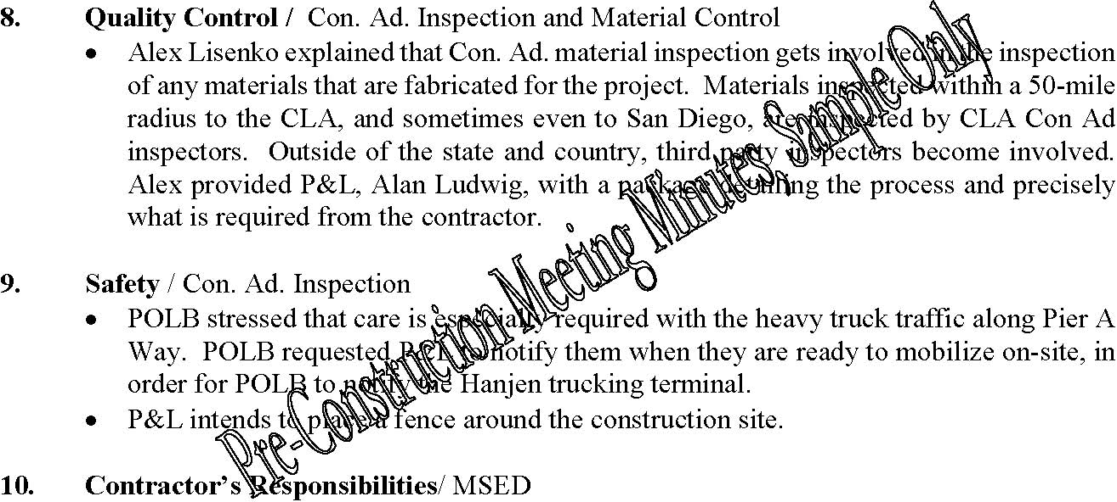
Attachment 16.7-1 Page 4 of 4
11. Permits
- Marte provided information needed for P&L to obtain permits.
- Mary Stephan of POLB is from the Warfinger’s office, and is the contact to obtain the no-fee hot work permit.

12. Submittals & As-Builts
• Contractor will provide 10 submittal copies, and shall receive three in return as outlined in the specifications.
13. NTP / Completion
- NTP was issued Jan 15, 2001. Project completion date is July 16, 2002.
- Marte encouraged the contractor to aim at completing the project in one year if possible.

14. Concerns of others not previously addressed
• Regarding the CIPP liner in the specifications, Insituform is no longer providing the product in small quantity. CLA would prefer the specified epoxy-vinylester material be used in order to meet the 140-degree F product conditions coming from Ultramar

