Bureau of Engineering: Wastewater Conveyance Construction Division

Super-Expedited Wastewater Emergency Repair for Sewers (SEWERS) Program
Project Delivery Procedures

Table of Contents

Introduction 2
Processing a BOS Work Request 3
Downloading CCTV from BOS/PDT 4
Opening a Work Order 6
Creating a Hard Copy Project Folder 10
Add a New Record on the SEWERS Planning Sheet 11
Preparing a Construction Order Design 12
Preparing Construction Order Package 21
Providing Construction Management Support 28
Drafting Change Orders 29
Processing CCTV from Contractor 37
Issue a Revised Construction Order 38
Processing Statement of Completion 41
Processing As-Builts 41
Work Order Close-Out 47

INTRODUCTION

The purpose of these procedures is to provide step-by-step guidance for delivering projects through the SEWERS program. These comprehensive procedures are arranged in sequential order, which include the Pre-Design, Design, Construction, and Post-Construction phases of project delivery.

Several external files and documents are referenced in these procedures and consist of sample design packages, forms, templates, and quality assurance/control guidelines. These documents will prove useful in efficiently preparing the multitude of documents essential to each SEWERS project.
Unless otherwise specified, all files referenced in these procedures can be found in the following directories:

Procedures, substructure abbreviations:
Q:\CM\Project Groups\4_SEWERS\SEWERS\SEWERS PROCEDURES

Document Templates – Design Files, Construction Orders, Change Orders, etc. Q:\CM\Project Groups\4_SEWERS\SEWERS\SEWERS6\Templates & Forms\Templates

Examples of executed SEWERS projects:
Q:\CM\Project Groups\4_SEWERS\SEWERS\SEWERS6\PROJECTS\CONST PHASE

Also reference the Bureau of Engineering’s (BOE) Project Delivery Manual (PDM), as well as the Wastewater Conveyance Construction Division's (WCCD) standard documents library and procedures in order to have a complete understanding of the Bureau's project delivery procedures.

In the SEWERS program, the Project Manager (PM) also serves in the capacity of the Construction Manager (CM). The Project Engineer (PE) supports the PM/CM through all project delivery phases of the SEWERS Program.

PRE-DESIGN

A Work request is received by the Project Manager (PM) from the Bureau of Sanitation (BOS), Wastewater Collection Systems Division (WCSD)

    - A work request is typically received from BOS via e-mailed PDF with the following information:

      - Work request number
      - Date
      - Location
      - Sewer up-stream (U/S) node and down-stream (D/S) node identifiers, otherwise referred to as the Sewer Inventory Maintenance Management System (SIMMS) numbers.
      - Sewer reach length, depth, diameter & pipe material
      - Problem description
      - Proposed method of repair
      - Method of identifying the problem. Typically, via CCTV inspection.

Examples of previous work requests can be found here:

Q:\CM\Project Groups\4_SEWERS\SEWERS\PDT REQUESTS

    - When a work request is received from BOS, PM reviews the work request and assigns to a PE.

    - The PE makes electronic copies of the BOS work request in the SEWERS electronic folders listed below:

Q:\CM\Project Groups\4_SEWERS\SEWERS\PDT REQUESTS

vi) The information from the work request is entered by the PM (or designated PE) into the BOE’s SEWERS Online Application, located at the following URL:

http://boe.ci.la.ca.us/sewers/

The PM indicates the project status in the SEWERS Online Application as "TO BE DESIGNED".

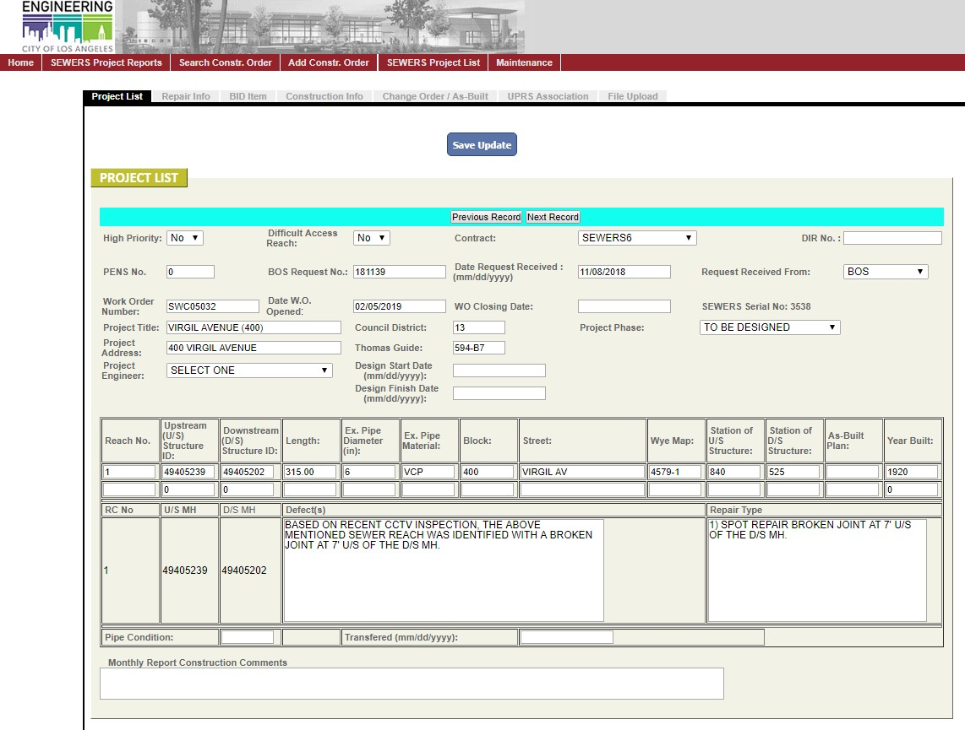

SEWERS work requests are typically executed in the order they are received. However, if BOS flags a work request as “high priority”, that work request is given priority over other work requests pending construction.

If there exists a backlog of SEWERS work requests pending construction, it is advisable to plot the work request locations on a map of the City to determine if any construction orders can be combined into a single package before issuing to the Contractor. This helps reduce project costs, minimizes community impacts, and increases the Contractor's production rate. Check the latest SEWERS Contract (General Requirements, Section 01112) to determine the requirements for issuing multiple construction orders into a single package.

- If available, CCTV accompanying a work request will be uploaded by BOS to the following location:

Drop Box URL:
https://www.dropbox.com/sh/s813he3exx27cv4/AABof1_7vY jobzE2mh120W7oa?dl=0

If the CCTV is not in the Drop Box, the PE can communicate with BOS to request the CCTV to be uploaded, only if the PDT request was identified by CCTV.

If CCTV is not available from BOS and is necessary for completion of a design package, the PM can issue an Engineer's Communication to the Contractor requesting them to provide a pre- construction CCTV of the reach.

- The PE creates a folder labeled with the name of the project on the network drive located at:

\\netapp1\cctv\wcc_cctv\SEWERS 6 CCTV The PE also creates the following subfolders:
  - BOS CCTV (PDT)
  - PRE-CONSTRUCTION CCTV
  - PRE-LINING CCTV
  - POST-CONSTRUCTION CCTV

- The PE copies the corresponding CCTV file to the sub-folders under the following directory:

For Videos acquired by BOS: 1-BOS CCTV (PDT)

For videos acquired through SEWERS Contract: 2-PRE-CONSTRUCTION CCTV

NOTE: The SEWERS program occasionally accepts work from other groups (ESRP, SSRP, etc.). These projects can be transferred to the SEWERS program if the following conditions are met:

- The current SEWERS contract bid items are applicable to the scope of work, and/or price agreements can be negotiated for work outside of the contract’s scope of work, and within a time frame acceptable to the program manager.

- There are adequate resources available for timely delivery of the project.

- The SEWERS Contractor’s workload can be adjusted without negatively impacting ongoing field activities.

Any exceptions to these conditions require approval from the program manager.

A Work Order (WO) is opened by the PE

SEWERS Projects are separated into two categories: Operations & Maintenance Program ("O&M"), and Capital Improvement Program ("CIP" or "Capital"). The funding source and project reporting method for O&M projects is different from CIP, and therefore must be designated properly when opening a new work order.

- O&M: work orders specifying work related to maintaining operation of an existing sewer reach. This type of work includes, but is not limited to: spot repairs, maintenance hole (MH) remodeling, sewer abandonment, cleaning and CCTV. This type of work does not count towards the City's "60-Mile Program".

- CIP: work orders specifying the replacement or rehabilitation of an entire sewer reach (MH to MH). This type of work includes but is not limited to: full reach (MH to MH) removal & replacement, non- structural lining, and structural lining. This type of work counts toward the City's "60-Mile Program".

    - Assign Work Order Number to a project:
Obtain and assign a work order number using the list of new work order numbers provided by the BOS Financial Management Division (FMD) on a recurring basis. The latest list can be found at:

Q:\CM\Project Groups\4_SEWERS\SEWERS\SEWERS6\Work Orders

      - Use "Capital" work order numbers for full-reach (MH-MH) repairs, installation of new maintenance hole, lining a reach (SZC#####).
      - Use operations & maintenance ("O&M") work order numbers for all other repairs (SWC#####).

        - Use the next available work order number on the list.
        - Enter the project serial number, title, BOS request number and Project Engineer’s name (the person opening work order), and the date WO to be opened to indicate that particular work order number has been taken.

    - Open a work order for the project by completing a work order form. The blank work order form can be found in the folder under the following link:

Q:\CM\Project Groups\4_SEWERS\SEWERS\SEWERS6\W.O. Templates\Work Order\OPEN WO forms

Create a folder under the above location with the following name convention:

Draft WO XX-XX-XX

Draft and save a copy of the Work Order Request form to this folder with the following file name convention:

SWCXXXXX_WO_REQUEST or SZCXXXXX_WO_REQUEST (e.g. SZC12594_WO_REQUEST)
    - Use the following guidelines to fill out the work order request form:

      - Work Order [see step 1B(i) above]
      - Open date: (MM/DD/YYYY)
      - Title/Subject: (e.g. SWRS5-FOOTHILL DR (5900), (Maximum 28 characters))
      - Report title: SWRS#### (#### = serial number assigned to each project on the SEWERS Online Application)
      - Enter Council District number.
      - Enter the project information under the project description section of the form.
      - Enter BOE Project Engineer / Manager name and phone number.
      - Cost Estimate & Budget:
- $70,000 budget for O&M work orders ($10K "FAP",$50K "CONS", $10K “FACM”)
- $135,000 for CIP work orders ($20K "FAP”, $100K "CONS”,
$14.5K “FACM”, $500 CTCM)
      - PE shall sign the “BOE Project Engineer/ Manager” field.
      - PM shall sign the “Division/District Engineer/ Group Manager” field.

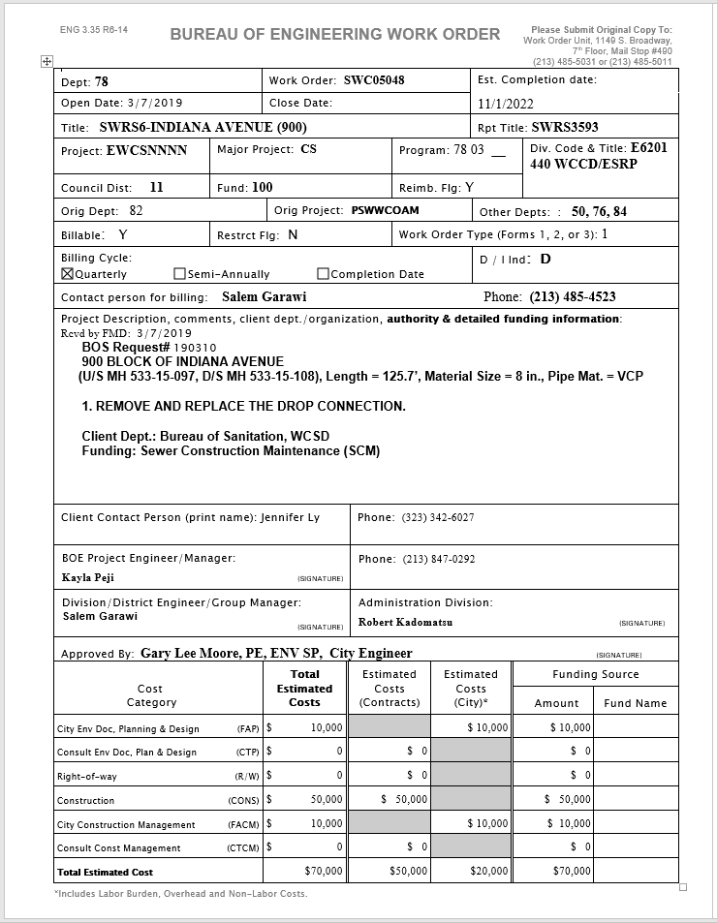PE TO UPDATE ALL FIELDS CIRCLED IN RED

    - Transmit the word document file to the following recipients from the BOS's Financial Management Division (FMD):

      - Group FMD Inbox: san.fmdworkorder@lacity.org
      - FMD/BOE Liaison: Douglas Hoy: douglas.hoy@lacity.org
      - FMD/BOE Liaison: Sylvia Sy: sylvia.sy@lacity.org

Note: Subject to personnel change. Verify with FMD for current liaison names.

If acceptable, BOS will return the form with the updated funding information within 1-2 business days. Once the final draft of the work order request form is received from FMD, save it to:

Q:\CM\Project Groups\4_SEWERS\SEWERS\SEWERS6\Work Orders\Received from FMD Liason

    - Enter the work order number & open date in the SEWERS Online Application (the project should have already been added to the SEWERS Online Application. See part 1.A.ii).

    - Collect all required WCCD signatures: PE, PM, etc.

    - Distribute final copies:

      - One hard copy to the project folder
      - One hard copy to WCCD admin for the master file & PENS (http://boe.ci.la.ca.us/pens/). Once WCCD admin places a copy in PENS, make note of the file code for use on the construction order cover letter.
      - Deliver the original, signed WO to the BOE's Work Order Unit in-box currently on the Public Works Building, 7th floor.

Create the Project Folder

The hard-copy project folder contains the documents and information from all phases of the project. The following information is included on the front of the project folder:

 | PROJECT TITLE [Street, Address]
WORK ORDER NO.: [SXX#####] BOS REQUEST NO.: [######] |  | PENS NO.: [xxxx]  SEWERS SERIAL NO.: [######]
HIGH PRIORITY (if applicable)
PROJECT TITLE: [street, address]
CD: TG: PE:
REVIEWER:
Staple a copy of the BOS Work Request form inside the project folder on the left side. Staple a copy of the signed Work Order form inside the project folder on the right side.

As the project progresses the following documents should be placed in the project and master folders:

- Pre-Design / Design Phase Documents:

  - BOS work request
  - Signed & executed copy of the work order form
  - Design package, including flow calculations
  - CCTV Log Sheet
  - Field Investigation checklist (if requested by the PM)
  - Design package checklist (if requested by the PM)
  - Necessary encroachment permits (when applicable)
  - Right of Entry forms (when applicable)
  - Notice of Sewer Repair Work (when applicable)
  - EMG CEQA NOE and transmittal memo (when applicable)

  - Street Damage Restoration Fee

- Construction / Post-Construction Phase Documents:
  - Change orders (when applicable), including the Inspector's request for change order and Time & Materials (T&M) sheets (if applicable)
  - As-built drawings
  - Engineer's correspondence (memos, engineer's communications, e-mails, RFIs, etc.)
  - Inspector's correspondence (Notices of non-compliance, job memos, requests for change order, etc.)

ADD NEW RECORD ON SEWERS PLANNING EXCEL SPREADSHEET

    - Add a new record to the bottom of the SEWERS Planning Excel Spreadsheet. The PE shall fill out the WO number, PENS Number, type of work and the BOS request #. The SEWERS Planning Spreadsheet can be found at:

https://docs.google.com/spreadsheets/d/1IwZcFMUqIukkJIc5pfgaCl aDN7wxWmsFIrMbJc3vvuo/edit?usp=sharing

    - If the BOS Request is a high priority request, then the PE shall indicate “PRIORITY” under type of work and shall highlight the row in Red background color.

DESIGN
PM uses his/her discretion in assigning designs to a PE. See SEWERS PM procedures for more info.

Prepare Construction Order Design
- The PE indicates the project status in the SEWERS Online Application as "IN DESIGN" and enters the “Design Start Date” and the “Project Engineer”.
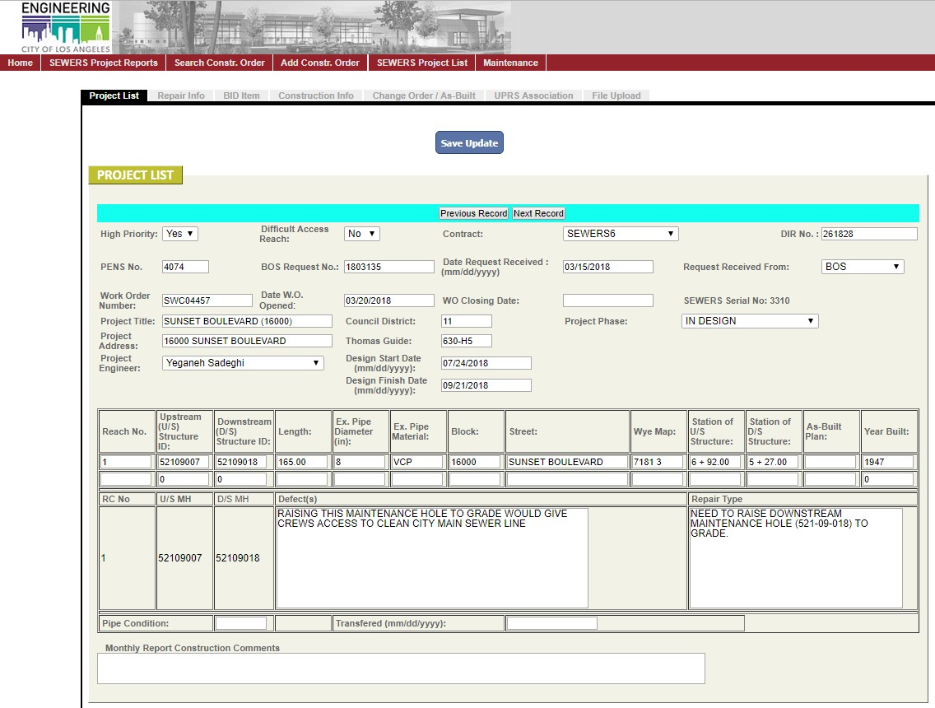

- Create a folder for the project on the Q-Drive at the following location:

Q:\CM\Project Groups\4_SEWERS\SEWERS\SEWERS6\PROJECTS\DESIGN PHASE
  - During design, the electric project folder will be saved in the location. When the project is issued to a contractor, the electronic project file shall be moved to the following location:
Q:\CM\Project Groups\4_SEWERS\SEWERS\SEWERS6\PROJECTS\CONST PHASE

After you have created the project folder, then create the following sub- folders:

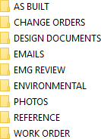

- For each design package, the PE prepares the following documents:

- Data Sheet – Specifies project location, repair limits, existing pipe conditions, nearby utility information, and other project-specific information. Include any additional important information in the “Notes” section, such as coordination requirements with 3rd parties and/or requirements for providing intermediate CCTV.

- Estimated Schedule Of Work & Prices – Consists of a quantity takeoff (QTO) of all anticipated construction activities such as mobilization, traffic control, sewer bypass, shoring method, pipe installation, MH remodel/installation, reconnecting service connections, backfill, paving and CCTV.

- Wye MAP – Prepared with wye maps from Navigate LA and imported into the MS Excel template. The map must contain a north arrow.
In Navigate LA: 1) show me: “infrastructure - sewer information” 2) expand layer: “maps & indices” 3) select: “substructures index” 4) double-click map box 5) download the corresponding substructure index using the menu on the right.

- Substructure Utility Map – Prepared with substructure utility maps from Navigate LA and imported into the MS Excel template. The map must contain a north arrow.
In NavigateLA: 1) show me: "infrastructure - sewer information" 2) expand layer: "maps & indices" 3) select: "substructures index" 4) double click map box 5) download the corresponding substructure index from the menu on the right.

- Job location photos – Prepared with photos taken by the PE at the field visit. Label MH numbers, sewer flow direction, street names, and any other pertinent information.

- BOE Survey Plat Map and/or Cut Sheets – Required for projects where the existing sewer reach runs close to major underground

improvements, within public easements on private property, or when a sewer re-alignment is necessary. For more information on how to make a survey request, refer to the PDM, Chapter 8.

- Street Damage Restoration Fee / One-year moratorium - determine the type of street, go to the Navigate LA Website and search for the project location. Double-click on the centerline of the street. Go to the “Old SDRF Calculator” and enter footage to determine the fee.

- Additional information as deemed necessary by the PM/PE – detailed plans, profile drawings, permits, 3rd party coordination requirements, Contractor work area restrictions, etc.

- CEQA Requirements
  - The SEWERS program has a blanket CEQA Notice of Exemption (NOE) for projects that fall under the following conditions:
    - Projects must be located in the public right of way, in previously disturbed areas and
    - They must be located outside the coastal zone;
    - They must be located outside the City or County Significant Ecological Areas;
    - They must be located outside the Historic Preservation Overlay Zones (HPOZs);
    - They must not require a tree removal permit;
    - Engineers should refer to the SEWERS6 NOE for additional information on the conditions of the blanket exemption.
  - Projects located outside the public right of way, or projects which are in the public right of way, but located in the coastal zone, or within a City or County Significant Ecological Area, or within the HPOZs, or within a Coastal Zone, or in need of a tree removal permit shall be subject to additional environmental review.
  - Installing a new sewer or realigning a sewer does not fall under the blanket CEQA NOE.
  - Coastal Zone / Significant Ecological Areas Check: Check to see if the project is in a Coastal Zone Commission by going to the Navigate LA Website and search for the sewer reach. Then, in the “Table of Contents”, expand the “Special Areas” layer and click on the following menu items:
    - “Historic Preservation Overlay Zone”
    - “Calvo Exclusion Area”
    - “Coastal Zone Commission Authority”
    - “Dual Jurisdictional Coastal Zone”
    - “Significant Ecological Areas”
    - “Zanja Madre”
Navigate LA will then highlight these areas. If the project is in or will impact any of these areas, then the PE shall request Environmental Management Group (EMG) to provide additional review regarding the CEQA requirements for the project.

- The PE will draft the Request for Environmental Review, by completing the cover letter and Questionnaire.

The Cover Letter and Questionnaire is found here:

Q:\CM\Project Groups\4_SEWERS\SEWERS\SEWERS6\Templates & Forms\Templates\Environmental Review

After completing the Cover Letter and Questionnaire, the PE will submit to the PM. PM will review the draft Cover Letter and Questionnaire and return to PE with corrections if necessary.
- After corrections, the PE will scan the signed and completed Cover Letter and Questionnaire in the Q drive electronic project folder.
- After saving a copy, the PE will email a copy of it to Maria Martin, Environmental Affairs Officer, from EMG and a hard copy will be sent to her physical inbox.
- Another hard copy will also be submitted to Admin to submit to PENS and to the Master Folder.
  - Historic Preservation Overlay Zones Check: Check to see if the project is in a Historic Preservation Overlay Zone by going to the Navigate LA Website and search for the sewer reach. Then, in the “Table of Contents”, expand the “City Planning Department” layer and click on the following menu items:
    - “Historic Preservation Overlay Zone District”
Navigate LA will then highlight these areas. If the project is in or will impact any of these areas, then the PE shall request Environmental Management Group (EMG) to provide additional review regarding the CEQA requirements for the project.

- General design guidelines and considerations:

  - Check to see if the street is a state highway by going to the Navigate LA Website (http://boemaps.eng.ci.la.ca.us/navigatela/) and search for the project location. In the “Table of Contents”, expand the “Street Information” layer and click on the menu item labeled “TBM State Highways”. Navigate LA will then highlight all state highways in green. If the project is on a state highway, then a Cal Trans permit must be acquired before construction. Additionally, the following table lists State Highways in the City of Los Angeles:

STATE ROUTE |  | LIMITS |  | LENGTH (MILES) | COUNCIL DISTRICT
NAME | NO. | BEGIN | END | LENGTH (MILES) | COUNCIL DISTRICT
Alvarado St | 2 | Glendale Blvd | Hollywood Fwy | 0.9 | 13
Gaffey St | 110 | Harbor Fwy | 9th St | 0.7 | 15
Glendale Blvd | 2 | Glendale Fwy | Alvarado St | 0.6 | 13

Lincoln Blvd | 1 | Santa Monica City Limits | Sepulveda Blvd | 5.7 | 11
Pacific Coast Hwy | 1 | L.A. County Limits | Santa Monica City Limits | 3.24
Santa Monica Blvd | 2 | Centinela Ave | Beloit St | 1.3 | 11
Santa Monica Blvd | 2 | La Brea Ave | Hollywood Fwy | 2.1 | 4, 13
Sepulveda Blvd | 1 | Lincoln Blvd | Imperial Hwy | 1.5 | 11
Topanga Canyon Blvd | 27 | Ronald Regan Fwy | s/o Mulholland Dr | 9.4 | 3, 12
Venice Blvd | 187 | Lincoln Blvd | Santa Monica Fwy | 5.5 | 10, 11
Western Ave | 213 | San Diego Fwy | 25th St | 5.1 | 15

To find detailed information about the project location, go to the Navigate LA Website and search for the project location. Double-click on a lot adjacent to the sewer reach. Then click on “parcel profile report”.

  - Length of Spot Repair guidelines:
    - For spot repair 0 to 10 feet in depth: Minimum 6 LF spot repair
    - For spot repair 10 to 19 feet in depth: Minimum 8 LF spot repair
    - For spot repair 19 to 35 feet in depth: Minimum 12 LF spot repair

  - Specify Beam & Plate shoring for MH-MH replacements with depths of over 20-feet.

  - For Spot Repair, if the repair is located at the beginning or ending of the reach, then indicate the beginning of the repair as 2-ft from the center of the MH.

  - For MH-MH replacement, indicate the start and end station of the repair from the center of the U/S and D/S MH.

  - All sewers to be replaced shall be replaced with the same diameter pipe, unless otherwise specified by BOS or the PM.

  - If the existing pipe to be replaced does not have a corresponding SEWERS bid item, the bid item(s) for the next bigger size sewer will be used (ex. Use 8-inch sewer bid items for a 6-inch sewer repair)

  - If up-sizing an existing sewer, include bid items for remodeling the U/S and D/S MHs.

  - For MH-MH replacements, assume a production rate of 50-75 linear feet per day. Use this rate to determine how many days of traffic control and bypass pumping are required on the QTO sheet. Consider

negative production impacts such as major utilities, trees, pipe depth, rush-hour restrictions, etc.

  - Pick the unit price depth that best fits the sewer reach to be repaired. If the reach falls within multiple bid item depths, split up the reach depth intervals accordingly in the estimated schedule of work & prices.

  - Backfill & compaction method bid item selection guidelines:

    - Choose "mechanical compaction" for MH-to-MH replacements unless the PM directs to use “jetting”.
    - Choose "slurry backfill" for all spot repairs.
    - Choose "slurry backfill" for any open-cut repairs on highways and major thoroughfares.

  - Shoring method bid item selection guidelines:

    - For unstable or non-cohesive soil (gravel, dry sand) conditions with few utilities, choose trench box shoring.
    - For all other soil conditions for trenches 19 feet deep or less, choose plywood and speed shores.
    - For trenches deeper than 19 feet, engineered shoring plans are required from the Contractor.
    - For trenches with significant groundwater, beam & plate shoring is recommended.

  - To determine the type of street, go to the Navigate LA Website and search for the project location. Turn off the sewer information layer and double-click on the centerline of the street.

  - Use the street resurfacing schedule as listed in the table below:

Street Resurfacing Schedule
Street Type | Saw-Cut Thickness | AC/CMB  Thickness | PCC  Thickness
Major | 12-24" | 8" / 8" | 8"
Secondary | 12-24" | 8" / 8" | 8"
Collector | 0-12" | 8" / 6" | 6"
Local, Alley | 0-12" | 6" / 6" | 6"

  - If the street to be resurfaced is concrete, denote as “PCC” in the applicable section on the data sheet.

  - If the street to be resurfaced is asphalt, denote as “AC” in the applicable section on the data sheet.

  - For trenches backfilled with slurry, base material (CMB) and temporary pavement are not required.

  - For MH-MH replacements, remember to include CMB on the QTO.

  - For Local Streets, Service Roads, and Alleys use 50 blow AC.

  - For Major, Secondary Highways, and Collector Streets use 75 blow AC

  - List house connections and wyes in ascending order (from D/S MH to U/S MH).

  - On the wye maps, there may be two stations indicated for live lateral connections. The first station may be the location of the wye. The section station may be 2-3 feet away and indicates the location of the private house lateral connection. For the purposes of design, the PE should use the station which identifies the location of the wye when a spot repair is called out to repair a live lateral connection.

  - Label substructures on the data sheet
  - Detailed information for Storm Drains owned by the County of LA may not be shown on Navigate LA. For additional information for County of LA storm drains go to: http://dpw.lacounty.gov/fcd/stormdrain/index.cfm

  - When installing cured-in-place liner, indicate if the liner is “non- structural” or “structural” on the data sheet.

  - If the designer can determine the reason for the repair work, then in the “Notes” section of the data sheet, indicate the reason for repair (ie.
…to repair a HC, …to repair broken pipe, etc).

  - If the scope of the work is MH-MH remove and replacement, then the PE should check for any historical boring logs in the vicinity of the project by going to the Navigate LA Website and search for the project location. In the “Table of Contents”, expand the “Geotechnical” layer and click on the menu item labeled “Soil Borings”. If a soil boring is shown on Navigate LA but cannot be downloaded, then the PE may contact the Geotechnical Engineering Group (GEO) to ask for their support in obtaining the soil boring as long as it does not require the GEO to go to the Department of Building and Safety (DBS) to pull the records. If the records can only be located at DBS, then consult with the PM for further direction. After the borings are obtained, the PE should review the boring to evaluate if the soil is sandy or loose or if the sewer is below groundwater. If any of these situations exists, then the PE should discuss the project further with the PM.

  - If the scope of the work is MH-MH remove and replacement and if the project is located on a street with high traffic or goes into an intersection with high traffic, then the PE should flag the project as a potential project requiring night work and shall discuss the project with the PM.

  - If the scope of work includes lining, then the PE should investigate if there are any large buildings or high water use facilities, such as a Laundromat, that have house connection laterals that connect to the sewer. If there are large buildings or high water use facilities that have a house connection lateral connected to the main line sewer, then the PE should flag the project as a potential project requiring night work and shall discuss the project with the PM.

  - The minimum linear footage for CCTV is 200ft/day. Therefore, the QTO should indicate 200 ft for CCTV for sewer reaches less than 200ft. For sewer repairs greater than 200ft, the CCTV linear footage indicated on the QTO shall equal the total reach length.

  - Do not include saw-cut, paving, or shoring bid item footage for scope to “Install New MH”. These items for MH installation are specified as part of the bid item description in the SEWERS contract.
  - Any changes to the scope of work as indicated in the BOS Request must be approved by BOS. The PE must obtain the PM’s approval prior to contacting BOS.

  - To help with future design work, create an account on the NavigateLA Website and bookmark your layers as a saved theme to be able to reference later. Note: These layer selections are an example. You may adjust as needed.
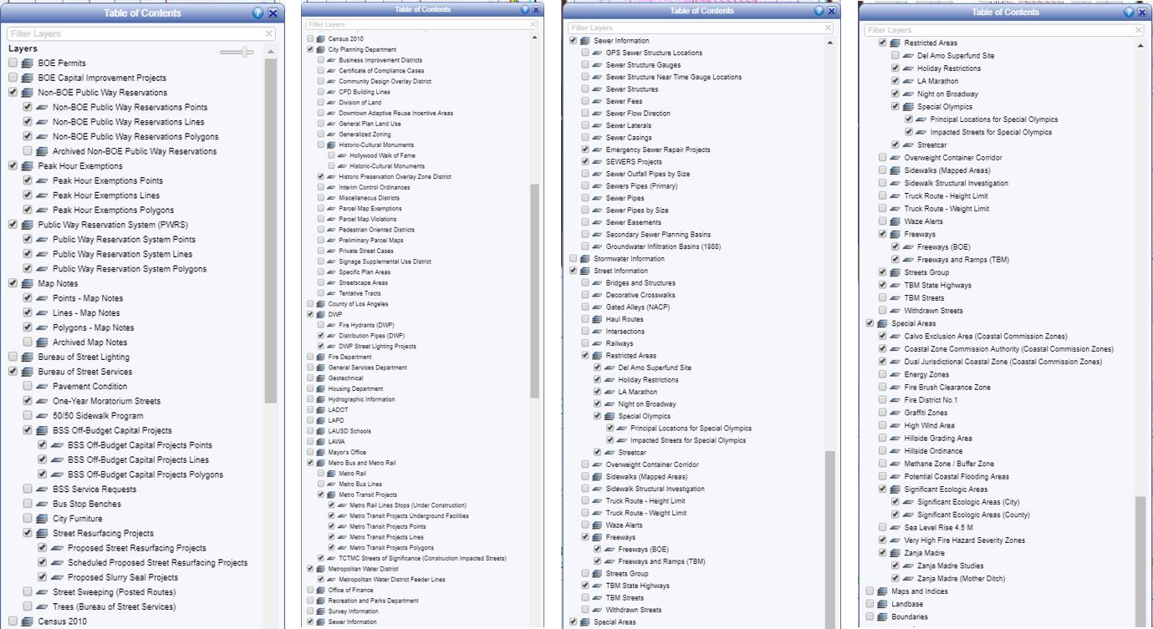

- Review the work request's CCTV footage
The PE is responsible for reviewing the CCTV footage to verify the limits and type of repair proposed on the BOS request form.

If the PE determines that the scope of work should be changed from what is specified on the BOS request, the PE proceeds with the change and the PE must inform BOS/WCSD liaison in writing of the change. Currently the BOS/WCSD liaison can be contacted at the following email address:

Jennifer Ly: jennifer.ly@lacity.org, (323) 342-6027

- Determine if any street moratoriums exist

  - Street moratoriums for recently paved streets can remain in effect for several years and may have penalties associated with them if the street pavement is disturbed before the moratorium expires. The resurfacing status of the street(s) within the SEWERS project location should be verified by the PE by using one of the following resources provided by the Bureau of Street Services (BOSS):

https://bss.lacity.org/resurfacing/rclose.cfm

BOSS hotline: (213) 847-3200

Email: bss.boss@lacity.org

The Street Damage Restoration Fee can be determined by the Navigate LA Website. Double-click on the centerline of the street. Go to the “Old SDRF Calculator” and enter footage to determine the fee.

The PE should include documentation of their findings in the project folder.
  - If the street is scheduled to be repaired in the near future, the PE has three options, depending on the urgency of the work request:
- Request from BOSS a postponement of the street repair to the estimated completion date of the SEWERS construction order.
- Request approval from the BOS to issue the construction order until after the street moratorium expiration date.
- Request approval from the Division Engineer to authorize transferring the project to the Emergency Sewer Repair (ESR) Program.
  - All work on highway and secondary highway streets are subject to rush-hour restricted work days (9AM – 3:30PM).

  - Some of the City's major roads are subject to holiday construction moratoriums. Check for the latest list of holiday street moratoriums at the following URL:
http://eng2.lacity.org/holiday_moratorium/

- If your project falls in the “TCTMC Streets of Significance” Metro Bus and Metro layer.

  - The PE will forward a request to eng.tctmc@lacity.org for inclusion to the next available agenda.
  - For more information, the link to the Traffic Management Committee website: https://eng.lacity.org/permits/tctmc

- Draft Notice of Sewer Repair Work if the sewer is in an easement within the private property.

  - Template “Notice of Sewer Repair Work” letter can be found at the following location:

Q:\CM\Project Groups\4_SEWERS\SEWERS\SEWERS6\Templates & Forms\Templates\Notice of Sewer Repair Work

  - Ask support from the BOE Real Estate Division (RED) in obtaining the Name, Address, Parcel No., and phone number for the property by sending an email to one of their officers.
  - After obtaining the homeowner’s address, draft the Notice of Sewer Repair Work and submit to PM. PM will review the draft Notice of Sewer Repair Work and return to PE with corrections if necessary.
  - Scan the signed and completed Notice of Sewer Repair Work in the Q drive electronic project folder.
  - The Notice of Sewer Repair Work will be attached to the construction order.

- Acquiring LADOT approval (If applicable), if your project falls in the “TBM Streets” Street Information layer, is within 250 ft of a signalized intersection or a boulevard/avenue that will have the left lane or multiple lanes closed, then LADOT approved Traffic Control Plans must be acquired before construction.

  - The PE will ask the contractor, after sending out the Construction Order, for a Traffic Control Plan Proposal to get drafted stamped plans.
  - After the Contractor sends you the proposal for review, print and review the proposal and after agreeing on the proposal send a signed copy of the proposal to the contractor.
  - Contractor will then send the stamped drafted traffic control plans to the PE for review.
  - The PE will then start the process for LADOT to begin their review of the Traffic Control Plans

- If the project scope of work is less than 72 hours and will not require k-rail, then you must send your request to the Citywide Temporary Traffic Control (CTTC) Division of the City of Los Angeles Department of Transportation (LADOT). https://ladot.lacity.org/what-we-do/plan-review/citywide- temporary-traffic-control
- If the project scope is more than 72 hours, you must send your request to the Permit Plan Review section of the City of Los Angeles Department of Transportation (LADOT). https://ladot.lacity.org/what-we-do/plan-review/permit-plan- review
  - The project will also have to be sent to the Local Council District to be notified prior to implementing the closure.

- It is required to complete the “SEWERS Design Package Review Checklist” and/or “Field Investigation Checklist”, unless directed otherwise by the PM. When conducting a field investigation, the PE should bring a measuring wheel, digital camera, and the project folder containing the draft design documents. Take pictures and measurements to substantiate the proposed design.

- Submit draft design package to the PM for review.

  - The PE updates the following in the SEWERS Online Application: Project Status, Date Design Completed, PENS Number and then submits the draft design package to the PM.
  - The PM will either review the draft design or assign another engineer to review the draft design.
  - If the design package requires corrections, the reviewer returns the package with comments. The PE then revises the design package and resubmits to the reviewer for another review.
  - Once the project is found acceptable, the PM (or person designated to review the draft designs for the PM) signs and dates the front of the project folder.

Prepare Construction Order Cover Letter

- When the design is complete, the PM will assign an engineer to issue the construction order. Use the cover letter template (doc. format) that best fits the nature of the construction order. The latest electronic versions of these documents can be obtained from the following location:

Q:\CM\Project Groups\4_SEWERS\SEWERS\SEWERS6\Templates & Forms\Templates\Construction Order Letters

- Assign the appropriate work order, file code, BOS request # and contractor information to the cover letter.

- The person assigned to draft the cover letter shall register the project on to the DIR website and obtain a DIR number. The link to the DIR website is:
https://www.dir.ca.gov/PWC100Ext/LoginPage.aspx

- Print out the final version of the cover letter.

Compile and Distribute Construction Order Package

- Compile the Construction Order Package – the entire package should be arranged in the following order: 1) Cover letter, 2) Data Sheet, 3) Estimated Schedule of Work & Prices, 4) Wye and Substructure Utility Maps (if applicable), 5) Job Location Photos (if applicable), 6) copy of the “Notice of Sewer Repair Work” letter (if applicable), 7) EMG CEQA NOE and transmittal memo (if applicable)

- Submit construction order package and the project folder to PM for final review and signature. Revise and re-submit if requested by the PM.

- PE records the following info from the construction order into the SEWERS Online Application:
- In the “PROJECT LISTS” tab input the PENS number, DIR number, Design Finish date and the Project Phase to "IN CONSTRUCTION"
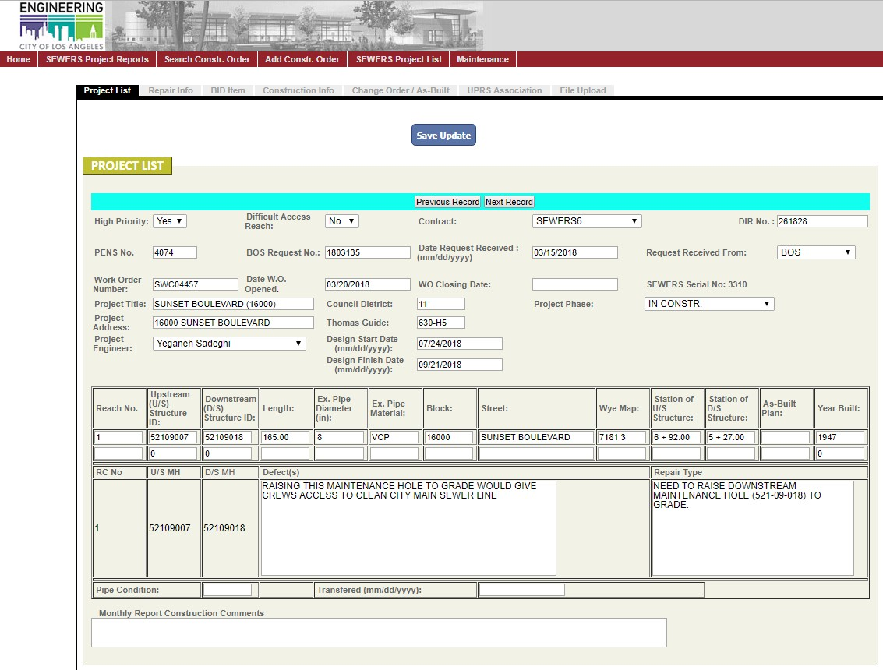

-In the “REPAIR INFO” tab input the Street Type, Repair Type, Project Remarks (if any), Repair Info, and Monthly Report Construction Comments (if any).
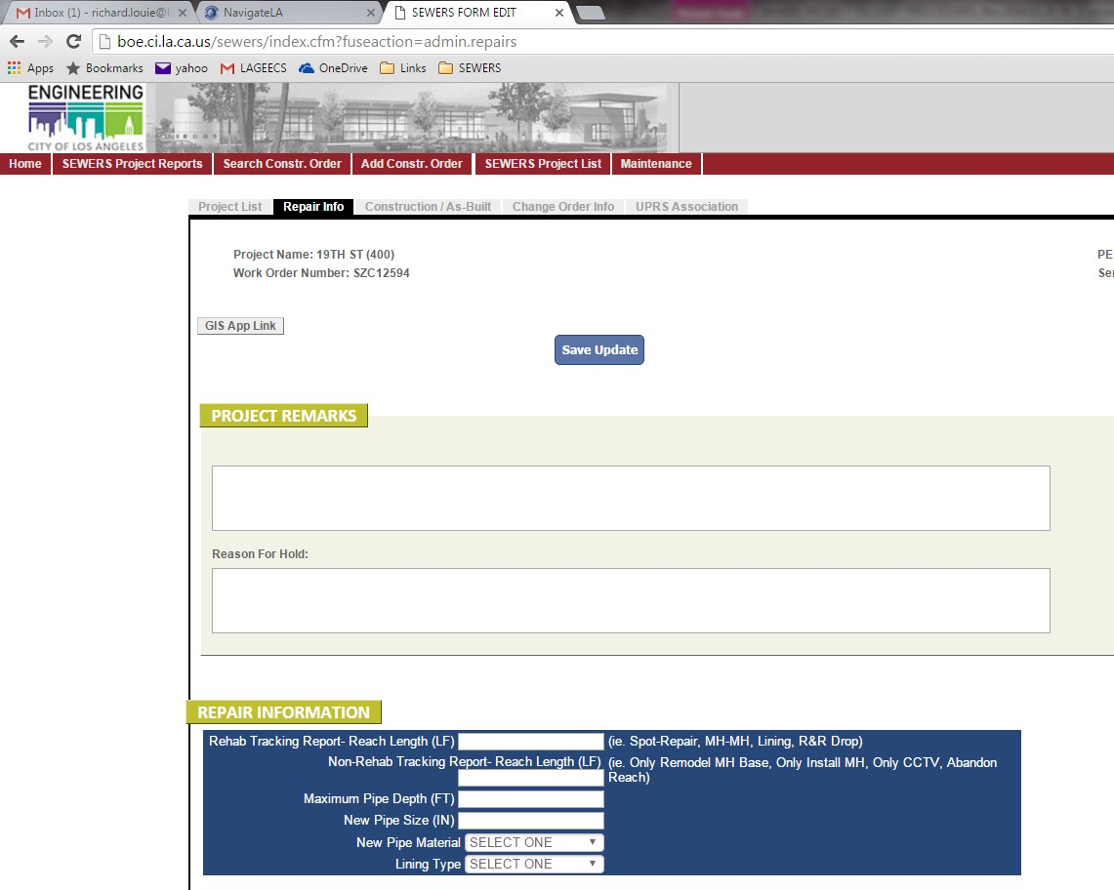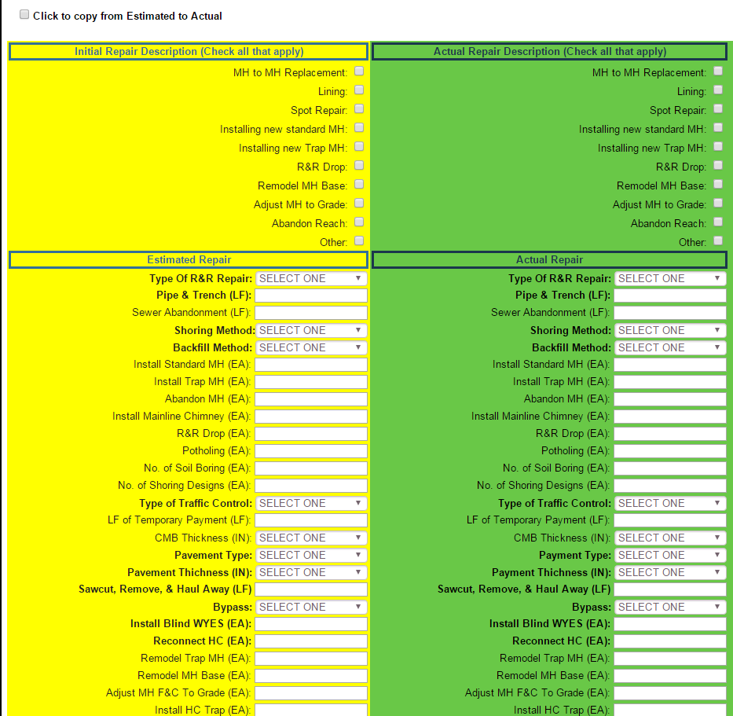
Input as applicable
At least one of these boxes must be checked
Typically, some of these boxes are filled in
Must fill in
One of these boxes must be filled in

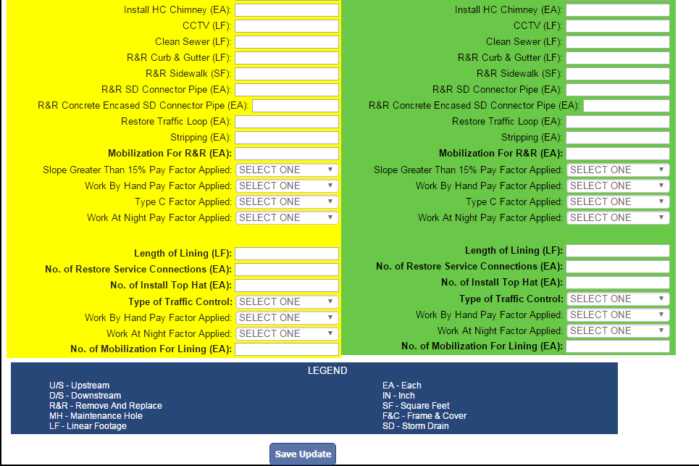
Input as applicable

-In the “CONSTRUCTION INFO” tab input the Contractor Information, Date Construction Order Sent to Mapping (Same date as Construction Start Date), Construction Start Date, and Estimated Cost.
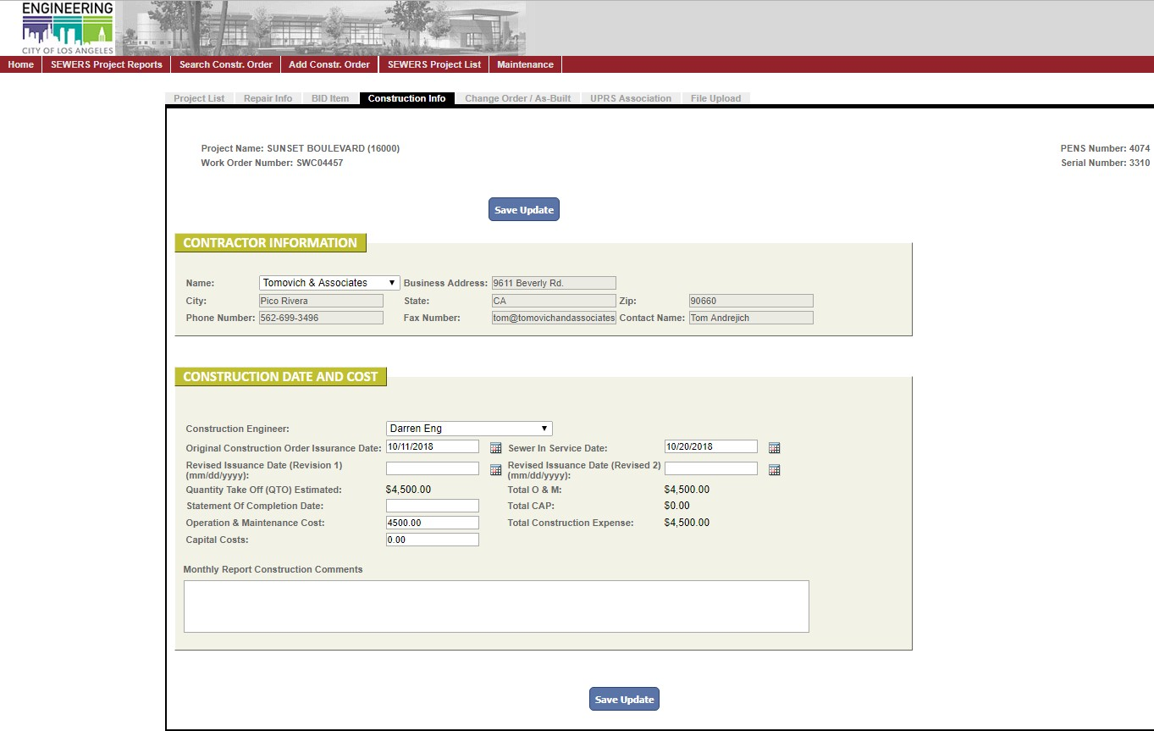

- If applicable, PE makes a copy of the “Notice of Sewer Repair Work” letter. Then PE gives the original hard copy of the “Notice of Sewer Repair Work” letter to WCCD admin personnel. WCCD admin personnel shall log it into PENS and distribute it to master file and recipients. PE will include the copy of the “Notice of Sewer Repair Work” letter in the construction order package.

- Distribute the construction order package using the following procedure.

  - PE makes a PDF copy of the package.

  - PE reviews the PDF to make sure all information is legible and contains no visible defects.

  - PE changes the PDF file to the following file name convention:

WORK ORDER_S#_CONSTRUCTION ORDER_PROJECT TITLE (ADDRESS)_DOLLAR AMOUNT_ISSUANCE DATE (YYMMDD)
(E.g. SZC12347_S6_CNOR_Foothill Blvd (5900)_$14012.12_181026)

  - PE e-mails the PDF file to the recipients listed on the distribution list as well as to the SEWERS group on the same day as the issuance date

listed on the construction order cover letter. The distribution list can be found on the construction order cover letter templates which can be found at:

Q:\CM\Project Groups\4_SEWERS\SEWERS\SEWERS6\Templates & Forms\Templates\Construction Order Letters

Use the following subject header for the e-mail:

"ISSUANCE OF CONSTRUCTION ORDER - [SEWERS# - STREET (BLOCK NUMBER)]"

If multiple construction orders are being issued in a single package, use the following subject header for the e-mail:

"ISSUANCE OF CONSTRUCTION ORDER(S) – SEWERS# - [STREET1 (BLOCK NUMBER)], [STREET2 (BLOCK NUMBER)] ...."

  - PE saves a copy of the PDF in:

Q:\CM\Project Groups\4_SEWERS\SEWERS\SEWERS6\Construction Orders

  - PE moves the digital project folder from Design Phase:

Q:\CM\Project Groups\4_SEWERS\SEWERS\SEWERS6\PROJECTS\DESIGN PHASE
to Construction Phase: Q:\CM\Project
Groups\4_SEWERS\SEWERS\SEWERS6\PROJECTS\CONST PHASE

  - PE prints a copy of the entire package and places it in the project folder. Project folder shall then be placed in the working file cabinet.

  - PE gives the original hard copy to WCCD admin personnel. WCCD admin personnel shall log it into PENS and distribute to master file and the recipients.

v) Additional procedures for "priority" projects: The PE is responsible for contacting BOE survey, indicating the emergency nature of the construction order. Unless otherwise directed by the Senior CM or Division Engineer, the site must be surveyed and marked by the Underground Safety Alliance (USA) before the Contractor can mobilize to the jobsite. On the construction order, indicate the project’s “priority”

designation clearly, as well as the mobilization deadline. On the email sent to the contractor, the PE shall note the priority of the project over any existing projects being scheduled.

- CONSTRUCTION

Providing Construction Management Support

  - Documentation

During construction, the PE will respond to questions and clarifications that arise in the field with the assistance of the PM if necessary. The PE is responsible for maintaining all project-related records, including electronic files and master files. These records shall be used as supporting documentation for any future change orders, audits and/or claims.

Differing Site Conditions (DSC)

The Contractor is required to notify the Engineer and Inspector of a DSC in compliance with the General Conditions, Section 501. Before any directive is given to the Contractor to address a DSC, the PE should first confirm the Contractor's claim with the field Inspector, as well as obtain approval from the PM for issuing a response and/or directive.

Engineer's Directives

The PE is responsible for issuing a directive to the Contractor through RFI responses and Engineer’s Communications. All issued directives should be preceded with a phone call to both the Contractor and the Inspector by the PE.

Submittals

Any required submittals are reviewed, tracked, transmitted and filed by the PE using the standard WCCD filing procedures. Copies shall be retained in the respective project folders (hard copy & electronic) and the Project Engineer’s Network System (PENS).

Completion

A SEWERS project is considered “completed” when the sewer is repaired and put back in service. When the PE confirms with the Inspector and Contractor that the project is completed, the PE updates the project status and completion date in the SEWERS Online Application.

Issue Change Order

During construction, issuing a change order may be necessary to compensate the contractor for extra work that may be encountered. However, most construction orders have a very short construction schedule (typically 1-3 days) to complete the work. Therefore, Change Order Initiation Forms and Preliminary Change Orders are not used for SEWERS program because the nature of the program requires extra work to be authorized quickly. To avoid delaying construction work, the Engineer will authorize extra work (either per bid item or on a time and material (T&M) basis) through email or other correspondence. The Engineer will place a hard copy of the email or other correspondence in the project folder and an electronic copy in the Q-drive project folder.
Immediately after authorizing extra work through email, the Engineer will begin drafting and issuing a change order to compensate the contractor if extra work will be compensated through bid items. If extra work will be compensated on a T&M basis, then the Engineer must wait for the contractor to turn in their T&M sheets before the change order can be processed.

    - The Engineer will draft change order(s) to compensate for extra work encountered during construction. Additionally, after construction is complete, and as necessary, the Inspector will issue a “request for change order form” to the PE. This document includes all information necessary to issue the final closeout change order, which includes, bid item adjustments, extra work tracked on time & materials (T&M) basis, and/or lump-sum extra work.

    - If there are T&M sheets to be processed by the engineer you will use the Time & Material Processing System (https://engpermits.lacity.org/tmps/).
      - The PE will create a work order on the TMPS site under the SEWERS tab by clicking on “add new work order”.

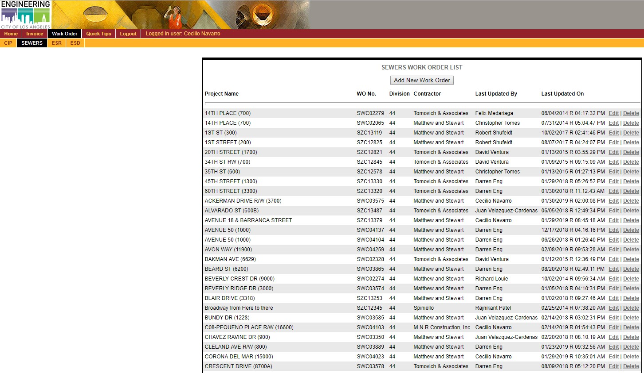

      - 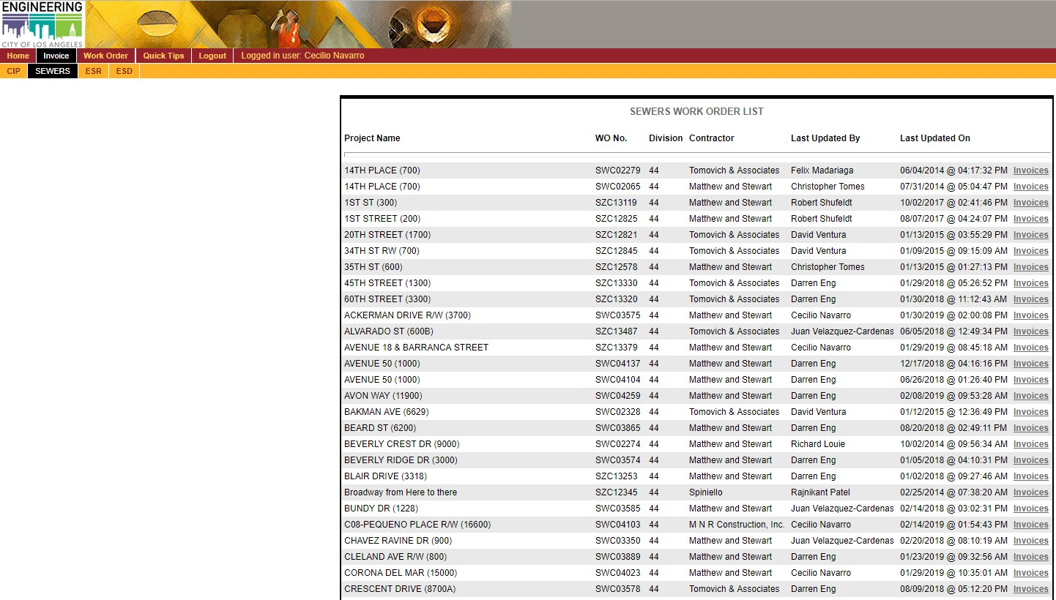After creating the work order, click on “invoices” under the newly created work order.

      - There should be no invoices for a newly created work order, create a new invoice under the SEWERS tab by clicking on “add new invoice”. Input the amount billed that can be found on the T&M sheets from the contractor.

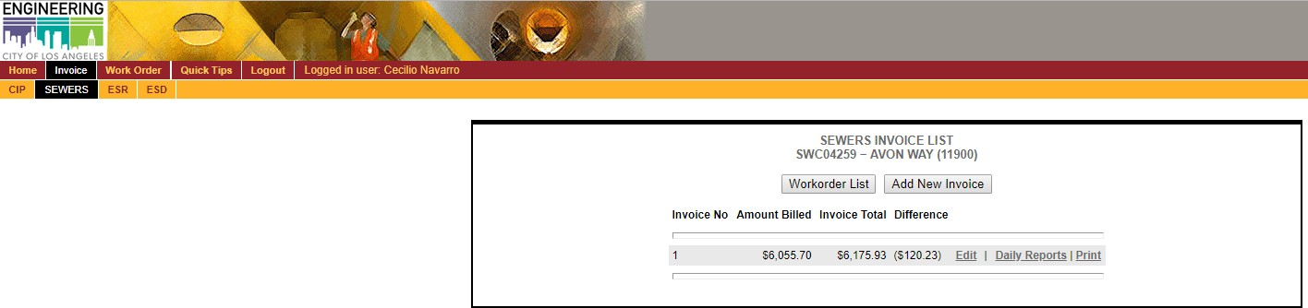

      - Add a daily report for every day of approved T&M for every work day, by clicking on “add daily report”.
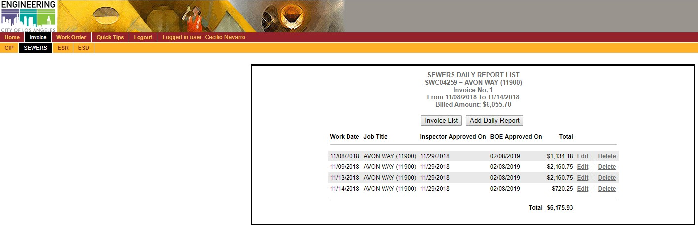

      - Now, the PE will carefully review the T&M sheets to identify any errors when inputting the labor details such as the amount of hours inputted for a day and the rate type. If there is any difficulty, contact Inspection and lastly the contractor to verify. After reviewing, input the labor details into the daily report by clicking on “add labor detail”.
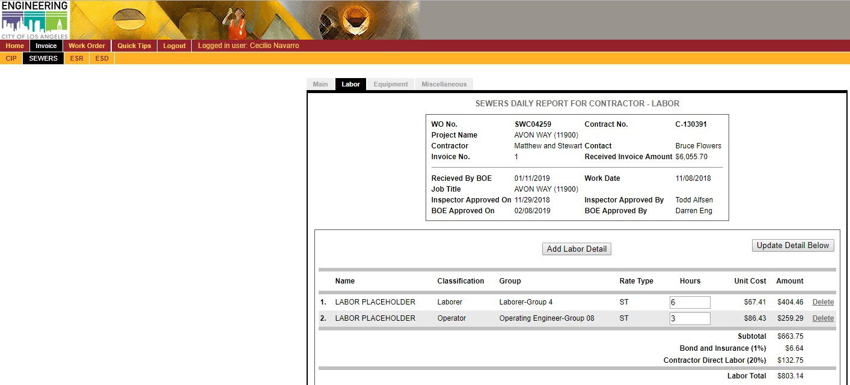

      - Now add the equipment information used for the workday. Carefully review the equipment details by reviewing the T&M sheets, look for any errors such as the wrong equipment for the type of work they are doing. If there is an excess quantity of standby equipment, look

for answers from Inspection and then the contractor. After verifying, input the equipment detail by clicking on “add equipment detail”.
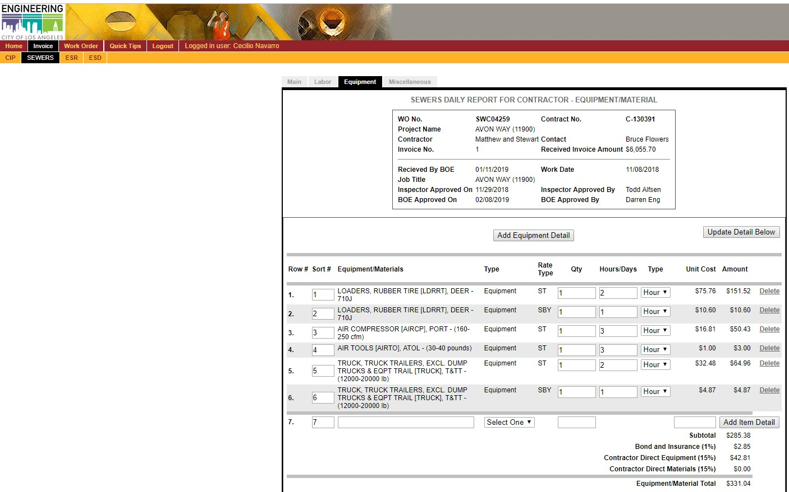

      - Repeat the process for extra work days by adding more daily reports, and after completing inputting all daily reports, the amount billed should be similar to the invoice total. Print the sheets for the invoices, and save a copy in the Q-drive, the prints should be attached and sent to the reviewer with the MS Excel template for Change Order or FCCO.

    - If a change order request is received from the Inspector, then the PE updates the project in the SEWERS Online Application with the date the change order request and as-built records were received. If no change order request is received, then the PE leaves the “Date Request Received” field blank.
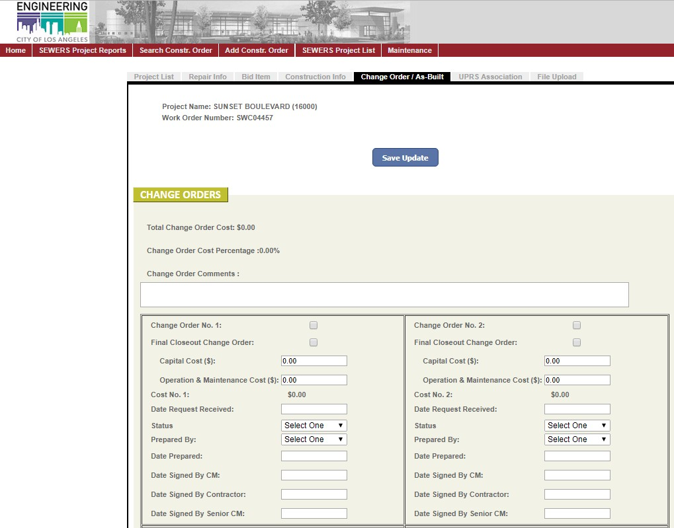

    - The PE prepares a change order using the standard template obtained from the following location:

Q:\CM\Project Groups\4_SEWERS\SEWERS\SEWERS6\Templates & Forms\Templates\Change Order & FCCO Cover Sheets

    - The PE drafts the change order using all supporting documentation substantiating the change order, such as T&M invoices, Engineer's directives, record of negotiation, etc.

    - If a RFCO was received from BCA, then the PE will verify that the RFCO is based on the latest authorized revision of the QTO when drafting the change order.

    - When a change order adds or deducts bid item quantities, if the bid item IS on the original/revised QTO, then you add or deduct the bid item quantities as “Bid Item Adjustments”.

    - When a change order adds or deducts bid item quantities, if the bid item IS NOT on the original/revised QTO, then you add or deduct the bid item quantities as “Extra Work”.

    - After the change order is drafted, the PE submits the draft change order to the PM for review with all supporting documentation. If corrections are necessary, then the PM returns the change order to the PE for revisions. The PE will incorporate all comments and return the change order to the PM for another review. This process continues until the change order is approved and signed by the PM.

    - The PM returns the signed change order to the PE. The change order is logged into the SEWERS Online Application by the PE with the date the change order was prepared by the PE, the date the change order was signed by the PM, and the dollar amount information for the change order.

    - The PE drafts and signs a cover letter for the change order using the contractor specific cover letter template obtained from the following location:

Q:\CM\Project Groups\4_SEWERS\SEWERS\SEWERS6\Templates & Forms\Templates\Change Order & FCCO Cover Sheets\Cover letters

    - The PE scans and saves a copy of the change order with cover letter in the electronic project folder on the Q-drive. Then the PE emails the scanned copy of the change order with cover letter to the people as listed on the contractor specific cover letter.
    - PE changes the PDF file to the following file name convention: For a Final Executed Change Order:
WORK ORDER_S#_FINAL EXECUTED CHANGE ORDER_PROJECT TITLE (ADDRESS)_DOLLAR AMOUNT_ISSUANCE DATE (YYMMDD)
(E.g. SZC13366_S6_FECO_Doheny Drive Alley (9100)_$3153.33_181221)

For a Final Closeout Change Order:
WORK ORDER_S#_FINAL CLOSEOUT CHANGE ORDER_PROJECT TITLE (ADDRESS)_DOLLAR AMOUNT_ISSUANCE DATE (YYMMDD)
(E.g. SZC12825_S6_FCCO_1st Street (200)_$2988.03_181212)

    - The PE places a hard copy of the change order with cover letter into the project folder. Then the PE places the original copy of the change order with cover letter into the WCCD Administrative Staff in-box for them to log into PENS and distribute to the Contractor for signature.

    - The Contractor signs and returns the change order to the PE. The PE gives a copy of the change order to WCCD administrative staff to log into PENS. If the Contractor refuses to sign the change order as written, the PE shall notify the PM to determine a resolution.

    - The PE submits the change order that has been signed by the CM and the Contractor to the Senior Construction Manager or Division Engineer for review and signature.

    - After the Senior Construction Manager or Division Engineer signs the change order the PE completes the change order information in the SEWERS Online Application and changes the status of the change order to “completed”.
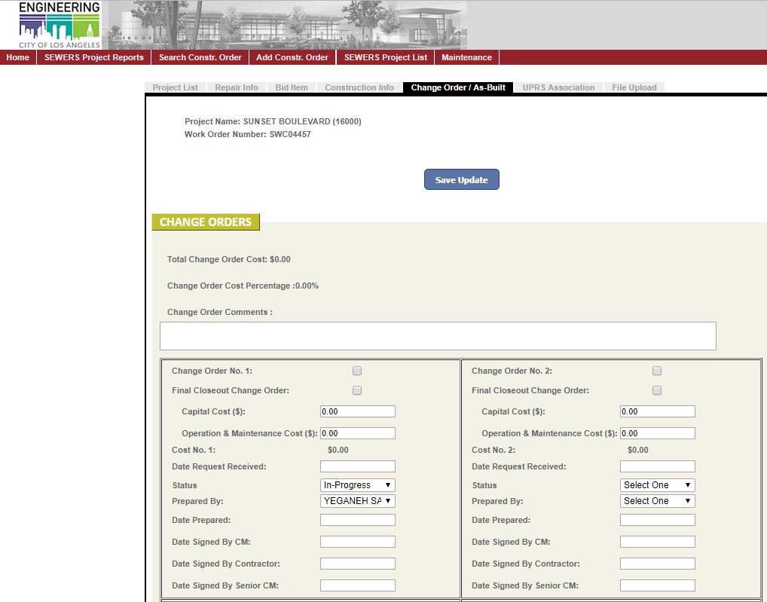

    - Then the PE attaches the standard WCCD distribution cover sheet to the fully executed change order (FECO) and scans and saves a copy of the FECO in the electronic project folder on the Q-drive. The PE then emails a scanned copy of the FECO to the people listed on the distribution cover sheet with cc to the WCCD Administrative Staff. The WCCD distribution cover sheet can be obtained from the following location:

Q:\CM\Project Groups\4_SEWERS\SEWERS\SEWERS6\Templates & Forms\Templates\Change Order & FCCO Cover Sheets\FECO distribution sheet template

    - The PE places a copy of the FECO with distribution cover sheet in the project folder and then places the original copy of the FECO with distribution cover sheet into the WCCD Administrative Staff in-box for them to log into PENS and distribute.

POST-CONSTRUCTION

CCTV

  - When a CCTV is received, the PE should review the CCTV to determine if it is the Final CCTV (e.g. post-repair or post-lining CCTV). If it is not a Final CCTV but is a Pre-lining CCTV or an Assessment CCTV, then the CCTV should be given to the CE right away for their review.

  - When Final CCTV is received:

    - PE date stamps the DVD and Inspection Report with the date received.

    - If necessary, the PE creates a folder and saves it onto the network drive located at:

\\netapp1\cctv\wcc_cctv

Then the PE creates a subfolder titled “4-Post Construction CCTV” (SEWERS6) and saves the CCTV in this folder.

    - PE changes the PDF file to the following file name convention:

US MH #_DS MH #_SEWERS# - PROJECT TITLE
(ADDRESS)_revcdYearMoDa

(e.g. 404-02-055_404-02-056_SEWERS6 – TEMPLE ST (1000)
_recvd20130324)

    - PE logs the CCTV information into the SEWERS Online Application.
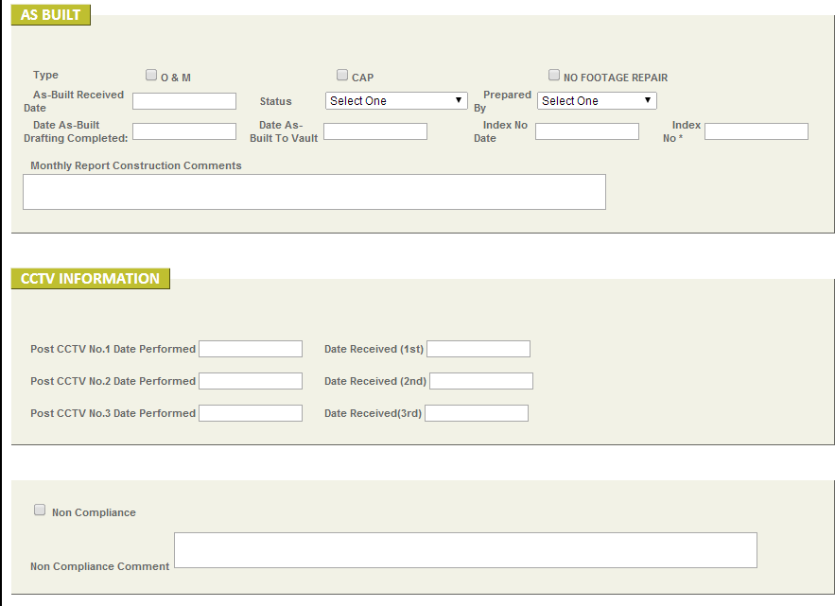

    - PE sends email to BOS indicating the project titles and BOS Request numbers of all the CCTV that will be delivered to BOS via grey mail.
    - PE prints a copy of the email, attaches the email to the DVD(s), and places the package in a grey mail envelope and sends it to BOS. The current contact information for BOS is:

STOP | TO Bureau of Sanitation, WCSD
536 | Attn: Jennifer Ly
536 | 2714 Media Center Dr.

    - gives the package to the WCCD representative who will deliver the package to BOS at the PDT meeting.

Issue a Revised Construction Order

A revised construction Order, for billing purposes, is a lot faster than processing a change order for payment. Inspection will hand out these requests for a revised construction order to the PM. The PM will hand them off to an assigned PE whom will log them into the SEWERS planning sheet and hand them off to an appropriate PE to work on the revised construction order:

- The MS Excel spreadsheet for a revised CO can be found here:

Q:\CM\Project Groups\4_SEWERS\SEWERS\SEWERS6\Templates & Forms

The PE copies over the revised QTO sheet over to the original QTO to work on.

- The PE will look in the project folder for associated emails detailing the approval of extra work. Any extra bid items not verified through emails can be verified through contacting Inspection, the PE whom worked on the project and lastly, the contractor. If the PE cannot verify the added work, the PE will remove the items from the request for revised construction order. The PE will print the emails, and attach the email to the revised construction order package to be handed off to the PM.

- iii. The PE will then draft a revised construction letter using the appropriate letter with the correct contractor and contract. The letter can be found here:

Q:\CM\Project Groups\4_SEWERS\SEWERS\SEWERS6\Templates & Forms\Templates\Construction Order Letters\Construction Order – Revised

The PE will reference the original construction order and note on the letter the type of work added.

- The PE will correct the QTO amount and input the revised construction order date into the SEWERS database.

- The PE will hand off the revised QTO, revised construction order letter, and emails verifying the extra work to the PM whom will sign the letter.

- PE changes the PDF file to the following file name convention:

WORK ORDER_S#_CONSTRUCTION ORDER_PROJECT TITLE (ADDRESS)_DOLLAR AMOUNT_ISSUANCE DATE (YYMMDD)
(E.g. SWC04010_R1_S6_CNOR_Washington Way Alley (500)_$1640_190408)

- PE e-mails the PDF file to the recipients listed on the distribution list as well as to the SEWERS group on the same day as the issuance date listed on the revised construction order cover letter. The distribution list can be found on the revised construction order cover letter templates which can be found at:

Q:\CM\Project Groups\4_SEWERS\SEWERS\SEWERS6\Templates & Forms\Templates\Construction Order Letters\Construction Order -
Revised

- PE saves a copy of the PDF in:

Q:\CM\Project Groups\4_SEWERS\SEWERS\SEWERS6\Construction Orders

- PE prints (2) copies of the entire package and places (1) copy in the project folder. The original copy will be put in the WCCD inbox with the

admin personnel. Another copy will also be placed in the inbox. WCCD admin personnel shall log it into PENS and distribute to master file and the recipients.

Statement of Completion

- Once the project has been issued Statement of Completion (SOC), the Bureau of Contract Administration will give a copy of the SOC to the PE.

- The PE saves a scanned PDF copy of the SOC at the following location:

Q:\CM\Project Groups\4_SEWERS\SEWERS\SEWERS6\Statement of Completion
- The PE places a hard copy of the SOC into the project folder and into the Master File.

- The PE goes to the SEWERS Online Application and updates the date that the SOC was issued.

(D) Process “As-Builts”

The Contractor’s "marked up" as-built records are delivered to the PE by the Inspector in the same package as the Request for Change Order and consists of a copy of the construction order data sheet with changes noted. When the marked up as-built record is received, the PE scans and saves a copy to the electronic project folder on the Q-drive.

Input as applicable
At least one of these boxes must be checked
  - The PE records the following information into the SEWERS Online Application:

- In the “REPAIR INFO” tab, under Repair Information, input the actual repair information.
Click this button to automatically copy the information from yellow section to the green section

Input as applicable

- In the “CHANGE ORDER/AS BUILT” tab input the type of as-built, the date the as-built record is received, the status, and the PE who is preparing the as-built.
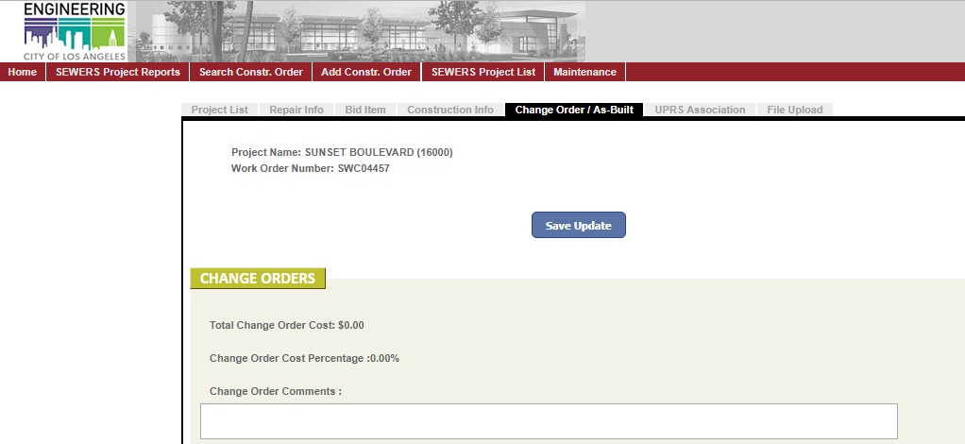

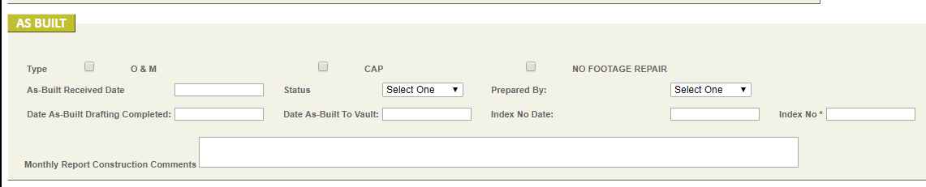

  - As-built records are to be reviewed, drafted and processed by the PE. The as-built can be generated by:

- The as-built will be attached with the FCCO sheet, that will be sent by BCA.

- Scan the as-built sheet and save it in the as-built folder under the project folder.

- The PE will make a copy of the SEWERS Design template and save it in the as-built folder under the project folder

- The PE will then rename the copied SEWERS Design template into SEWERS as-built. After copying, change the “AS-DESIGNED” to “AS- BUILT” in the SEWERS as-built file. With the as-built from BCA, make the changes shown.

  - The PE submits final as-built to the PM for review. If corrections are necessary, the PM returns the as-built to the PE for revisions.

  - The PM returns the stamped and signed as-built to the PE. Then the PE drafts a “Plan Processing Transmittal Memo” and signs the memo on behalf of the PM (ie. Signature for Salem Garawi). The “Plan Processing Transmittal Memo” template can be found at the following link:
Q:\CM\Project Groups\4_SEWERS\SEWERS\SEWERS6\Templates & Forms\Templates\As-Builts

  - After the Plan Processing Memo is drafted, the PE performs the following:

- Update the project status in the SEWERS Online Application with the date the as-built drafting was completed.
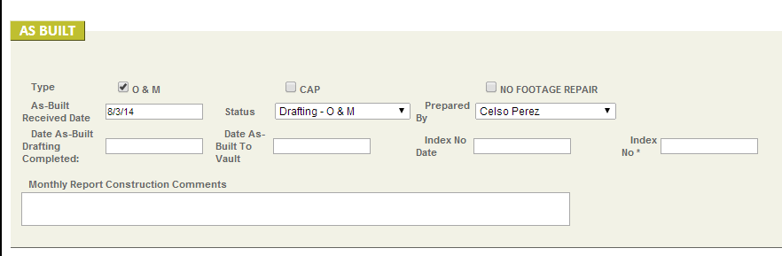

- Save an electronic copy of the Plan Processing Transmittal memo and signed As-built plan to the Q-Drive project folder.

- Place one hard copy of the Plan Processing Transmittal Memo and stamped and signed As-Built Plan in the project folder.

- Give one hard copy of the Plan Processing Transmittal Memo and stamped and signed As-Built Plan to WCCD admin to log into PENS (http://boe.ci.la.ca.us/pens/) and to place in master file.

  - The PE will transmit completed as-built records to the Vault using the following procedures:

- Email an electronic copy of the “Plan Processing Transmittal Memo” and As Built to the Vault (currently Rolf Clever), Mapping (currently Randy Price), and Bureau of Sanitation (currently Vincent Tan). The following is an example email language:

Subject: SEWRS6 As-Builts Hello,
The As-Built for SEWERS6 – Hillsdale Dr (4800) is being submitted to the Vault for approval. If you have any questions, please feel free to contact me at (xxx) xxx-xxxx.

Sincerely,

- Update the project status in the SEWERS Online Application with the date the as-built was transmitted to Vault and update the status of as- built as “Pending Index No.”.

  - The PM is notified via e-mail within 1-2 weeks that the submission is either accepted by the Vault, or corrections are required. If notification is not received from the vault within this timeframe, contact the vault for the status.

  - When the submission is accepted by the Vault, the Vault assigns the as- built an Index Number.

- The PE obtains the Index number from the Vault and enters the Index No. and date the record was created (as listed on the Vault website: (http://engvault.lacity.org/epps/) into the SEWERS Online Application.

- Save an electronic copy of the As-Built Plan with Index No. to the Q- Drive project folder.

- Place one hard copy of the As-Built Plan with Index No. in the project folder and give the original copy to WCCD admin to log into PENS (http://boe.ci.la.ca.us/pens/) and to place in master file.

- After the As-Built plans are approved by the Vault, Mapping uploads the As-Built plan to Navigate LA.

(E) Work Order Close-Out

i.) Before the Project Closeout Form is processed, the PE shall verify that the Statement of Completion, Fully Executed Final Closeout Change Order, and As-Built with Index number has been obtained for the project. If any of these documents are missing, then the PE shall obtain these documents before processing the Project Closeout Form.

ii.) The PE fills out the Project Closeout Form that can be obtained from the following link:

http://boe.ci.la.ca.us/eforms/index.cfm?fuseaction=public.formlist&cid=14

iii.) The PE also drafts a memo to file indicating the date the Project Closeout Forms is submitted to Mapping for processing using the template from the following location:

Q:\CM\Project Groups\4_SEWERS\SEWERS\SEWERS6\Templates & Forms\Templates\Project Closeout

iv.) The memo and Project Closeout Form(s) are printed out by the PE and submitted to the PM for review the forms and initial the memo.

v.) Following approval by the PM, the PE emails an electronic copy of the Project Closeout Form to BOE Mapping division. Currently the recipient at Mapping Division is Raul Garcia (MS 230).

vi.) Then the PE submits the original hard copy of the memo to file to WCCD Admin personnel to log in to PENS and place in master file.

vii.) Upon return of the signed Project Closeout Form from the BOE Mapping Division, the PM conducts a final review. Then the PE submits the Project Closeout Form to the Division Engineer (DE) who will sign and return the form to the PE if it is acceptable.

viii.) The PE updates the SEWERS Online Application with the date the Project Closeout form was signed by the DE.
ix.) The PE drafts a memo to file indicating the date that the Project Closeout form is submitted to the BOE Work Order Unit for processing using the template from the following location:

Q:\CM\Project Groups\4_SEWERS\SEWERS\SEWERS6\Templates & Forms\Templates\Project Closeout

x.) The PE submits the memo to the PM to review and initial the memo.

xi.) The PE submits the original hard copy of the Project Closeout form to the BOE Work Order Unit for processing.

xii.) Lastly, PE attaches a copy of the Project Closeout Form(s) to the memo to file gives the memo to WCCD Admin personnel to log in to PENS and place in master file.

AC: Asphalt Concrete

BOE: Bureau of Engineering BOS: Bureau of Sanitation BOSS: Bureau of Street Services CCTV: Closed Circuit Television
CIP: Capital Improvement Program

CM: Construction Manager

CMB: Crushed Miscellaneous Base

CONS: Consturction

CTCM: Consultant Construction Mangement CTTC: Citywide Temporary Traffic Control D/S: Downstream
DE: Division Engineer

DSC: Differing Site Conditions

EMG: Environmental Management Group

ESRP: Emergency Sewer Repair Program

FACM: Forced Account (City) Construction Management

FECO: Fully Executed Change Order

FMD: Financial Management Division

LADOT: Los Angeles Department of Transportation MH to MH: Maintenance Hole to Maintenance Hole MH: Maintenance Hole
MS: Mail Stop

O&M: Operations & Maintenance Program

PCC: Portland Cement Concrete PDM: Project Delivery Manual PDT: Project Development Team

PE: Project Engineer

PENS: Project Engineer’s Network System

PM: Project Manager QTO: Quantity Take Off RED: Real Estate Division ROE: Right-of-Entry
SEWERS: Super Expedited Wastewater Emergency Repair of Sewers

SIMMS: Sewer Inventory Maintenance Management System

SOC: Statement of Completion

SSRP: Secondary Sewer Renewal Program

T&M: Time & Material

U/S: Upstream

USA: Underground Safety Alliance

WCCD: Wastewater Conveyance Construction Division (part of BOE)

WCSD: Wastewater Collection Systems Division (part of BOS)

WO: Work Order

Bureau of Engineering: Wastewater Conveyance Construction Division

Super-Expedited Wastewater Emergency Repair for Sewers (SEWERS) Program
Project Manager Procedures

Introduction
The purpose of these procedures is to provide step-by-step guidance for performing project management of the SEWERS program. These procedures are arranged in sequential order, which include the Pre-Design, Design, Construction, and Post-Construction phases of project delivery.

In the SEWERS program, the Project Manager (PM) manages the SEWERS contract and SEWERS group. The SEWERS group staff serve in both the capacity of Project Engineer (PE) and in the capacity of the Construction Engineer (CE). The PE/CE supports the PM through all project delivery phases of the SEWERS Program.

Procedures

PRE-DESIGN

- A Work request is received by the Project Manager (PM) from the Bureau of Sanitation (BOS), Wastewater Collection Systems Division (WCSD)

  - The PM forwards the email with the BOS requests to a Project Engineer (PE) and designates the PE to perform the following tasks (details on how to perform these tasks can be found in the SEWERS Project Delivery Procedures):
    - Save an electronic copy of the BOS Request in the Q-drive
    - Add a new record for the project on the SEWERS Online Application and enter the information from the BOS Request into the SEWERS Online Application
    - Open a Work Order for the BOS Request
    - If available, download a copy of the CCTV
    - Create a hard copy project folder
    - Add new record on the SEWERS Planning Spreadsheet

  - After the PE has created the hard copy project folder(s) for the new BOS Request(s), the PE will place the project folder(s) in the PM’s in- box.

  - The PM will check to verify that the CE has added the information for the BOS Request on the SEWERS Planning Spreadsheet. The PM will also check to see if any of the BOS Requests are high priority and to verify that the CE has indicated the request is high priority on the SEWERS Planning Spreadsheet.

  - After checking the project information is accurately listed on the SEWERS Planning Spreadsheet, the PM will then place the project folder(s) in the file cabinet for projects pending design.

  - Additionally, once a month, the PM will link the new work orders opened in the past month, into UPRS. The following procedure is used to link the work orders to UPRS.

UPRS
    - Log into UPRS. If you do not have a UPRS login, then contact WCED for a login and username. The current contact person in WCED is Samer Suliman.
    - Select the current SEWERS project placeholder in UPRS.
    - Select the tab titled “WO Information”.
    - Determine the last SWC and the last SZC work orders that have been linked to the project.

SEWERS App
    - Next, log into SEWERS Online database application
    - Click on the “SEWERS Project List” tab.
    - Select a project that has not been linked in UPRS.
    - After you opened the record for the project, click on the “UPRS Association” tab.
    - Click on the “Add Association” button.
    - Repeat this process for all projects that have not been linked in UPRS.

DESIGN
- PM assigns designs to a PE (Designer)

  - When a PE is ready for a new project, the PM will refer to the SEWERS Planning Spreadsheet (for the location of the spreadsheet, see Pre- Design section above) to determine the next project to be designed. In general, the oldest outstanding projects should be assigned to be designed first.

  - The PM assigns the design to a PE and enters in the name of the PE and the date the design was assigned to the PE on the SEWERS Planning Spreadsheet.

  - The PM organizes, plans, assigns, tracks, and manages the projects in design and aims to issue a minimum of 5 construction orders per week.

  - The PM aims to issue projects out to construction within 2 months of receiving the BOS request.

- When the initial draft of the design is complete, the PE (Designer) will place the project folder in the PM’s in-box. The PM will indicate that the draft design is complete on the SEWERS Planning Spreadsheet. Then the PM will place the all project folders with a completed draft design in a central location such as vertical file organizer.

- If the PM chooses, he/she may delegate the task of reviewing draft designs to a PE (Reviewer).

  - The PM will only assign draft designs for review to a PE who has already been trained by the PM in how to review the design packages.

  - The PM will refer to the SEWERS Planning Spreadsheet to determine the next project to be reviewed. In general, the oldest outstanding projects should be reviewed first.

  - The PM will group projects together that have a completed draft design and that are within a 1.5-mile radius of each other. The PM uses the “Public Reservations” function on the internal Navigate LA to determine if projects are within a 1.5-mile radius of each other. In the “Public Reservations” function:
    - Select the Category of “SEWERS Projects”
    - Select the Date Filter of “Request Received Date”
    - Then search based on a buffer distance of 1.5 miles from the selected SEWERS6 project
Based on the search results, the PM indicates the groupings of projects on the SEWERS Planning Spreadsheet.

  - The PM assigns a PE to review the draft design and enters the name of the PE on the SEWERS Planning Spreadsheet.

  - If the design package requires corrections, then the Reviewer returns the draft design to the Designer. The Designer revises the draft design and returns to the Reviewer for another review. This process continues until the design is approved by the Reviewer. When the design is approved by the Reviewer, the Reviewer will sign and date the front of the project folder and returns the project folder to the PM. The PM will indicate that the design review is complete on the SEWERS Planning Spreadsheet.

- Once the design is approved, the PM performs a Final Design Review and then determines the number of active projects for each contractor.

  - The PM performs a final review of the design to ensure consistency in the designs and Quantity Take Offs (QTO).

  - The PM then determines the number of active projects for each contractor by opening the SEWERS Planning Spreadsheet and creating a copy of the most recent worksheet that was used to evaluate the number of active projects for each contractor.

  - The PM renames the copied worksheet with the current date.

  - On the right-hand side of the worksheet, there is a table with a list of the SEWERS6 projects grouped by contractor. The PM will update this table by copying the SEWERS6 project information from the GoogleDocument created by Bureau of Contract Administration (BCA) Inspector Sara Hernandez. This GoogleDocument is updated on an ongoing basis by BCA with information on the project including but not limited to the dates that construction started and the dates that sewer is in service. This GoogleDocument can be found at:

https://docs.google.com/spreadsheets/d/1Wz2NJJ- MdVrYYAKeDAMNgSCOs6bm_k4OV0LttpvUZLk/edit#gid=55867118 8

If you cannot access the GoogleDocument, then you must contact BCA (currently Sara Hernandez) to ask them to share access rights to the document with you.

  - After copying the project information into the SEWERS Planning Spreadsheet from GoogleDocument, the PM identifies how many projects are active for each contractor.

  - The PM enters in the project title(s) and Quantity Take-Off (QTO) estimate(s) for the contractors into the worksheet under the section labeled, “SEWERS6 – Combined Construction Order Cost Load Sheet”.

  - After the number of active projects is determined, the PM prints a copy of the list of projects showing the number of active projects and places it in the project folder for record purposes.

  - Using the total of the QTO estimate(s) and using the number of active projects, the PM determines which contractor the construction order will be issued to, in accordance with the contract documents. If only 1 construction order will be issued, then there is no need to print out a copy of the “SEWERS6 – Combined Construction Order Cost Load Sheet”. If more than 1 construction order is packaged together, then the PM prints a copy of the “SEWERS6 – Combined Construction Order Cost Load Sheet” and attaches it behind the Construction Order cover letter.

  - Once the PM has determined which contractor the construction order will be issued to, the PM updates the worksheet titled “Work Issued” with the project information including name of the contractor and the name of the person you will designate to be the Construction Engineer (CE).

  - The PM will aim to designate persons as the Construction Engineer (CE) to evenly distribute construction orders between the Construction Engineers assigned for each respective contractor. Additionally, if possible, the PM will assign the same person who performed the design to also perform the construction management of the construction order as long as construction orders are approximately evenly distributed between the Construction Engineers

  - Lastly, the PM goes to the worksheet titled “Planning Sheet” and enters the PENS number for the project, the name of the Contractor for the construction order, and changes the background color for the cells to 25% grey to indicate the project is in construction. Then the PM moves the row of the project to the bottom of the list of the projects that have been issued to the respective contractor.

- After the PM has 1) determined the number of active projects, 2) determined which Contractor to issue the work to, and 3) updates the SEWERS Planning Spreadsheet, the PM then gives the project folder to the person designated to be the CE for the project and asks them to draft the construction order cover letter.

- The CE places the draft construction order cover letter with the construction order package and the project folder in the PM’s in-box. The PM reviews the construction order cover letter and package to for accuracy (especially verify accuracy of Contractor name, Issuance Date, DIR number, Project Title, Work Order, PENS file number, and BOS Request number).

- After reviewing the construction order package, the PM signs the cover letter and gives it to the CE to process the construction order as described in the SEWERS Project Delivery Manual.

CONSTRUCTION

- The PM provides support and direction to the CE and ensures that CE addresses issues when problems or differing site conditions arise during construction.

  - The CE should take the initiative to call the Inspector to verify the field conditions, research available documents (such as as-built plans, substructure maps, etc.), and review the contract documents.

  - The CE should take the initiative to make a recommendation to the PM as to whether the field issue is an extra and if so, provide a recommendation as to what is considered extra and how to compensate the contractor (ie. bid items, T&M, lump sum, etc.).

  - The PM is responsible to make sure the CE maintains good documentation during construction including but not limited to responding in writing to authorize or deny claims of differing site conditions / extra work. The PM is also responsible to make sure the CE processes documentation in a timely manner (ie. change orders, responses to claims for differing site conditions / extra work, review of Assessment CCTV, etc.). If necessary, the PM asks other CEs to assist with tasks depending on the work load of individuals in the group.

  - The PM is responsible to assist the CE in finding resolutions when the CE is cannot find a solution to field issues.

- When extra work is authorized during construction, the CE shall draft a change order and give it to the PM to review right away, if possible. If the extra work is authorized on T&M basis, then the change order must wait for the contractor to submit their filled-out T&M sheets before the change order can be drafted.

  - The CE should aim to draft the change order and submit to PM for review and signature within 1 or 2 days of authorizing extra work.

  - Once the change order is submitted to the PM, the PM should review and return comments to the CE if necessary. The CE corrects the change order and returns it to the PM for another review. This process continues until the change order is approved and signed by the PM. After the change order is signed by the PM, the CE will send the change order to the contractor for the contractor’s signature. See SEWERS Project Delivery Procedures for more details on how to process a change order.

  - The change order should be signed and sent to the contractor for the contractor’s signature within 1 week of the date that extra work is authorized.

POST-CONSTRUCTION

- After the construction order is complete, the Final Closeout Change Order (FCCO) must be drafted.

  - The contractor submits their request for final payment and as-built mark up to the BCA Inspector and the Inspector reviews the documents.

  - If the documents are accurate, the BCA Inspector submits a “Request for Final Change Order” (RFCO) and the As-Built to the PM.

  - The PM assigns a CE to draft the FCCO and to draft the As-Built plan. The PM will aim to assign FCCOs and As-Builts to evenly distribute the FCCOs and As-Builts between the Construction Engineers assigned for each respective contractor. The PM enters the date the RFCO was received and enters the name of the CE and the date the Change Order & As-Built was assigned to the CE on the SEWERS Planning Spreadsheet. For the location of the spreadsheet, see Pre-Design section above.

  - When the draft FCCO and As-Built are complete, the CE will place the FCCO in the PM’s in-box. The PM will then indicate that the draft FCCO is complete on the SEWERS Planning Spreadsheet.

  - The PM will review the FCCO. If the PM chooses, he/she may delegate the task of reviewing the draft FCCO to another CE (Reviewer). The PM will only assign draft FCCOs to a CE who has been trained by the PM in how to review the FCCO. The PM enters the name of the person assigned to review the draft FCCO in the SEWERS Planning Spreadsheet.

  - The person reviewing the FCCO will verify the information on the change order is accurate, will verify the FCCO matches the information on the RFCO, will verify that the change order uses the “Sample Reasons for Change” (unless otherwise approved by the PM), and will review the T&M sheets to ensure the approved labor and equipment rates are used.

  - If the FCCO requires corrections, then the Reviewers will return the draft FCCO to the CE. The CE revises the FCCO and returns the draft FCCO to the Reviewer for another review. This process continues until the FCCO is approved by the Reviewer.

  - After the FCCO is approved by the Reviewer, the Reviewer will place the FCCO in the PM’s in-box. The PM will indicate that the FCCO Review is Complete on the SEWERS Planning Spreadsheet.

  - The PM will perform a final review of the FCCO. If no additional corrections are needed, then the PM signs the FCCO. Then the PM gives the FCCO back to the CE to send to the contractor for contractor to sign. Additional details on how to process the FCCO can be found in the SEWERS Project Delivery Procedures.

- As described above, the BCA Inspector receives and reviews the As-Built plan from the contractor. If the document is accurate, the BCA Inspector forwards the As-Built to the PM and the PM assigns a CE to draft the As- Built.

  - The CE drafts the As-Built and places it in the PM’s in-box.

  - The PM reviews the As-Built. If the As-Built requires corrections, the PM returns the package to the CE with comments. The CE then revises the As-Built and resubmits to the PM for another review. This process continues until the As-Built is approved by the PM.

  - When the As-Built is approved by the PM, the PM stamps and signs the As-Built. Then the PM gives the As-Built back to the CE for the CE to process the As-Built. Details on how to process the As-Built can be found in the SEWERS Project Delivery Procedures.

  - The PM is responsible to follow up with the Vault (currently Rolf Clever) to inquire about the status of the review and approval of the As-Built if the significant time has passed since the As-Builts were submitted to the Vault. Once the Vault has reviewed and approved the As-Built(s), they will return the hard copy As-Built with Index Number to the PM.

  - When the As-Built is returned, the PM assigns a CE to update the SEWERS Online Application with the Index Number for each project.

- When the Statement of Completion is received, BCA will send an email to the PM with an electronic copy of the Statement of Completion attached.

  - The PM assigns a CE to process the Statement of Completion as described in the SEWERS Project Delivery Procedures.

- After field work is complete, the contractor sends copies of the CCTV to the PM.

  - The PM is responsible to assign a CE to process the Post-Construction CCTV as described in the SEWERS Project Delivery Procedures. The PM will assign Post-Construction CCTV to evenly distribute the processing of Post-Construction CCTV between the Construction Engineers assigned to each respective contractor.

  - After the CE has processed the Post-Construction CCTV, the CE gives the CCTV to the WCCD Engineer (currently Rafael Solorzano) who will attend the next Project Development Team (PDT) meeting.

- The Project Closeout Form can be processed once the SOC is issued, the FCCO has been fully executed, and the As-Built Plans have been indexed. When the project is complete, the PM assigns a CE to draft the Project Closeout Form in order to close the work order for the project. The CE processes the Project Closeout Form as described in the SEWERS Project Delivery Procedures.

Guidelines for Determining Capital Cost and O&M Cost

When drafting the Quantity Take Off (QTO) estimate for a construction order or when drafting a change order, the Engineer will indicate if the work is Capital Work or O&M Work.

Work that is considered Capital Work (CAP or CIP):
- Install New Standard Maintenance Hole (MH)
- Install New Trap MH
- MH to MH Remove and Replacement (R&R)
- Non-Structural Lining entire reach
- Structural Lining entire reach
Work that is considered Operation and Maintenance (O&M) Work:
- Spot Repair
- Remodel MH Base
- Adjust MH Frame and Cover to grade
- Remove and Replace a Drop MH Connection (unless this is part of MH to MH R&R scope)
- Install a Sectional Liner Only
- Install a Service Lateral Connection (Top Hat) Liner Only
- Abandon entire reach
If the construction order has scope that includes both Capital Work and O&M Work, then the Engineer should indicate on the QTO or change order the bid items that apply only to Capital Cost and the bid items that apply only to the O&M Cost. If there are bid items that apply to both Capital Cost and O&M Cost (i.e. bypass, traffic control, mobilization) then the Engineer should indicate 50% of the bid item is Capital Cost and 50% of the bid item is O&M Cost.

If there is a situation that does not fit within these guidelines, then the PE shall contact the PM for further direction.

